Car Rental

Sebastian Wisniewski, Nojus, Arnas, Daniel Giedraitis,

Contents

User Interface 5

Menu 5

Layout 5

Background 5

Font 5

Slideshow 5

Add A Car 6

Delete A Car 6

Amend/View A Car 6

Add A Company 8

Delete A Company 8

Amend/View A Company 8

Add A Blacklist 9

Layout 9

Background 9

Font 9

Button 9

Delete A Blacklist 10

Layout 10

Background 10

Font 10

Button 10

Amend/View A Blacklist 11

Layout 11

Background 11

Font 11

Button 11

Add A Rental Category 12

Layout 12

Background 12

Font 12

Button 12

Delete A Rental Category 13

Layout 13

Background 13

Font 13

Button 13

Amend/View A Rental Category 14

Layout 14

Background 14

Font 14

Button 14

Returns 15

Rentals 16

Rental Report 17

Layout 17

Background 17

Font 17

Car Report 18

Layout 18

Background 18

Font 18

Button 18

System Layout 19

Database Tables 20

Blacklist 20

Structure 20

Populated Version 20

Rentals 21

Structure 21

Populated Version 21

RentalCategory 22

Structure 22

Populated Version 22

CarReport 23

Structure 23

Populated Version 23

Group Work 24

Screen 24

Html 26

CSS Code 29

CSS Code 2 34

Arnas 36

Nojus 37

Sebastian Wisniewski 38

Add Blacklist 38

Screen 38

Code 39

Html Code 39

PHP Code 40

CSS Code 41

CSS Code 2 46

Amend Blacklist 48

Screen 48

Code 49

Html Code 49

PHP Code 52

CSS Code 53

CSS Code 2 58

Delete Blacklist 60

Screen 60

Code 61

Html Code 61

PHP Code 63

CSS Code 64

CSS Code 2 69

Rental Report 71

Screen 71

Code 72

Html/PHP Code 72

CSS Code 74

CSS Code 2 79

Daniel Giedraitis 80

Add Rental Category 80

Screen 80

Code 80

Html Code 81

PHP Code 82

CSS Code 83

Amend / View a Rental Category 86

Screen 86

Code 87

Html Code 87

PHP Code 89

CSS Code 90

Delete Rental Category 93

Screen 93

Code 94

Html Code 94

PHP Code 95

CSS Code 96

Car Report 99

Screen 99

Code 100

Html + PHP Code 100

CSS Code 102

Database Code 105

# User Interface

## Menu

### Layout

The layout of the page is simplistic with the navigation bar horizontally on top following 3 text grids side by side, a map of the surrounding area and the fleet of cars the rental has to offer.

### Background

The background of the page such as the layout is very minimalistic with a white background which first perfectly with the blue colour scheme of the page.

### Font

The font size is set to 12px with the family-sans font style as it modern in look and greatly suits the look and feel of the page. The text colour is grey to make it stand out from the plain white background while the heading is blue in colour.

### Slideshow

The slideshow at the bottom of the page shows the rentals car fleet the images are 1600x900 px in size with 2 buttons one making the slideshow go forward other to make it go back. The car make is also show in the black bar below the image. All the fleet is displayed below the bar with smaller images.

## Add A Car

### Layout

The layout of the page is simplistic with the navigation bar horizontally on top, and the form aligned the centre of the page.

### Background

The background of the page such as the layout is very simple with a white background which first perfectly with the light blue colour scheme of the page.

### Font

The font size is set to 14px with the family-sans font style as it modern in look and greatly suits the look and feel of the page. The text colour is black to make it stand out from the plain white background.

### Button

The buttons are light grey with a bigger size from the text to make them stand out to the user. They are also positioned at the bottom of the form with a smooth edge to make them look better than a plain button. The button text is black to make it stand out to the user.

## Delete A Car

### Layout

The layout of the page is simplistic with the navigation bar horizontally on top, and the form aligned the centre of the page.

### Background

The background of the page such as the layout is very simple with a white background which first perfectly with the light blue colour scheme of the page.

### Font

The font size is set to 14px with the family-sans font style as it modern in look and greatly suits the look and feel of the page. The text colour is black to make it stand out from the plain white background.

### Button

The buttons are light grey with a bigger size from the text to make them stand out to the user. They are also positioned at the bottom of the form with a smooth edge to make them look better than a plain button. The button text is black to make it stand out to the user.

## Amend/View A Car

### Layout

The layout of the page is simplistic with the navigation bar horizontally on top, and the form aligned the centre of the page.

### Background

The background of the page such as the layout is very simple with a white background which first perfectly with the light blue colour scheme of the page.

### Font

The font size is set to 14px with the family-sans font style as it modern in look and greatly suits the look and feel of the page. The text colour is black to make it stand out from the plain white background.

### Button

The buttons are light grey with a bigger size from the text to make them stand out to the user. They are also positioned at the bottom of the form with a smooth edge to make them look better than a plain button. The button text is black to make it stand out to the user.

## Add A Company

### Layout

The layout of the page is simplistic with the navigation bar horizontally on top, and the form aligned the centre of the page. A picture is accompanied in the top left hand corner just below the navigation bar.

### Background

The background of the page such as the layout is very simple with a white background which first perfectly with the light blue colour scheme of the page.

### Font

The font size is set to 14px with the family-sans font style as it modern in look and greatly suits the look and feel of the page. The text colour is black to make it stand out from the plain white background.

### Button

The buttons are light blue with a bigger size from the text to make them stand out to the user. They are also positioned at the bottom of the form with an edge to make them look better than a plain button. The button text is light to make it stand out to the user.

## Delete A Company

### Layout

The layout of the page is simplistic with the navigation bar horizontally on top, and the form aligned the centre of the page. A picture is accompanied in the top left hand corner just below the navigation bar. The Layout is very similar so its user friendly.

### Background

The background of the page such as the layout is very simple with a white background which first perfectly with the light blue colour scheme of the page.

### Font

The font size is set to 14px with the family-sans font style as it modern in look and greatly suits the look and feel of the page. The text colour is black to make it stand out from the plain white background.

### Button

The buttons are light blue with a bigger size from the text to make them stand out to the user. They are also positioned at the bottom of the form with an edge to make them look better than a plain button. The button text is light to make it stand out to the user.

## Amend/View A Company

### Layout

The layout of the page is simplistic with the navigation bar horizontally on top, and the form aligned the centre of the page. A picture is accompanied in the top left-hand corner just below the navigation bar.

### Background

The background of the page such as the layout is very simple with a white background which first perfectly with the light blue colour scheme of the page.

### Font

The font size is set to 14px with the family-sans font style as it modern in look and greatly suits the look and feel of the page. The text colour is black to make it stand out from the plain white background. Some text is underlined to grab users attention

### Button

The buttons are light blue with a bigger size from the text to make them stand out to the user. They are also positioned at the top & bottom of the form with an edge to make them look better than a plain button. The button text is light to make it stand out to the user.

## Add A Blacklist

### Layout

The layout of the page is simplistic with the navigation bar horizontally on top, and the form aligned in the middle of the page.

### Background

The background of the page such as the layout is very minimalistic with a white background which first perfectly with the blue colour scheme of the page.

### Font

The font size is set to 12px with the family-sans font style as it modern in look and greatly suits the look and feel of the page. The text colour is grey to make it stand out from the plain white background.

### Button

The buttons are light blue with a bigger size from the text to make them stand out to the user. They are also positioned at the bottom of the form with a nice smooth edge to make them look oval. The button text is white to make it stand out to the user.

## Delete A Blacklist

### Layout

The layout of this page is identical to the last page as we would like the user to familiarise him/her self with the page form and not have to worry about to look out for new elements. However, there is a slight change as the dropdown with all the companies on record is placed at the top of the form.

### Background

The background of the page such as the layout is very minimalistic with a white background which first perfectly with the blue colour scheme of the page.

### Font

The font size is set to 12px with the family-sans font style as it modern in look and greatly suits the look and feel of the page. The text colour is grey to make it stand out from the plain white background.

### Button

The buttons are light blue with a bigger size from the text to make them stand out to the user. They are also positioned at the bottom of the form with a nice smooth edge to make them look oval. The button text is white to make it stand out to the user.

## Amend/View A Blacklist

### Layout

The layout of this page is identical to the last page as we would like the user to familiarise him/her self with the page form and not have to worry about to look out for new elements. However, there is a slight change as the dropdown with all the companies on record is placed at the top of the form. After selection the information appears below the dropdown.

### Background

The background of the page such as the layout is very minimalistic with a white background which first perfectly with the blue colour scheme of the page.

### Font

The font size is set to 12px with the family-sans font style as it modern in look and greatly suits the look and feel of the page. The text colour is grey to make it stand out from the plain white background.

### Button

The buttons are light blue with a bigger size from the text to make them stand out to the user. They are also positioned at the bottom of the form with a nice smooth edge to make them look oval. The button text is white to make it stand out to the user.

## Add A Rental Category

### Layout

The page layout is straightforward, with the navigation bar horizontally on top and the form aligned in the centre of the page with text boxes for the user to enter details for a new rental category and the form also has a field set.

### Background

The page background, as well as the layout, is very simple, with a car and nice scenery as its background that contrasts beautifully with the page's blue and white colour scheme.

### Font

The font size is set to 16px with the Arial font style because it is modern and complements the look and feel of the page well. The text is black which suits the white background of the text box in the form.

### Button

The buttons are white in colour, and they are also placed at the bottom of the form. The button text is black has a black border around the button.

## Delete A Rental Category

### Layout

The layout of this page is identical to the layout of the previous page because we want the user to become familiar with the page form and not have to worry about looking for new elements. However, there is a minor change in that the dropdown with all the rental categories is placed at the top of the form.

### Background

The page background, as well as the layout, is very simple, with a car and nice scenery as its background that contrasts beautifully with the page's blue and white colour scheme.

### Font

The font size is set to 16px with the Arial font style because it is modern and complements the look and feel of the page well. The text is black which suits the white background of the text box in the form.

### Button

The buttons are white in colour, and they are also placed at the bottom of the form. The button text is black and has a black border around the button. The drop-down list box also has the same features as the buttons.

## Amend/View A Rental Category

### Layout

The layout of this page is identical to the layout of the previous page because we want the user to become familiar with the page form and not have to worry about looking for new elements. However, there is a minor change which there is a amend/view button under the drop-down list of the rental categories.

### Background

The page background, as well as the layout, is very simple, with a car and nice scenery as its background that contrasts beautifully with the page's blue and white colour scheme.

### Font

The font size is set to 16px with the Arial font style because it is modern and complements the look and feel of the page well. The text is black which suits the white background of the text box in the form.

### Button

The buttons are white in colour, and they are also placed at the bottom of the form. The button text is black and has a black border around the button. The drop-down list box also has the same features as the buttons.

## Returns

### Layout

The layout of the page is simplistic with the navigation bar horizontally on top, and the form aligned the centre of the page.

### Background

The background of the page such as the layout is very simple with a white background which first perfectly with the light blue colour scheme of the page.

### Font

The font size is set to 14px with the family-sans font style as it modern in look and greatly suits the look and feel of the page. The text colour is black to make it stand out from the plain white background.

### Button

The buttons are light grey with a bigger size from the text to make them stand out to the user. They are also positioned at the bottom of the form with a smooth edge to make them look better than a plain button. The button text is black to make it stand out to the user.

## 

## Rentals

### Layout

The layout of the page is simplistic with the navigation bar horizontally on top, and the form aligned the centre of the page. A picture is accompanied in the top left hand corner just below the navigation bar.

### Background

The background of the page such as the layout is very simple with a white background which first perfectly with the light blue colour scheme of the page.

### Font

The font size is set to 14px with the family-sans font style as it modern in look and greatly suits the look and feel of the page. The text colour is black to make it stand out from the plain white background.

### Button

The buttons are light blue with a bigger size from the text to make them stand out to the user. They are also positioned at the bottom of the form with an edge to make them look better than a plain button. The button text is light to make it stand out to the user.

## Rental Report

### Layout

The layout of this page is very simplistic with the report being directly in the middle of the page. While the navigation bar being displayed horizontally above the report. The form is grey and blue in colour with slight shadows around the edges. The form also includes a responsive hover option.

### Background

The background of the page such as the layout is very minimalistic with a white background which first perfectly with the blue colour scheme of the page.

### Font

The font size is set to 14px with the sans-serif font style as it modern in look and greatly suits the look and feel of the page. The text colour is grey with the titles being white to make it stand.

## Car Report

### Layout

The page layout is straightforward, with the navigation bar horizontally on top and a car report table aligned in the centre of the page with information on model name, manufacturer, registration number, status, date added to fleet and cumulative records.

### Background

The page background, as well as the layout, is very simple, with a car and nice scenery as its background that contrasts beautifully with the page's blue and white colour scheme.

### Font

The font size is set to 16px with the Arial font style because it is modern and complements the look and feel of the page well. The text is black which suits the grey background of the form.

### Button

The buttons are white in colour, and they are also placed at the top of the form. The button text is black and has a black border around the button.

# System Layout

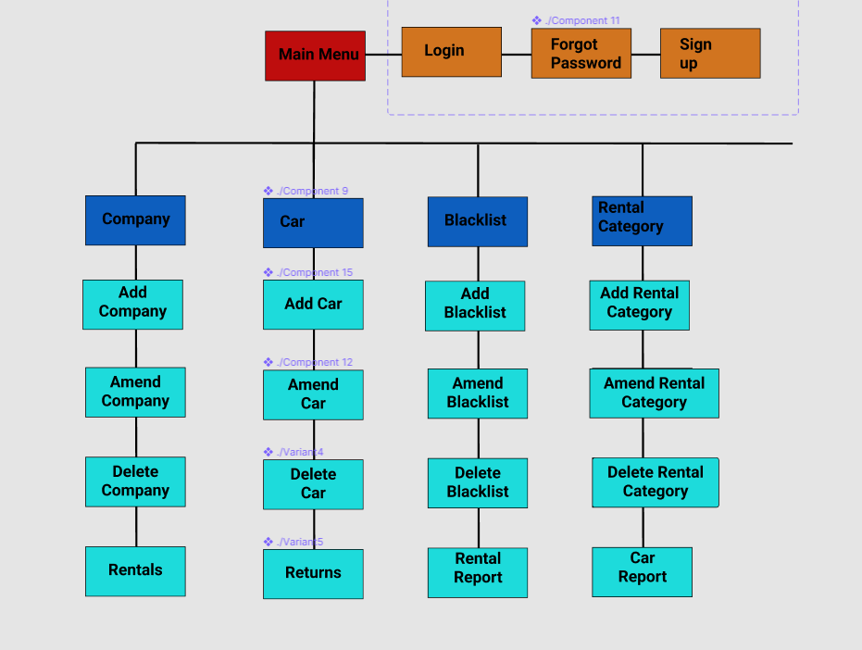

# Database Tables

## Blacklist

Sebastian Wisniewski

### Structure

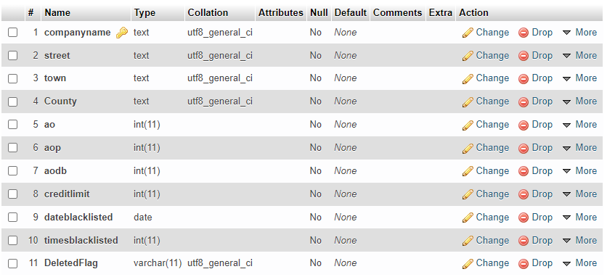

### Populated Version

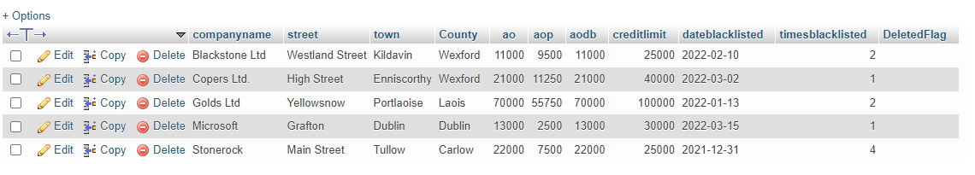

## Rentals

Sebastian Wisniewski, Nojus

### Structure

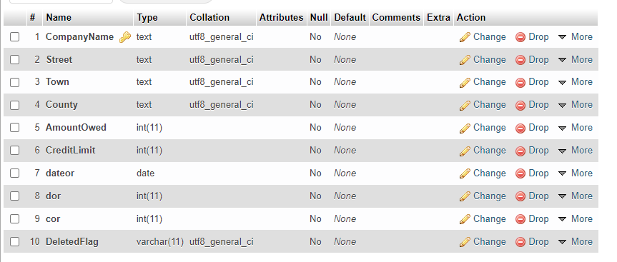

### Populated Version

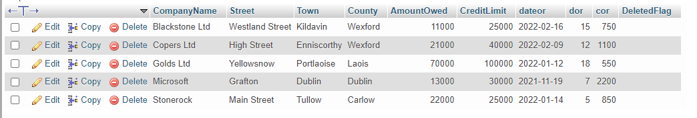

## RentalCategory

Daniel Giedraitis

### Structure

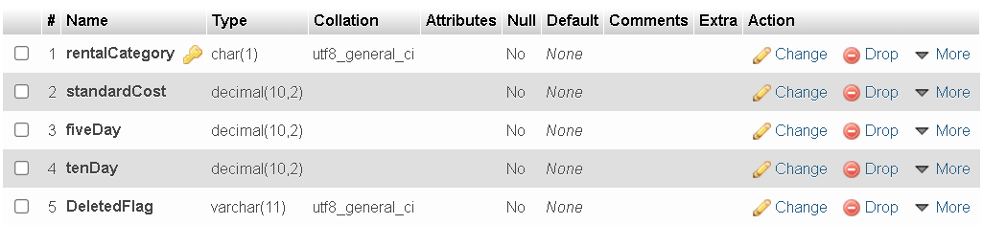

### Populated Version

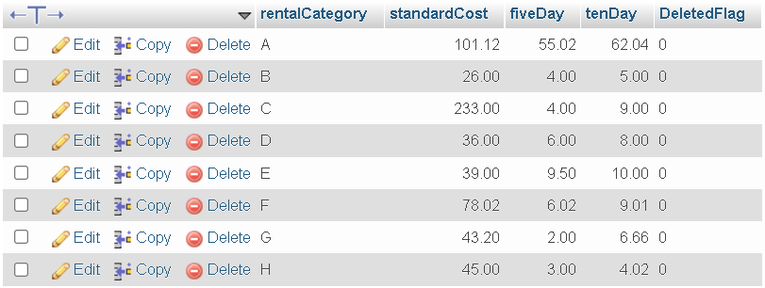

## CarReport

Daniel Giedraitis

### Structure

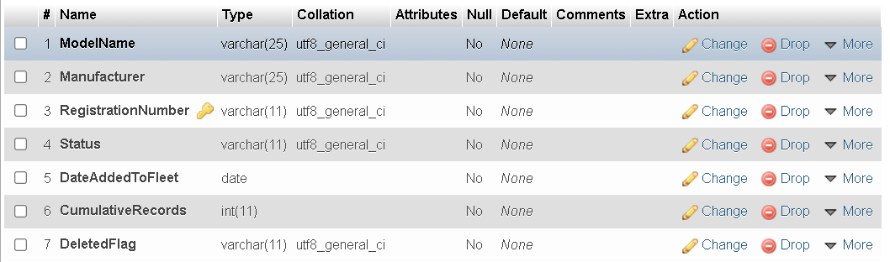

### Populated Version

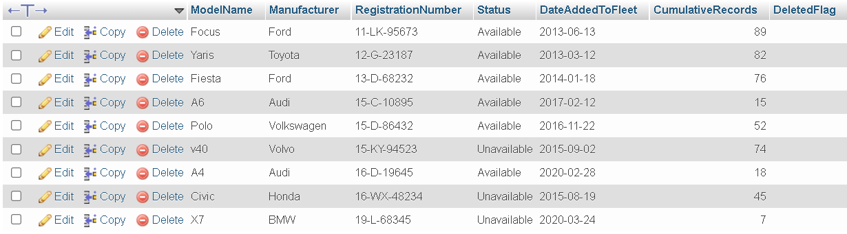

## Cars

### Structure

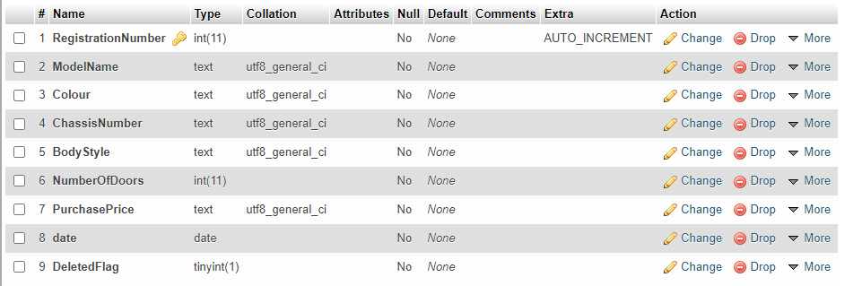

### Populated Version

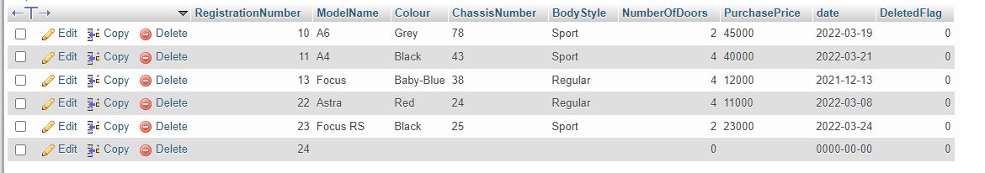

## Company

Nojus Satikauskas

### Structure

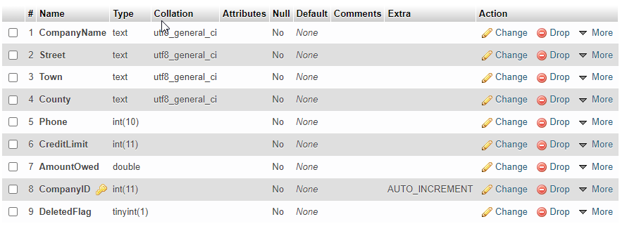

### Populated Version

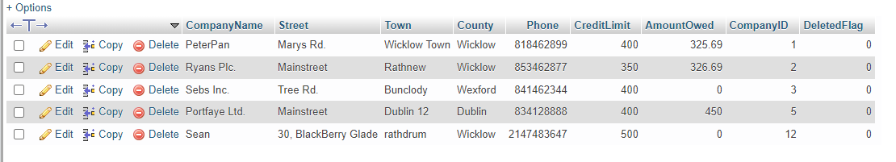

## Password

### Structure

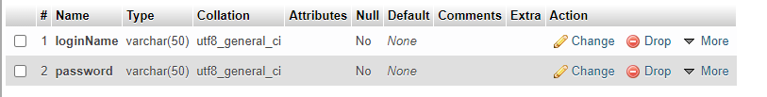

### Populated Version

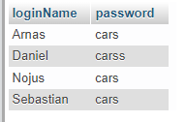

# Group Work

Sebastian Wisniewski, Daniel Giedraitis, Nojus Satikauskas

### Screen

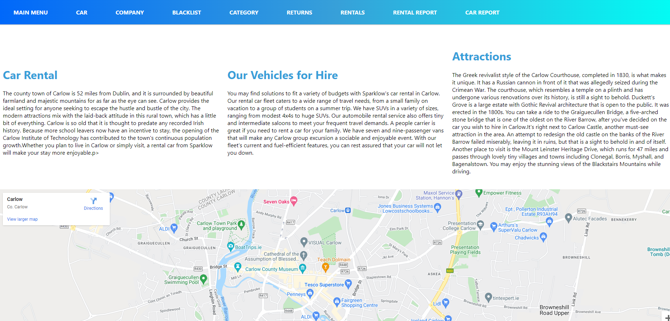

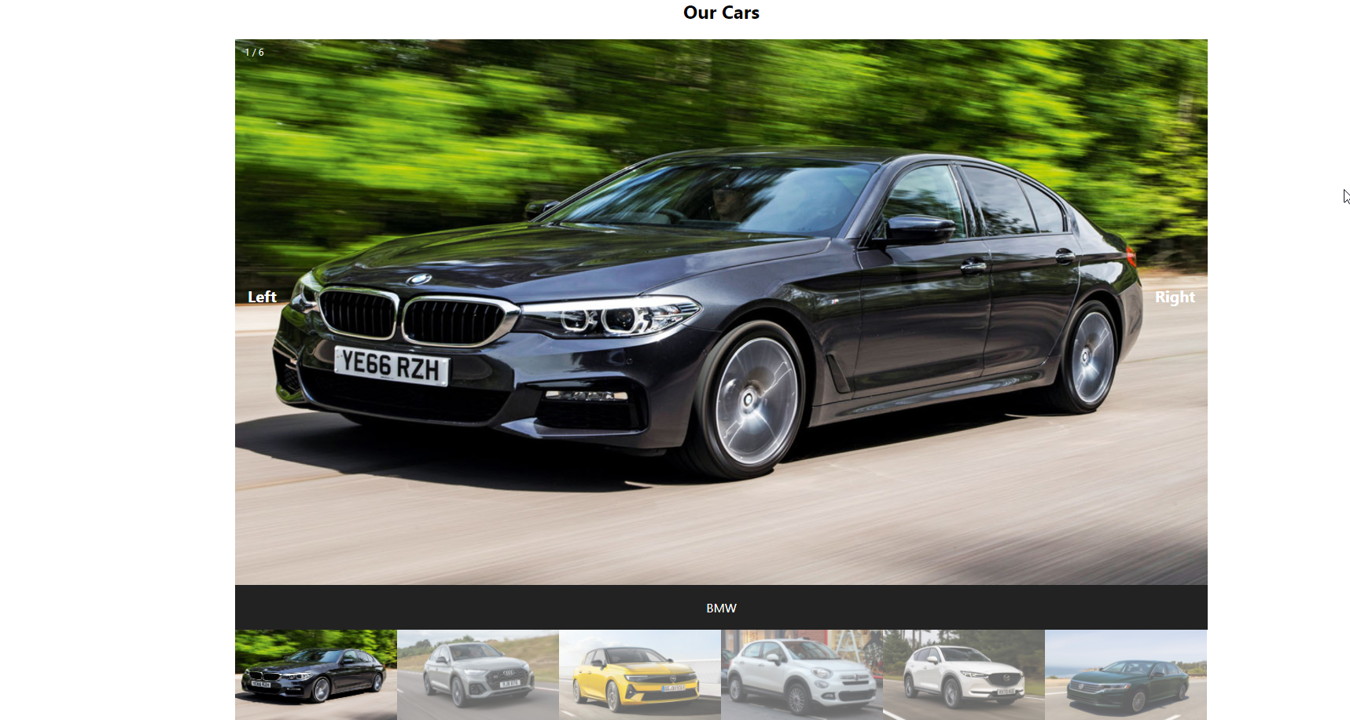

### Html

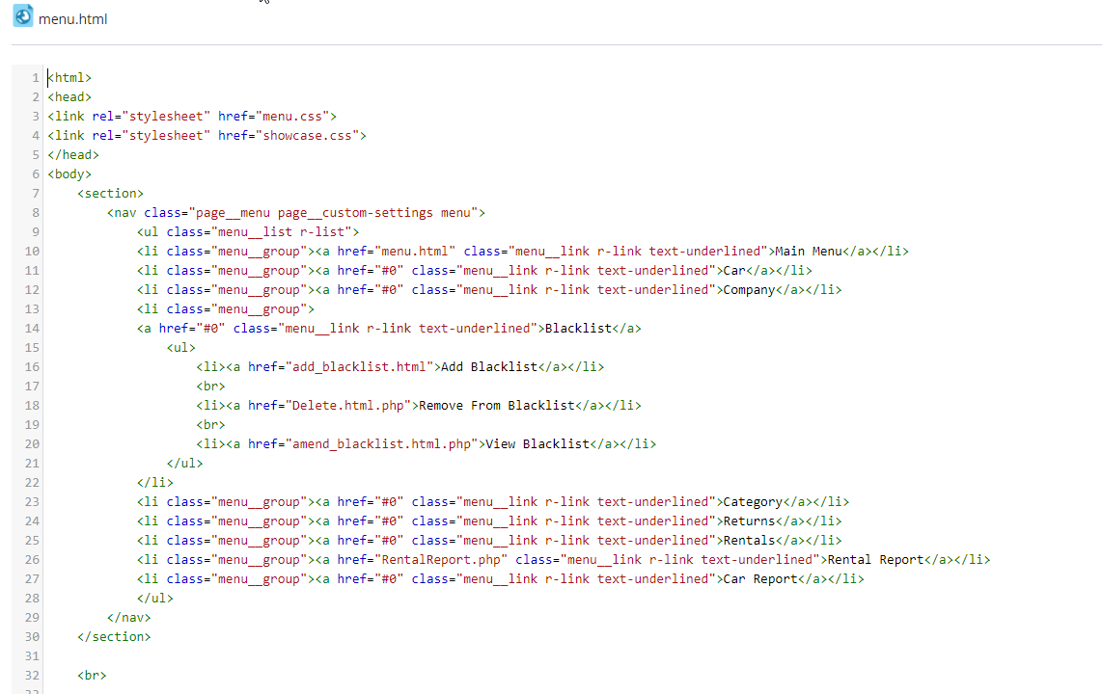

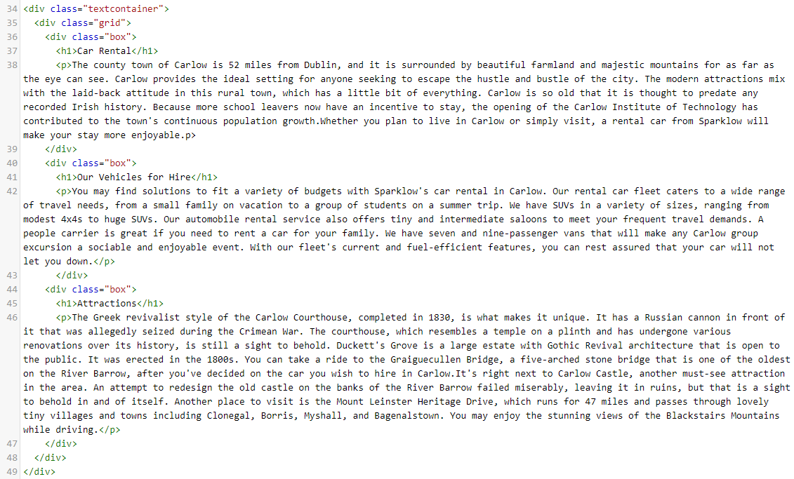

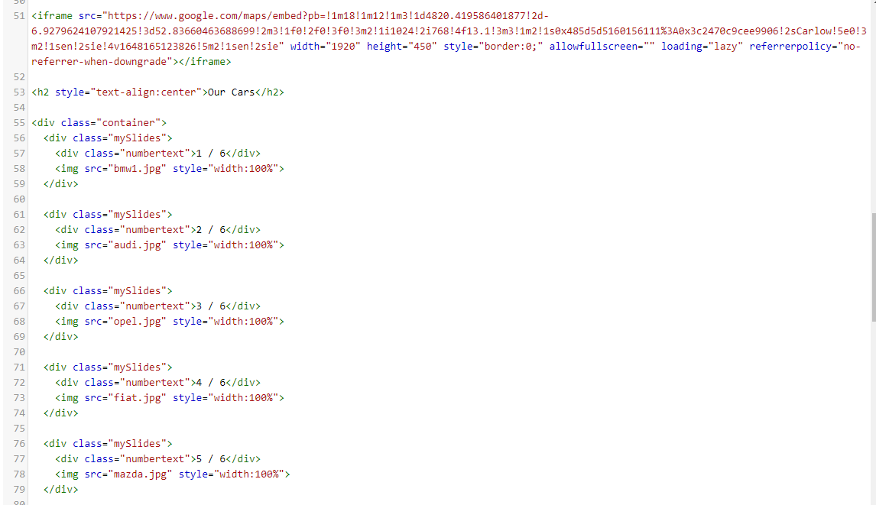

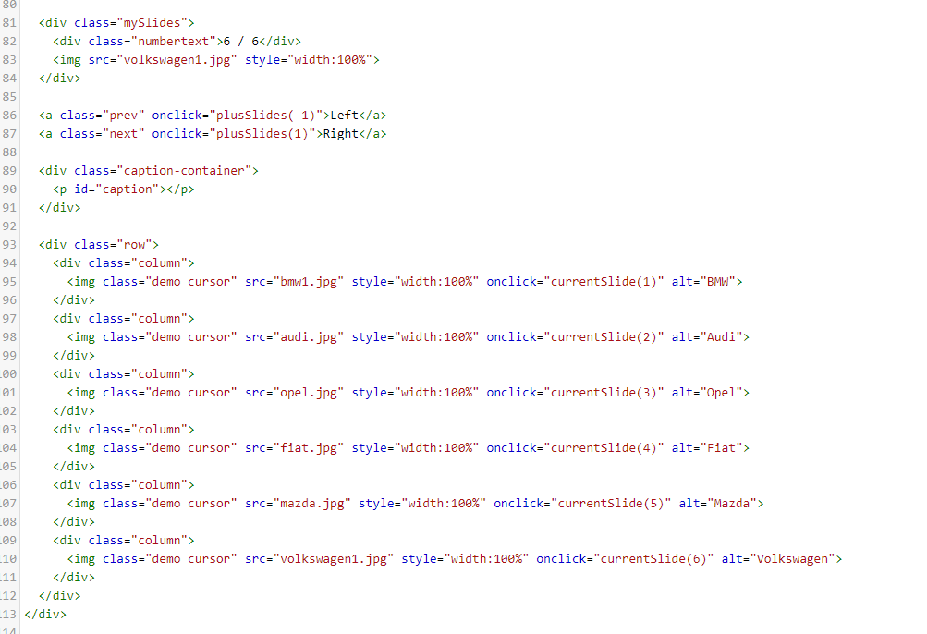

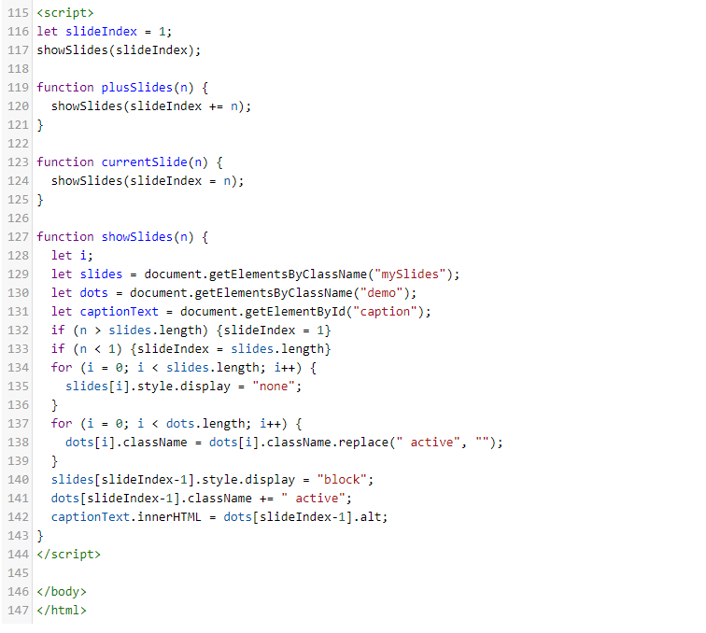

### CSS Code

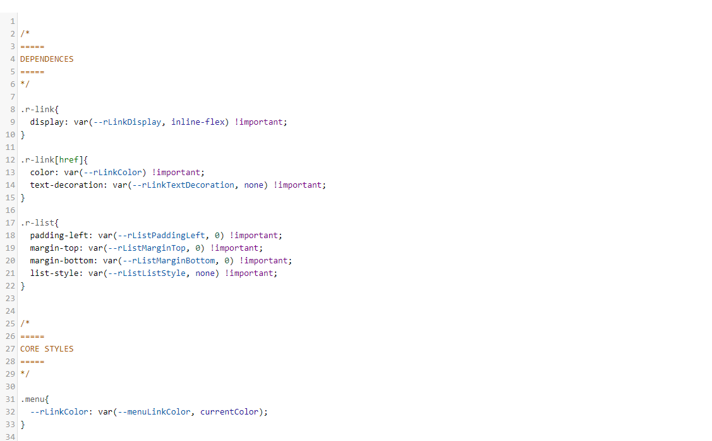

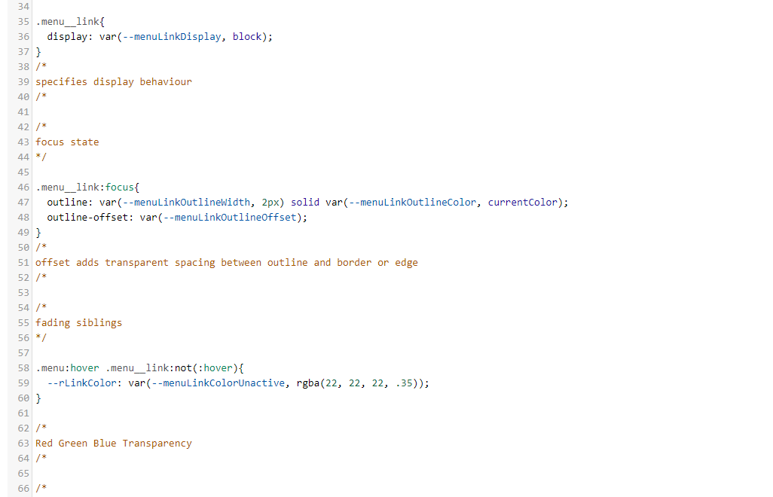

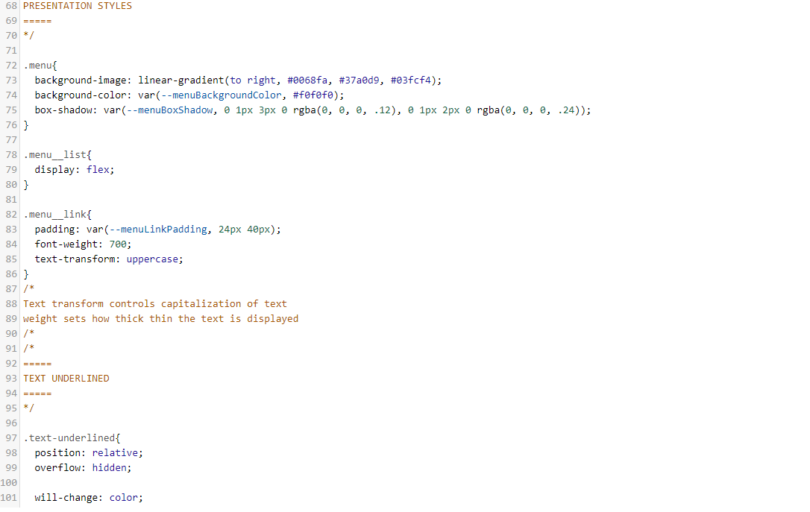

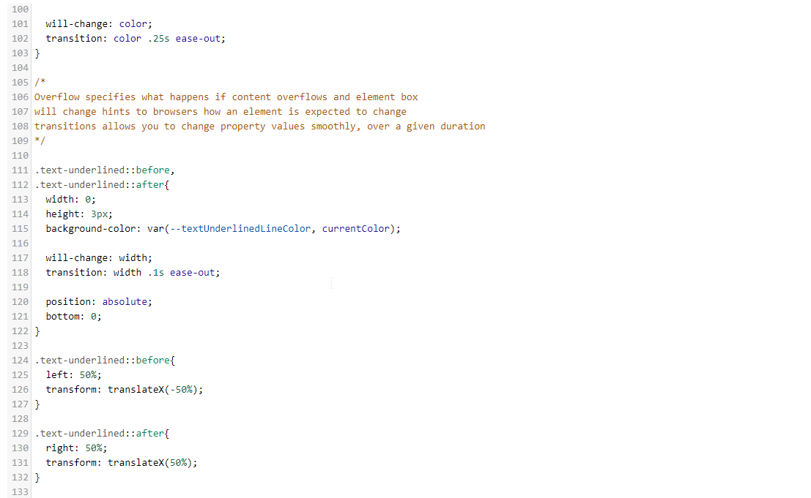

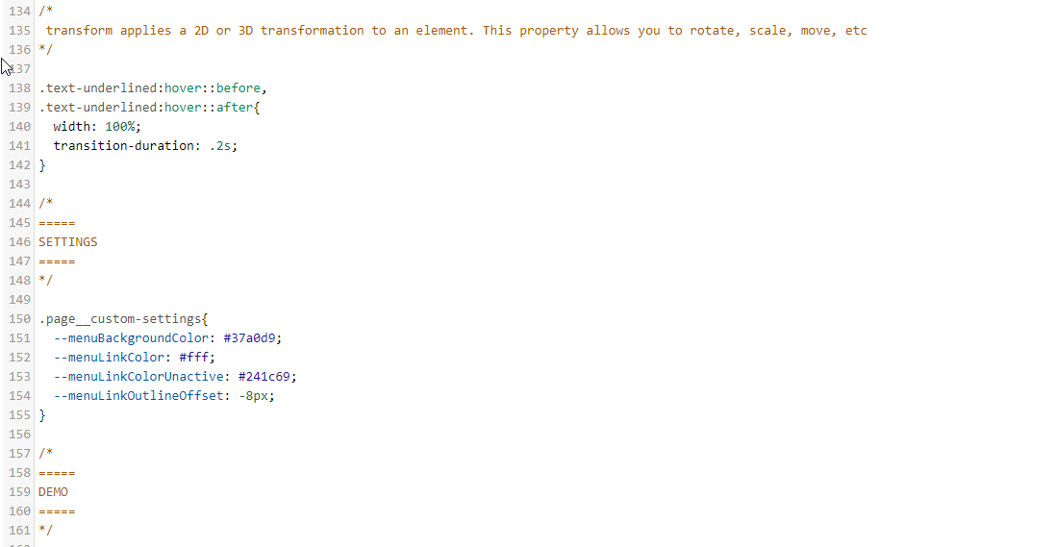

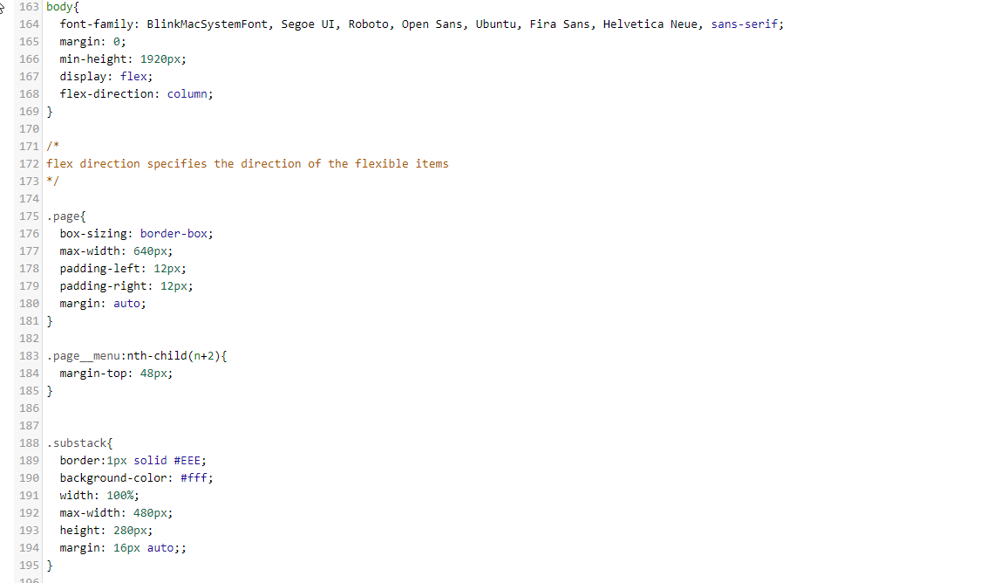

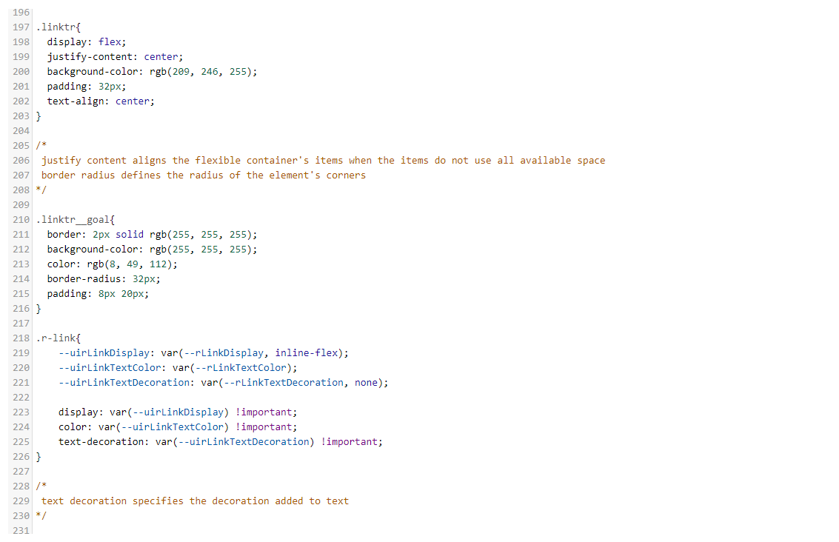

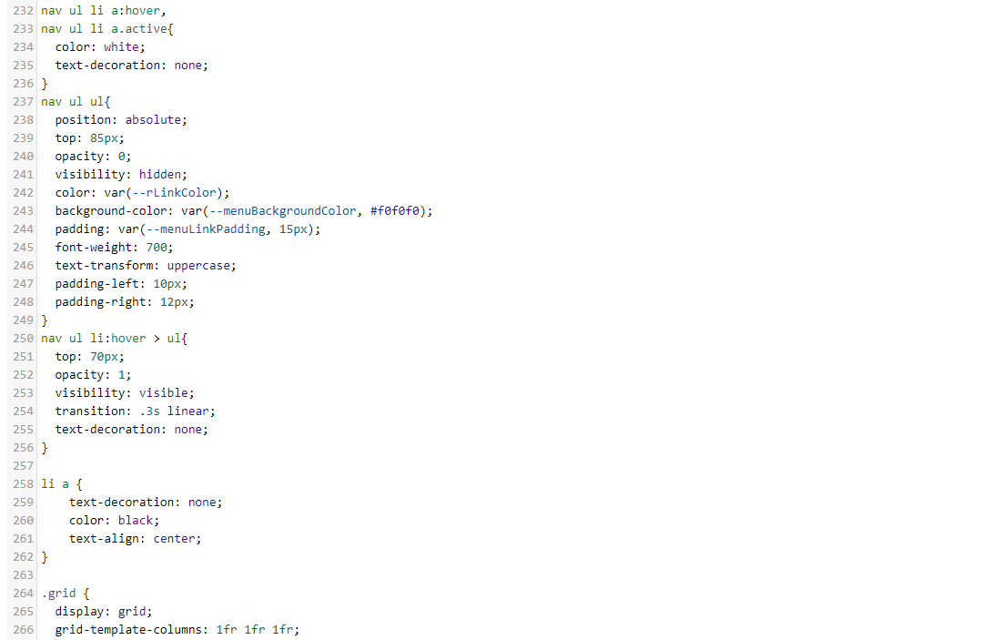

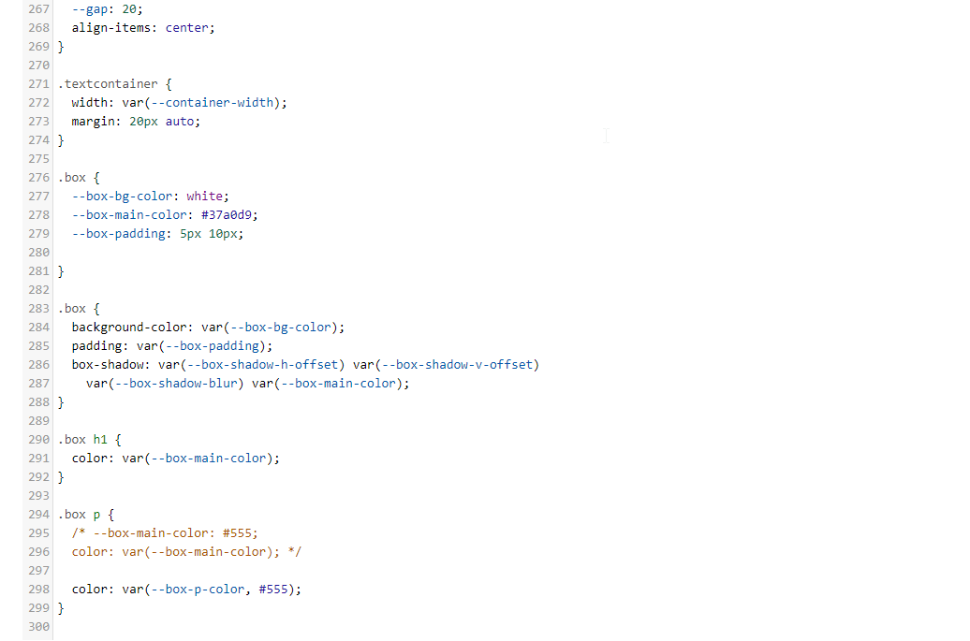

### CSS Code 2

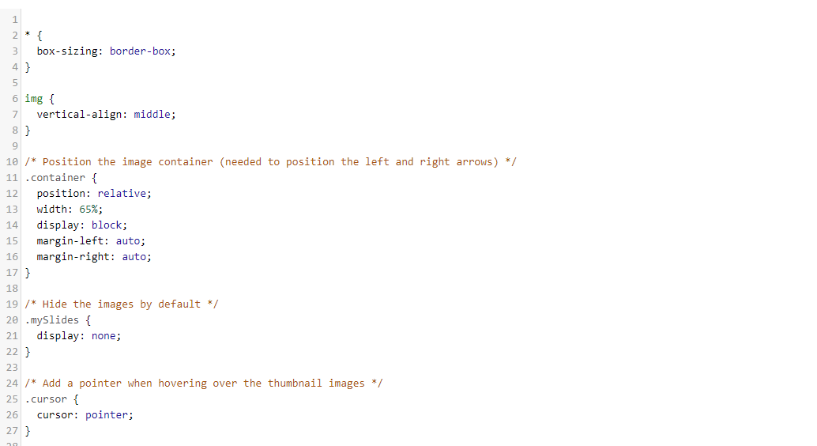

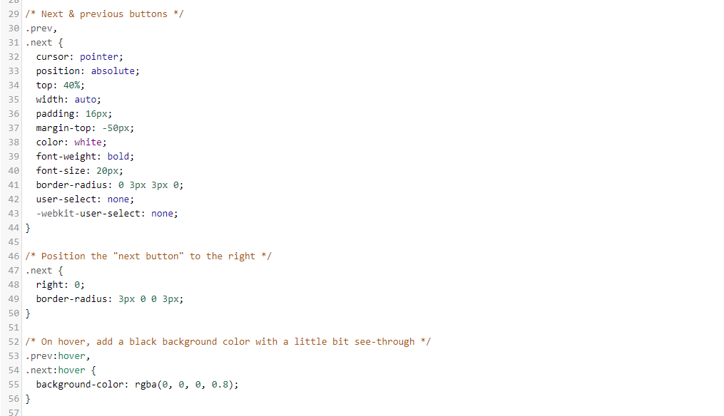

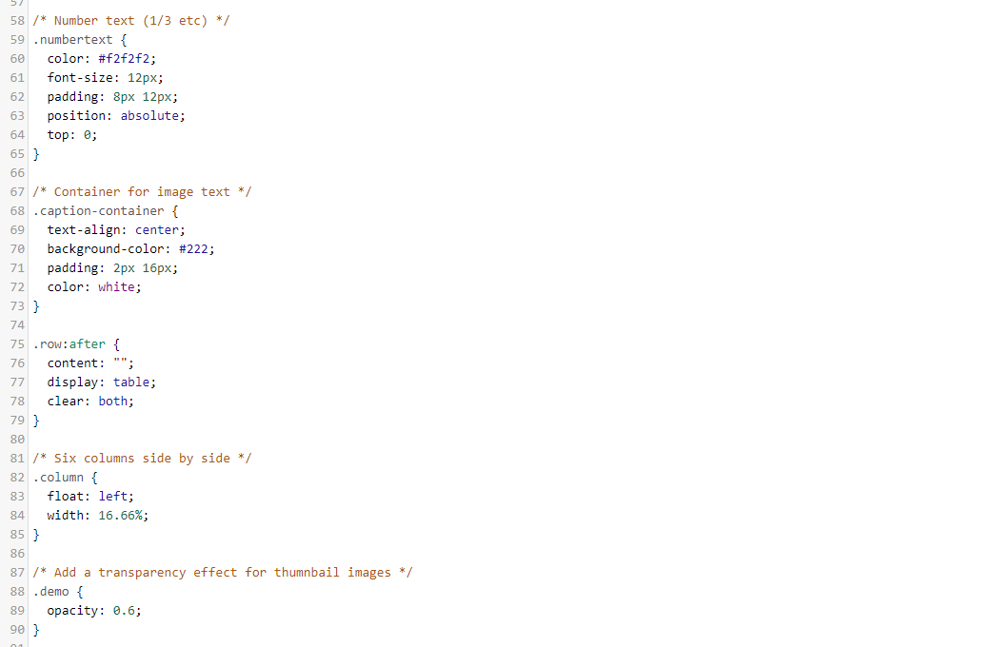

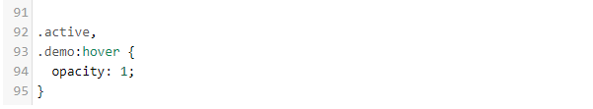

### Login Screen

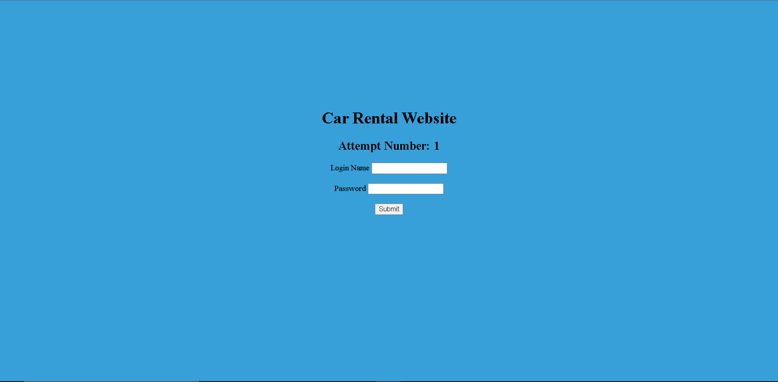

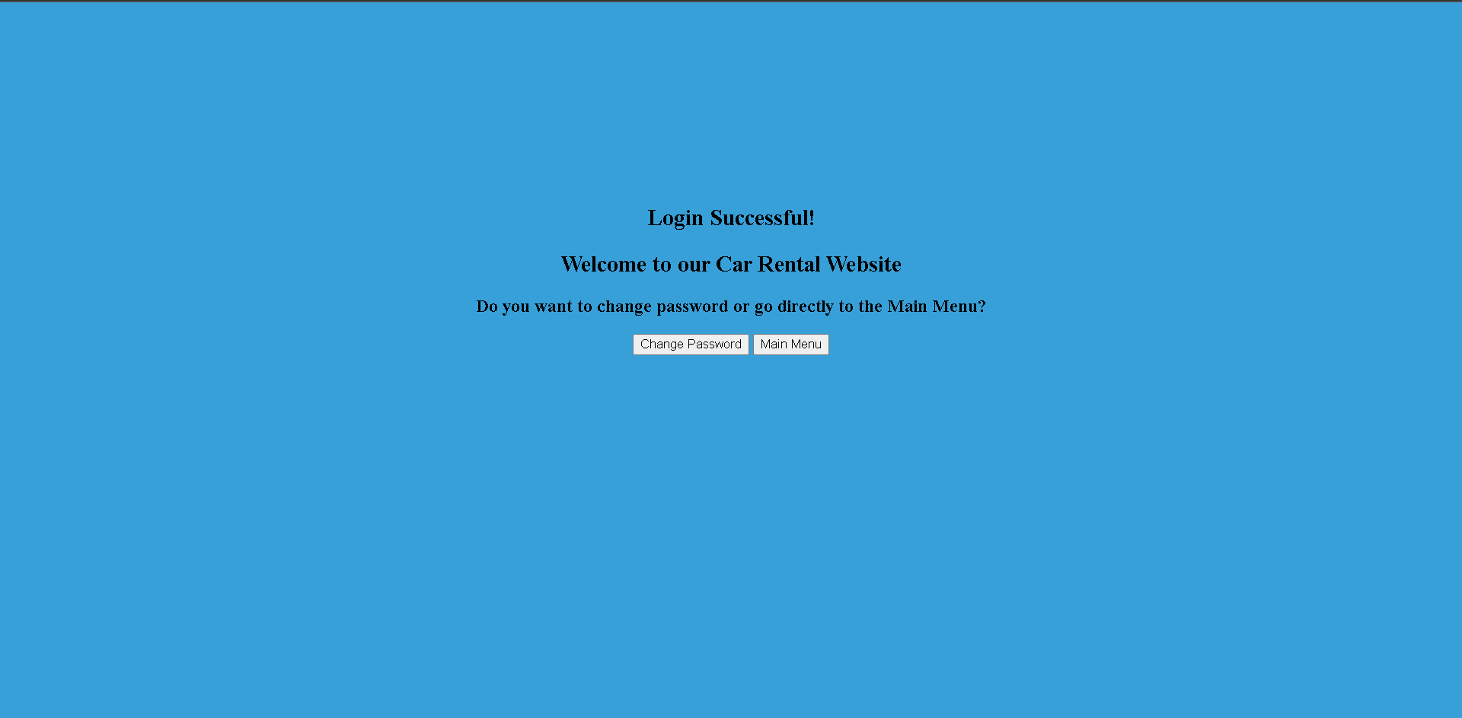

### Php / Html

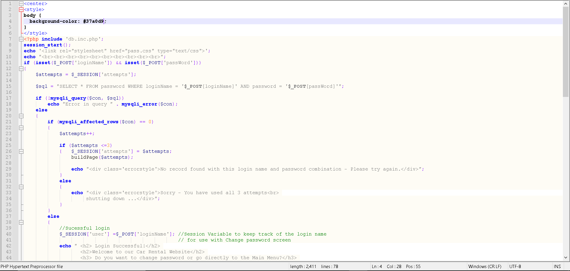

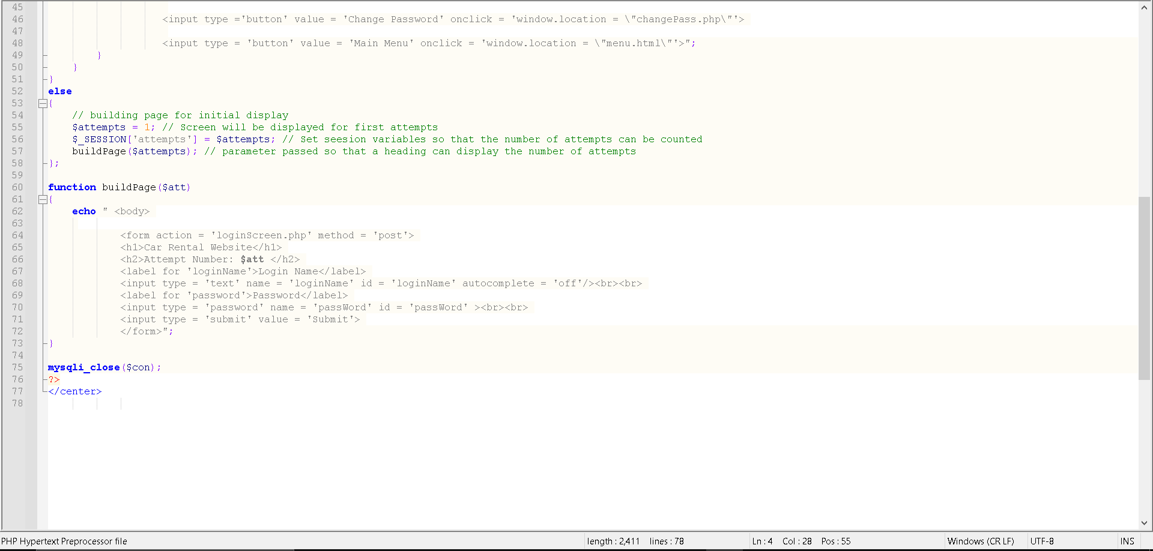

### Forgot Password

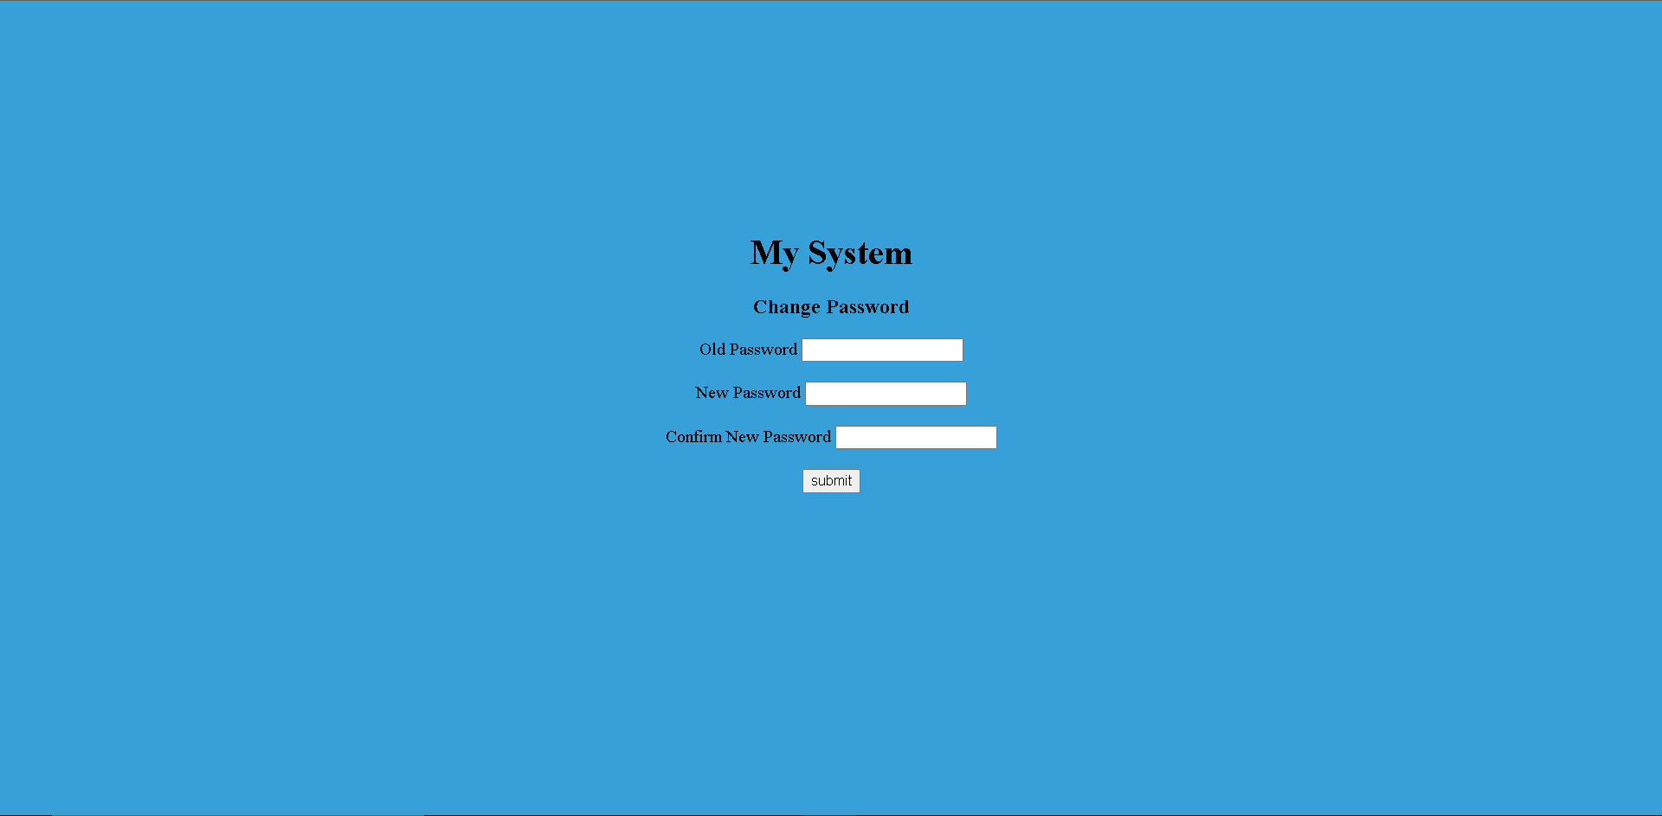

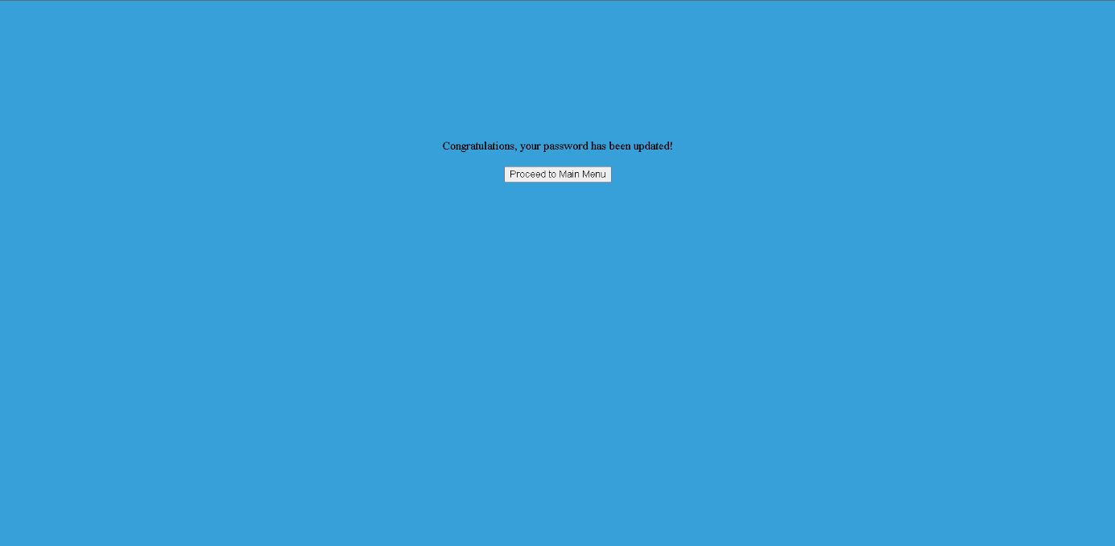

### Php / Html

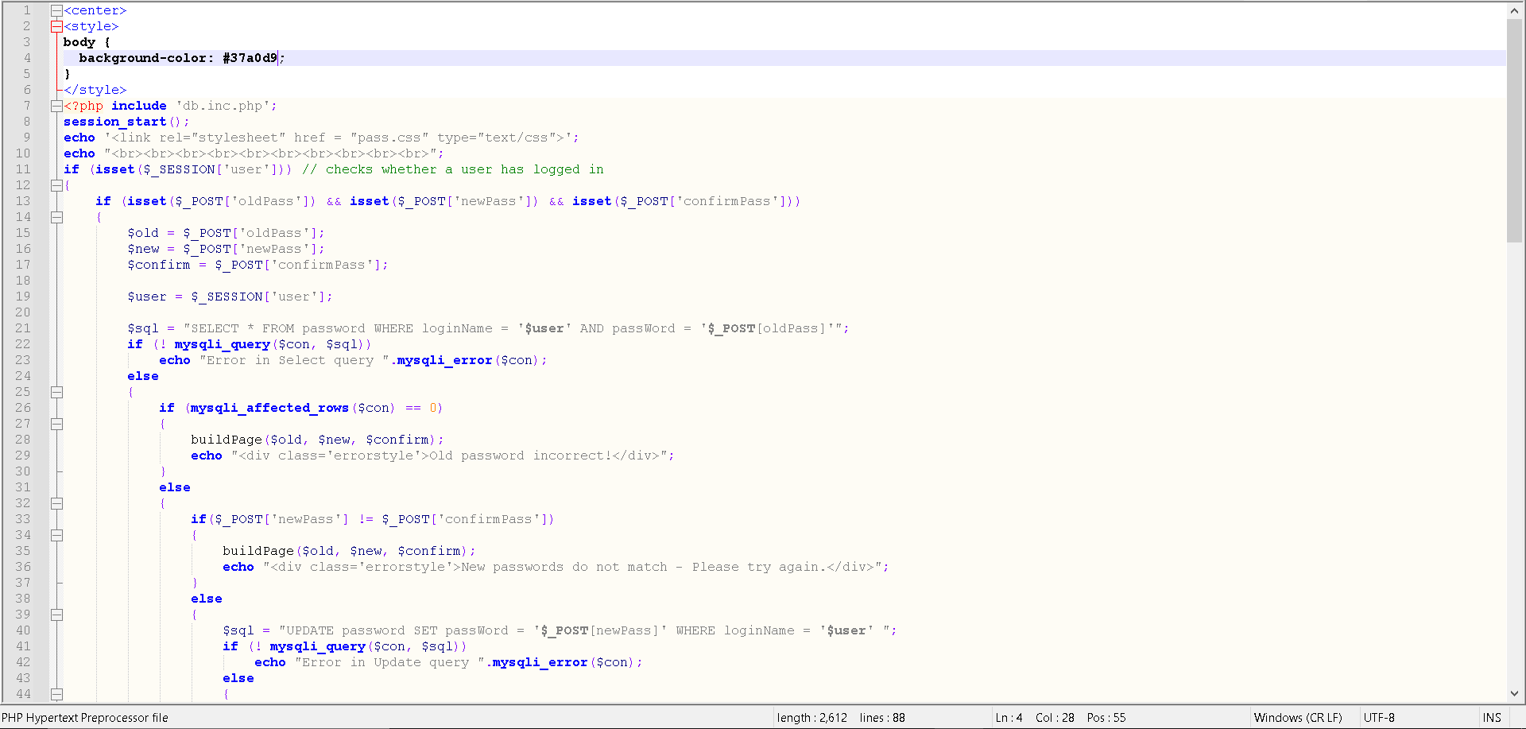

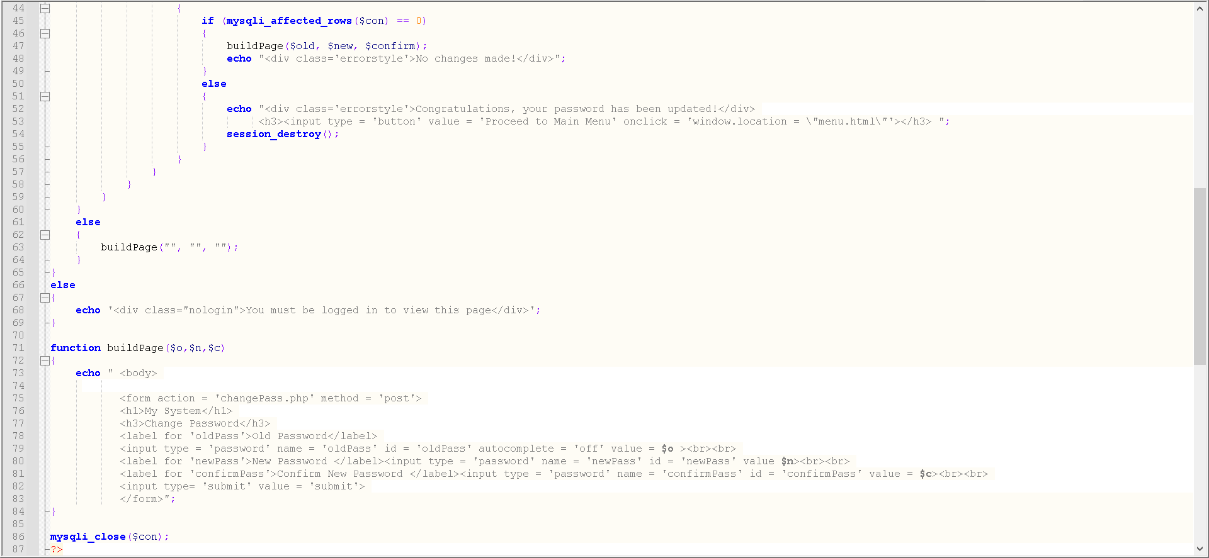



# Arnas

## Insert Screen

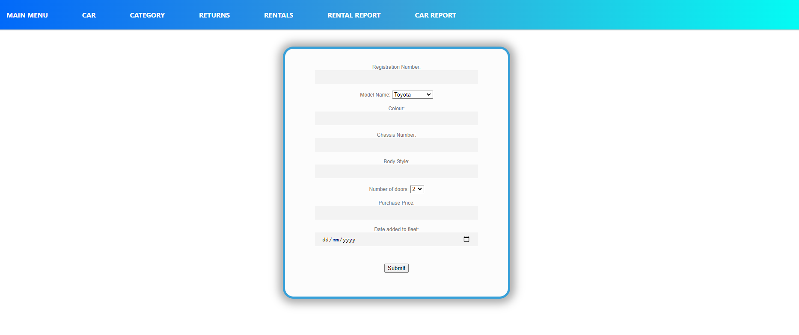

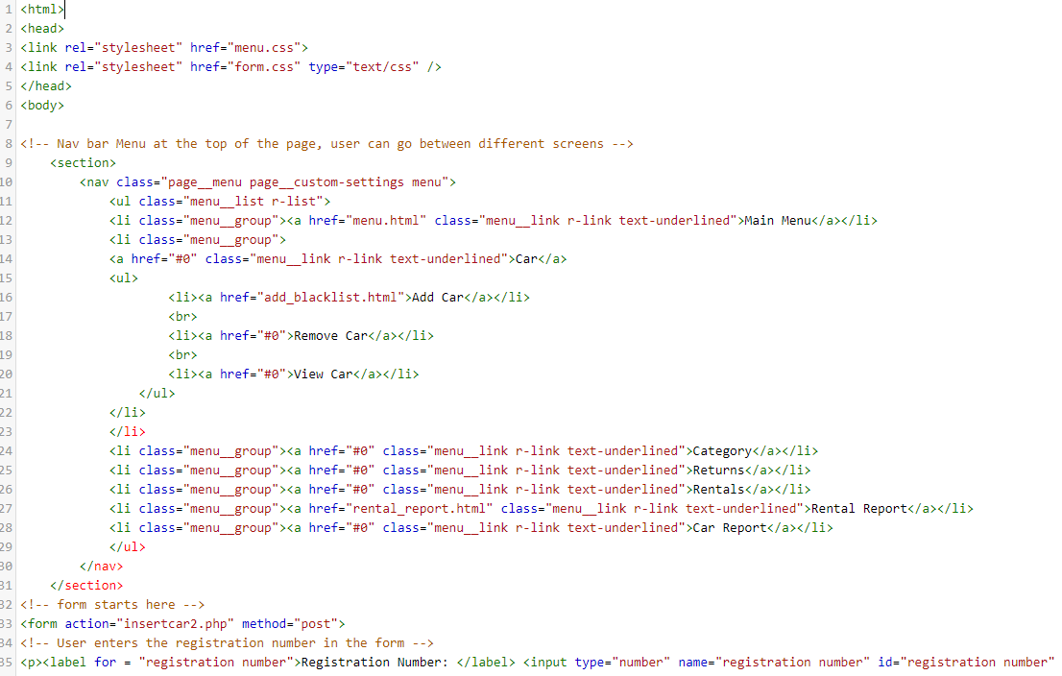

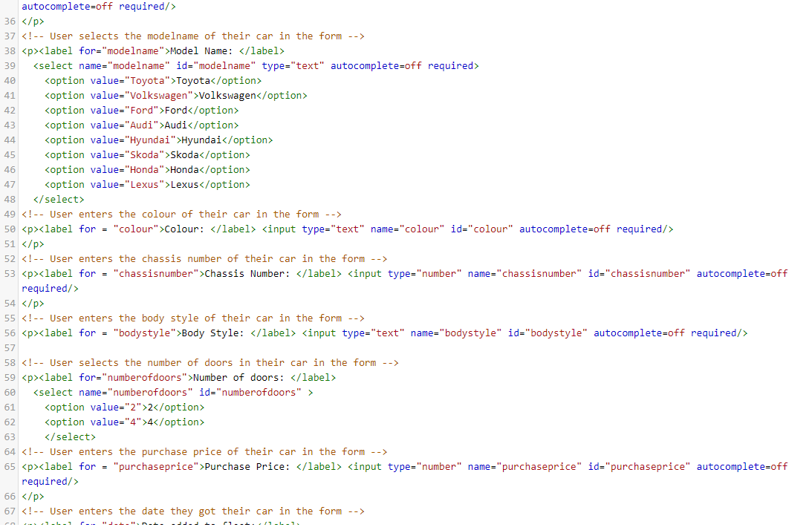

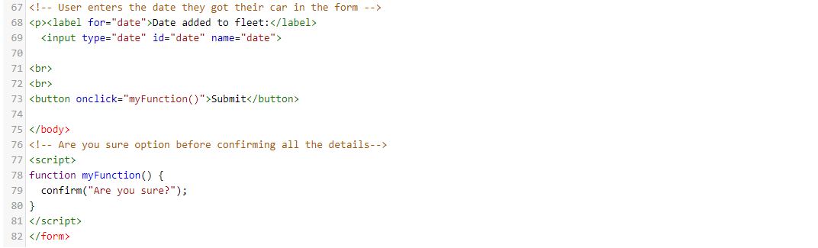

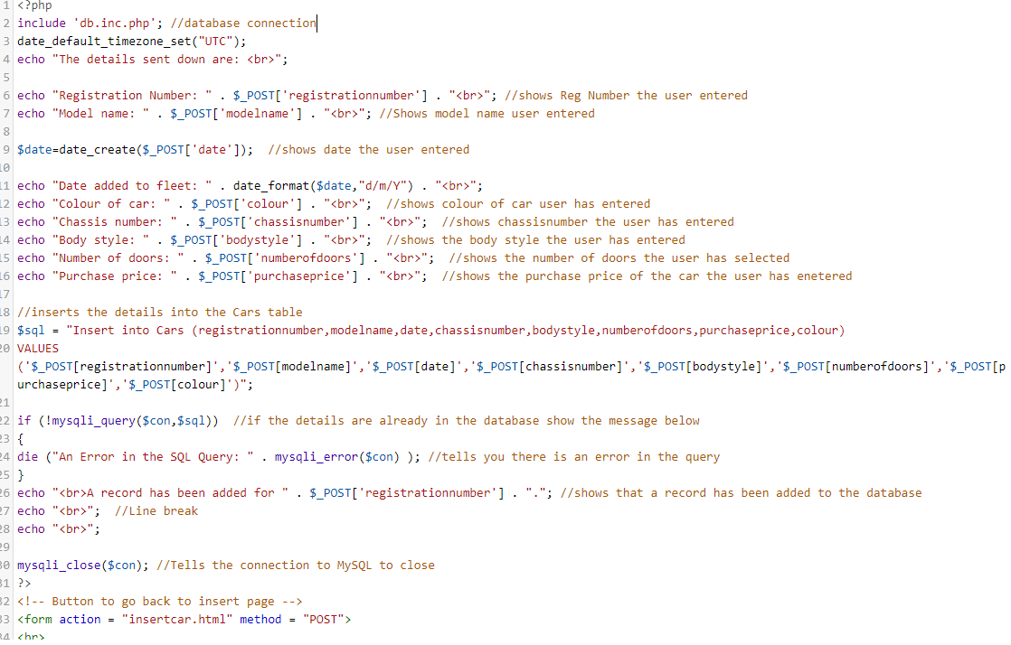



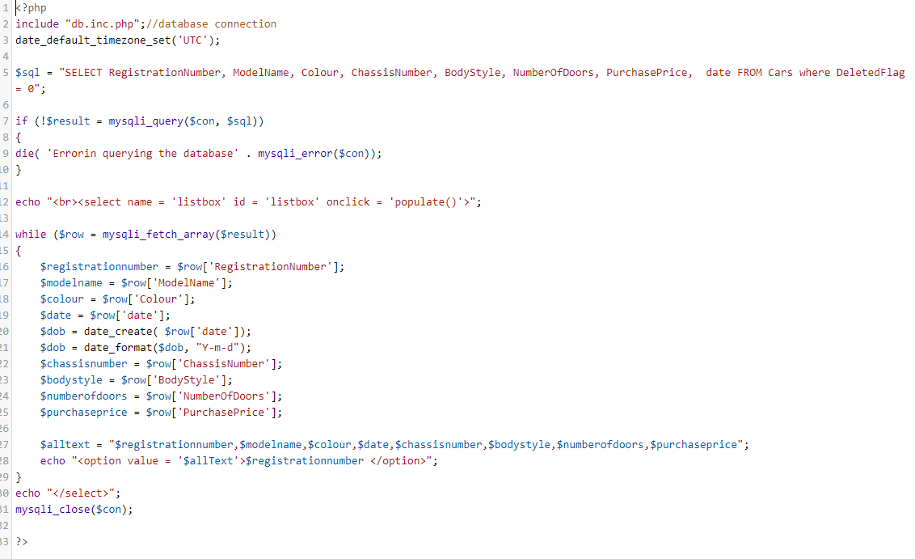

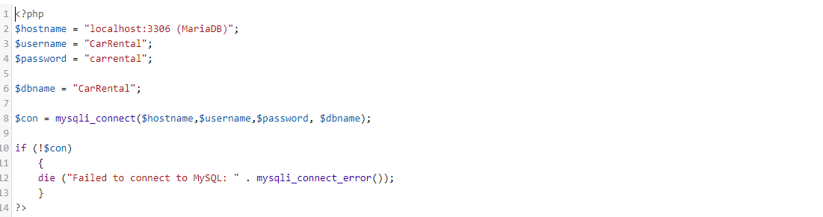

The database file above is included in all four screens.

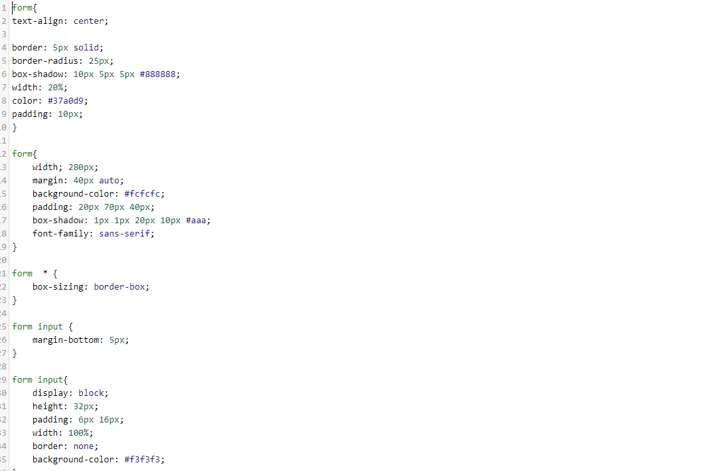

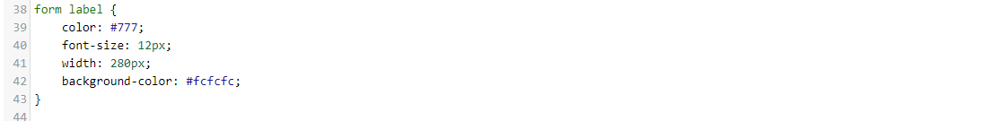

## Amend View

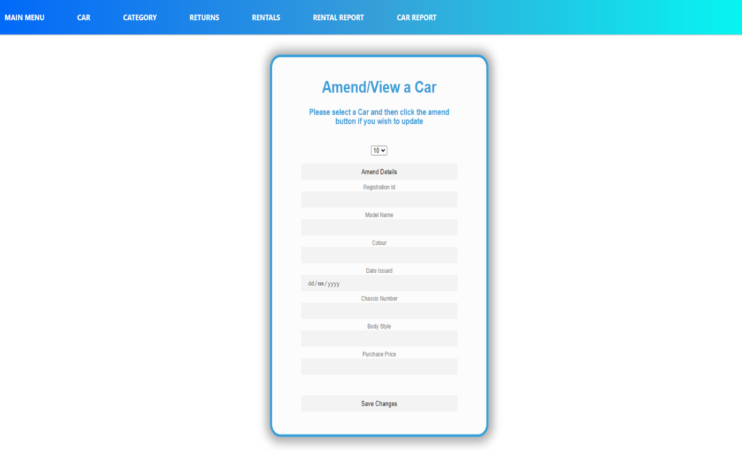

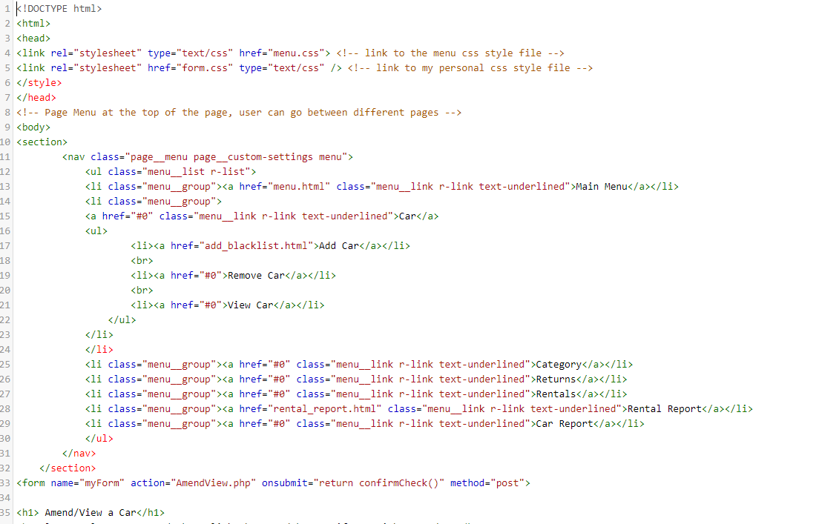

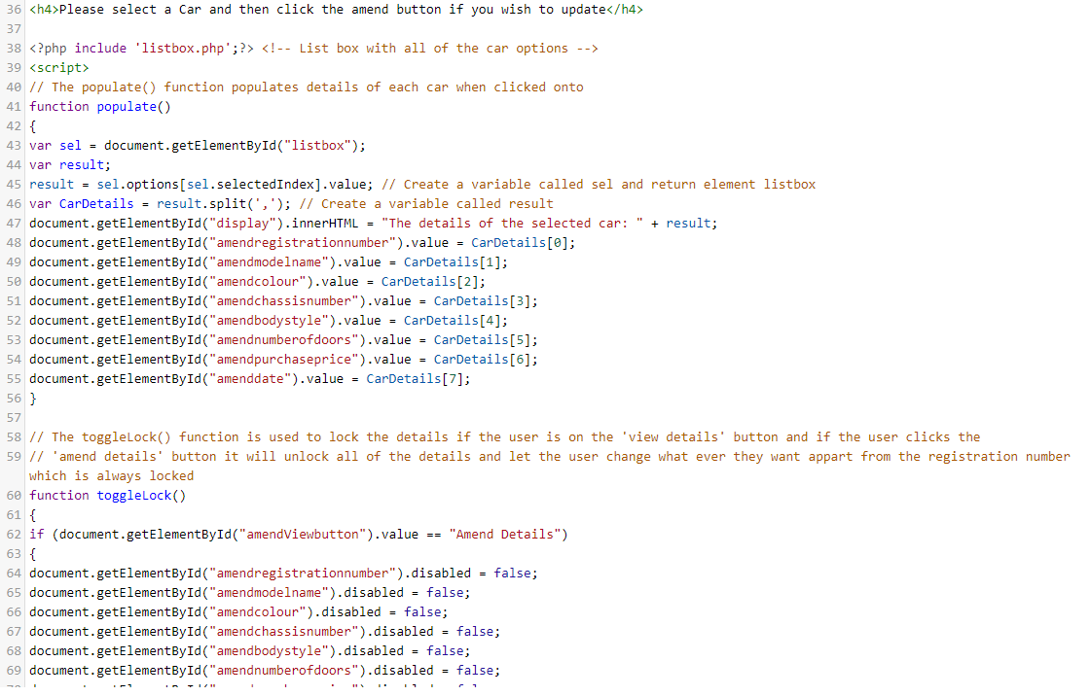

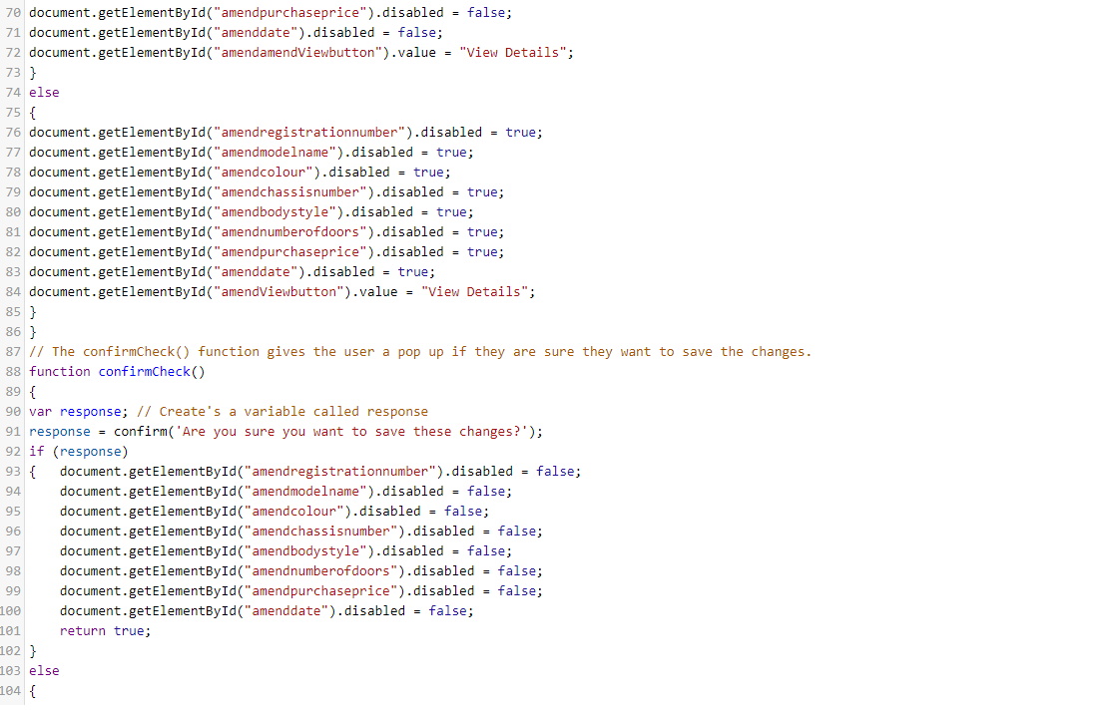

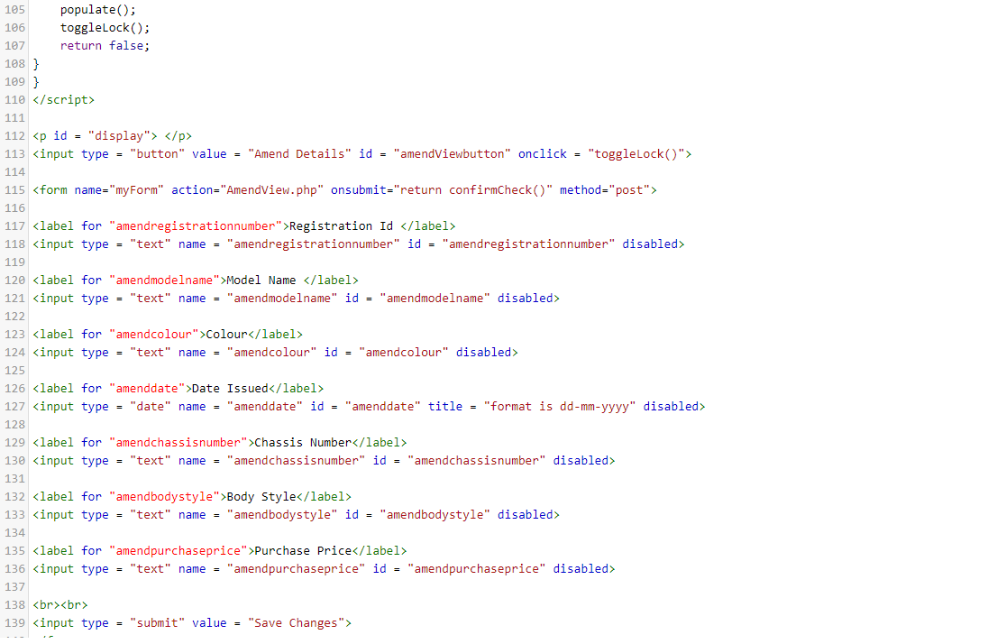



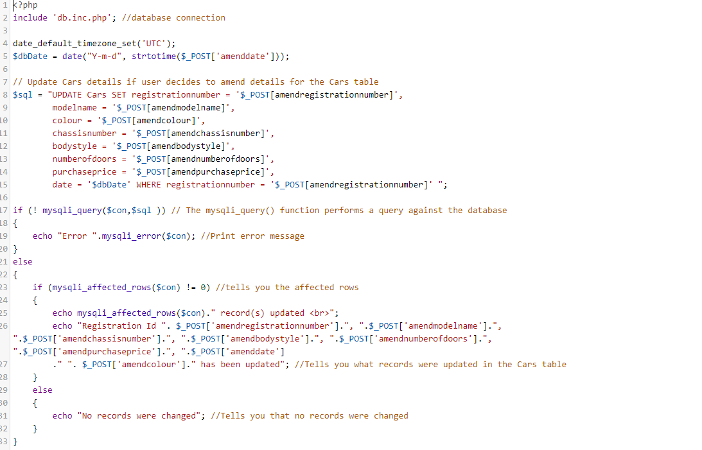

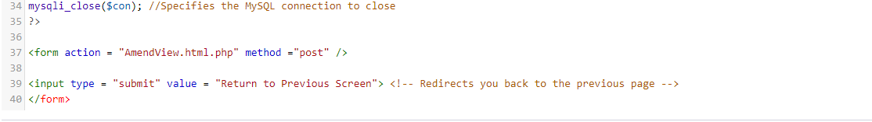

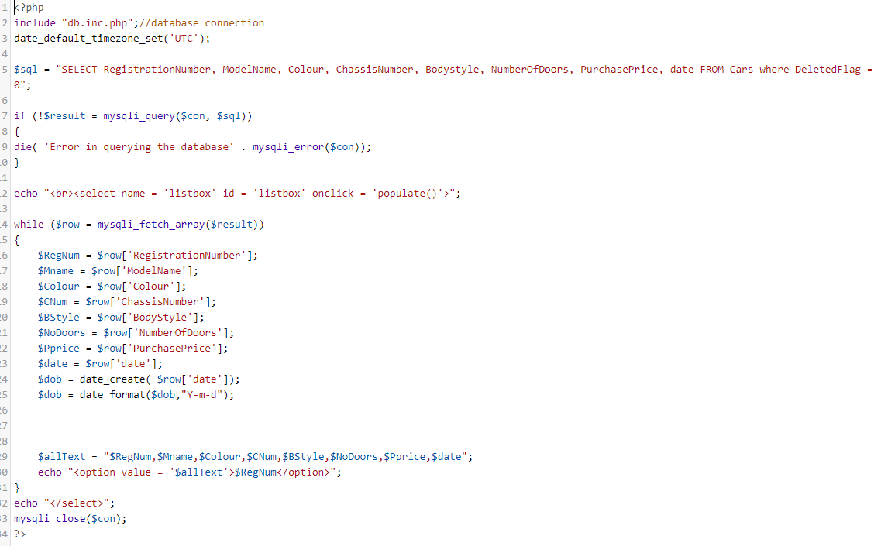

## Delete Screen

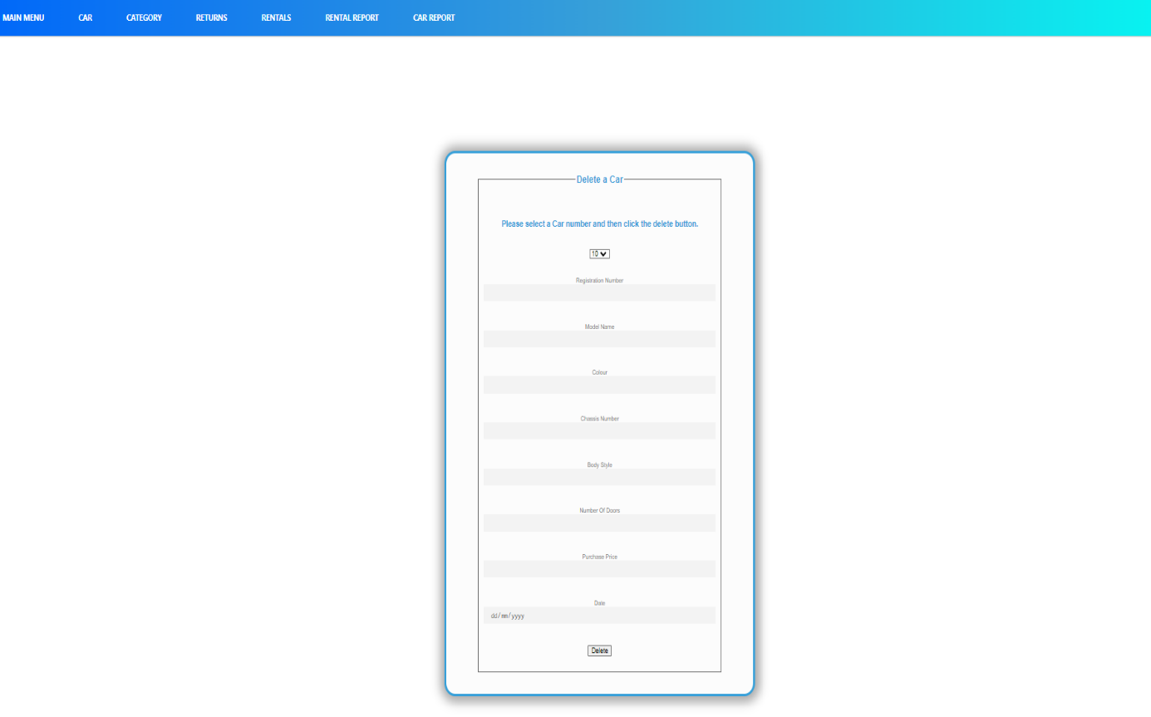

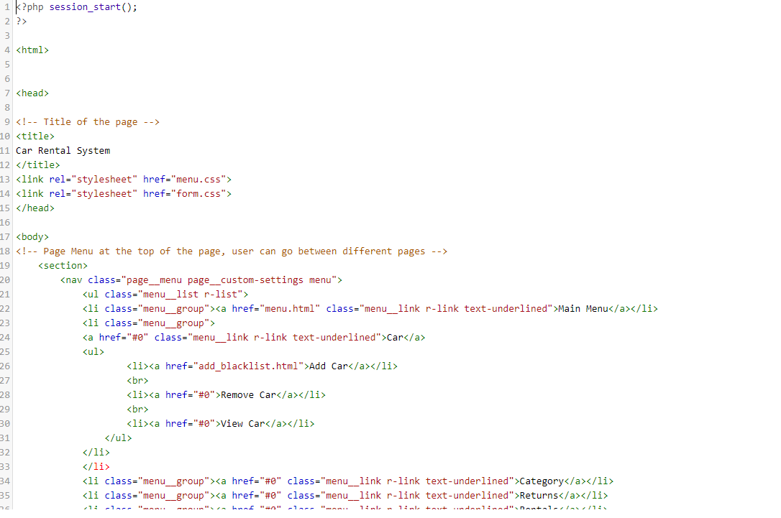

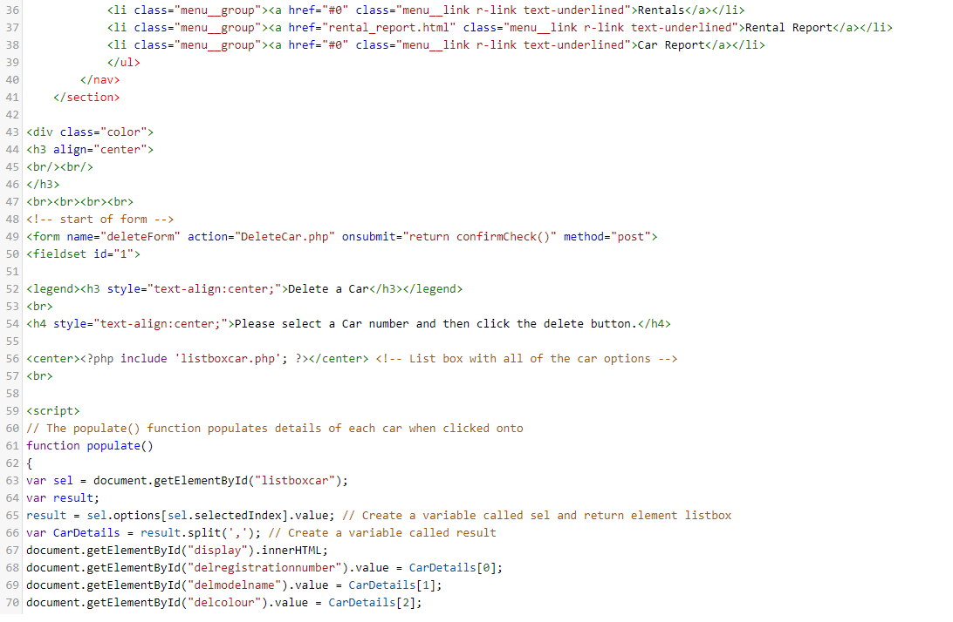

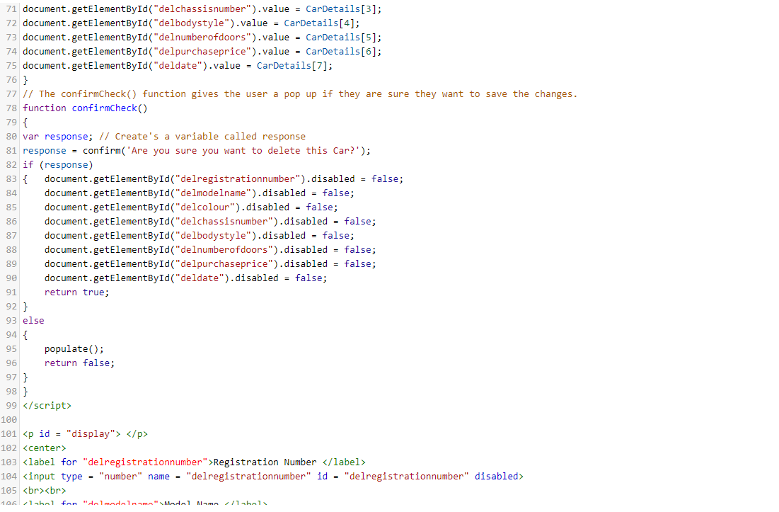

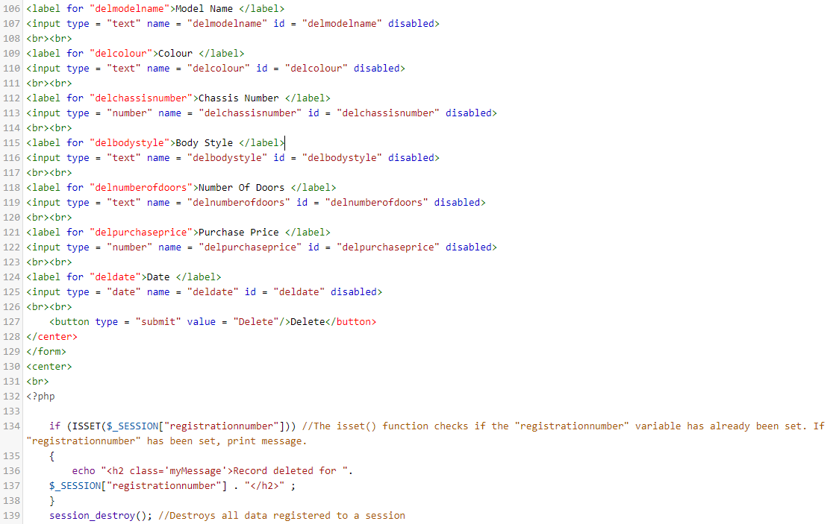



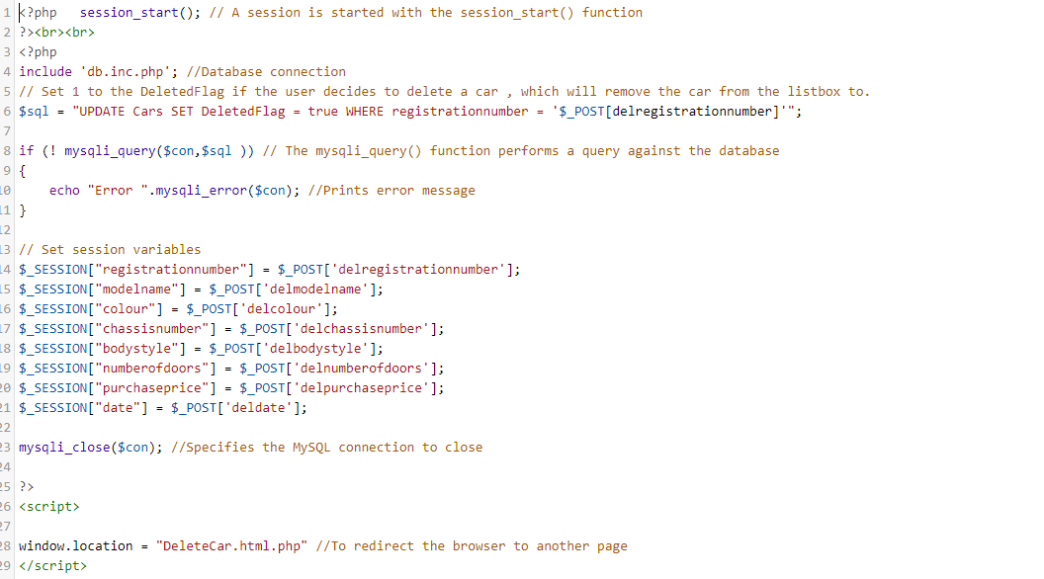

## Returns Screen

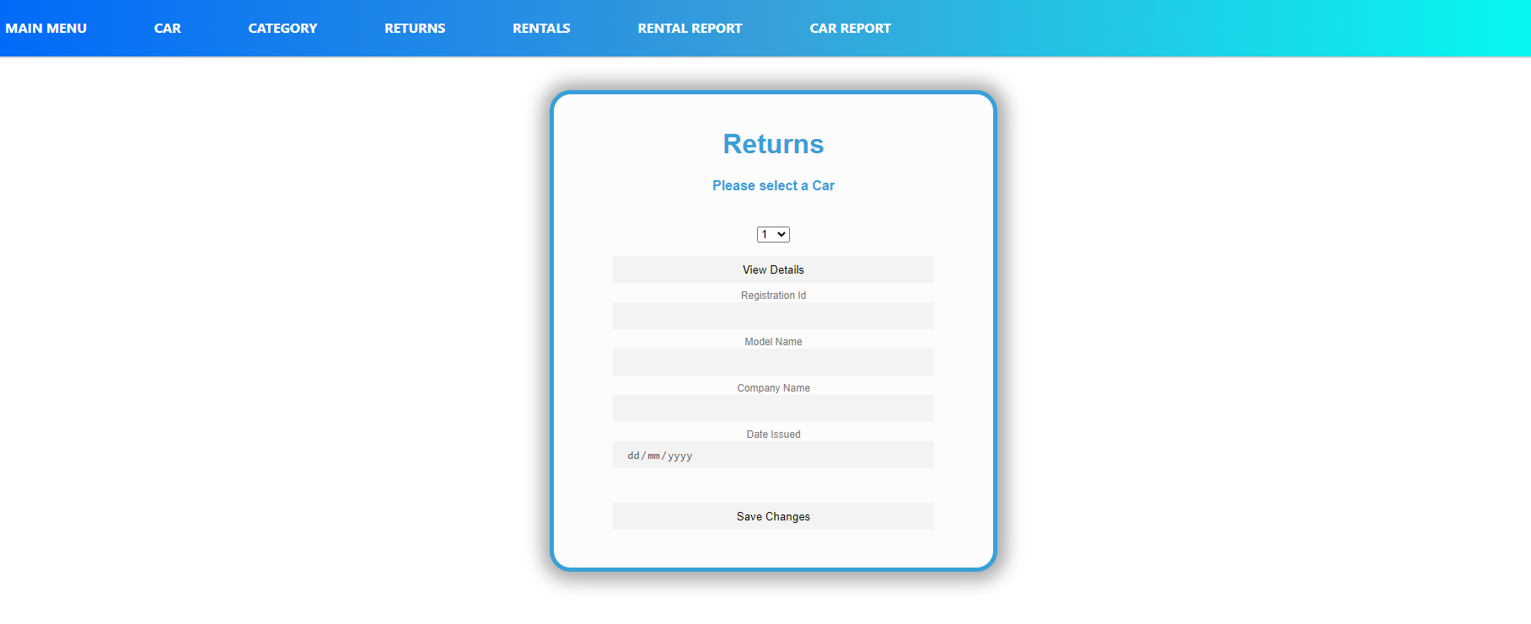

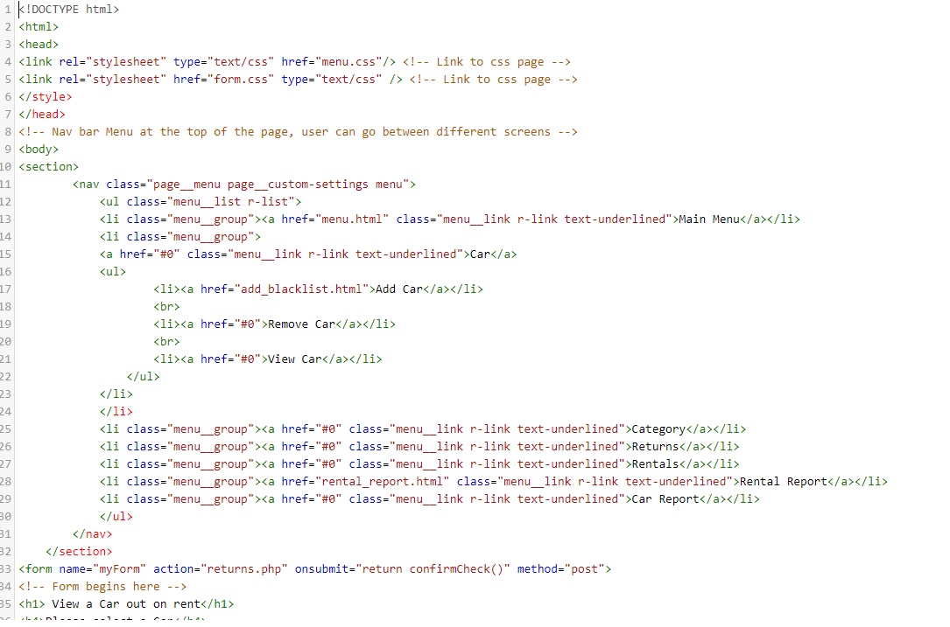

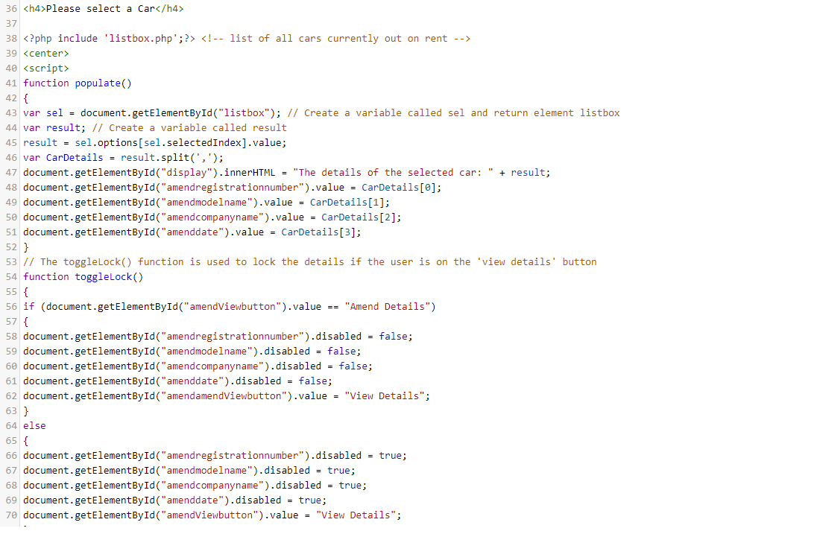

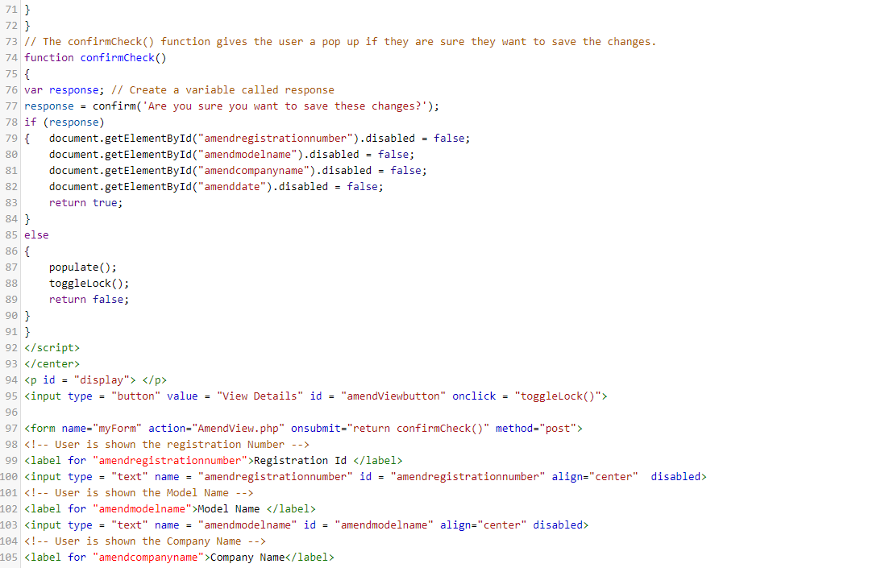

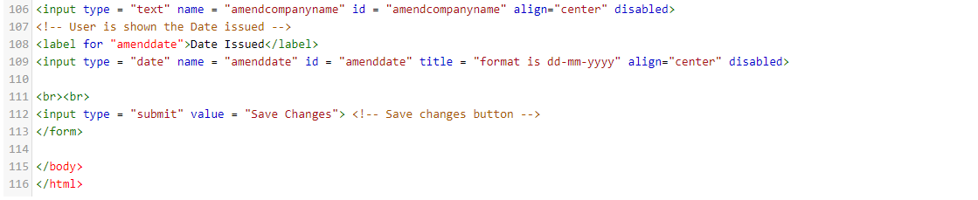

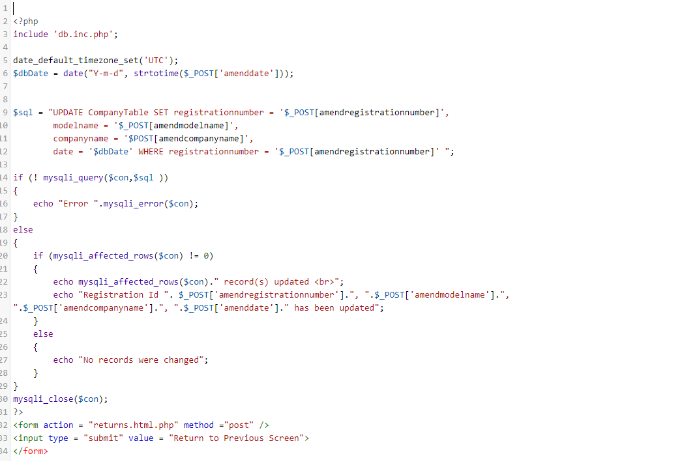

# Nojus

## Insert

### Screen

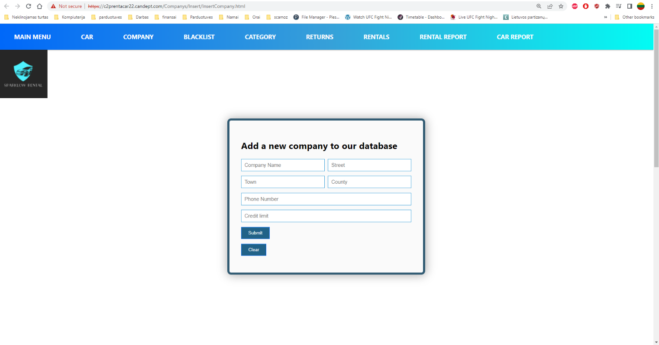

## Code

html

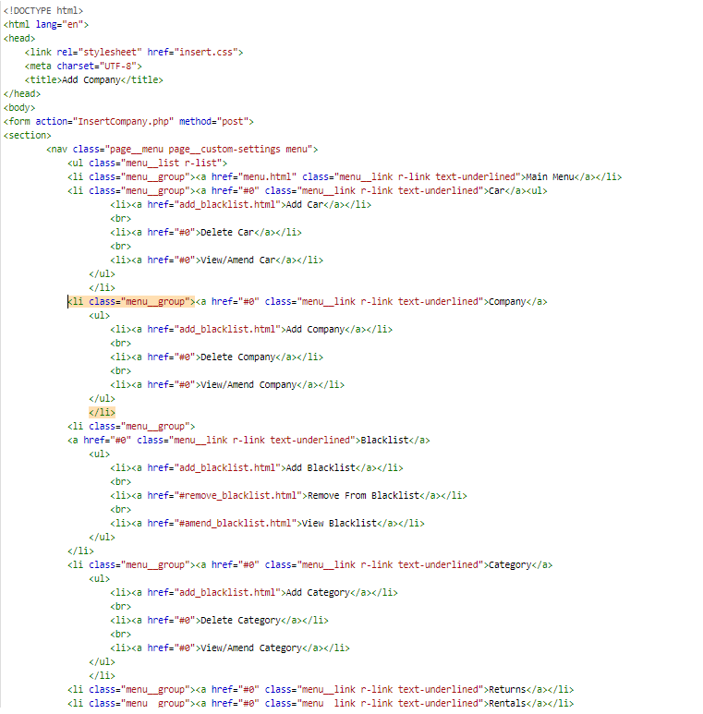

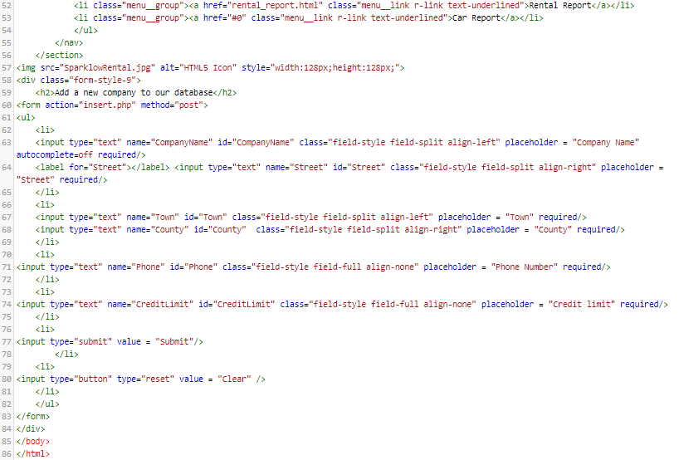

php

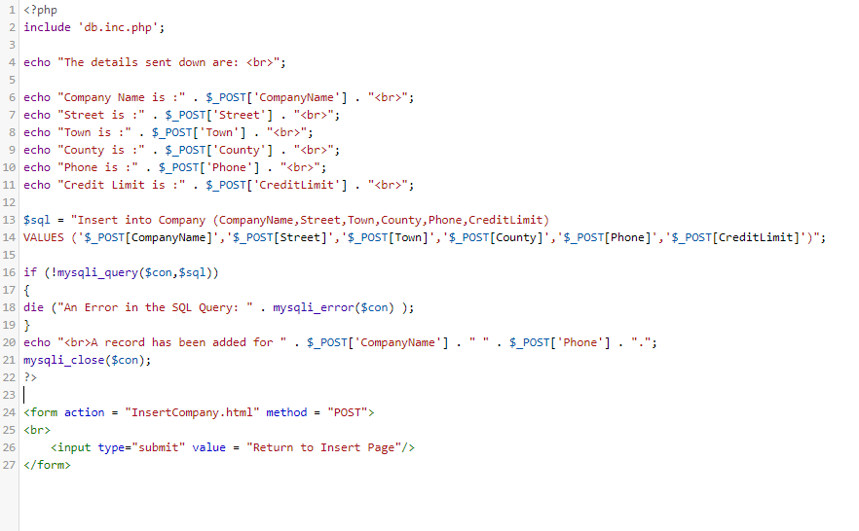

Form Css (Used in all html)

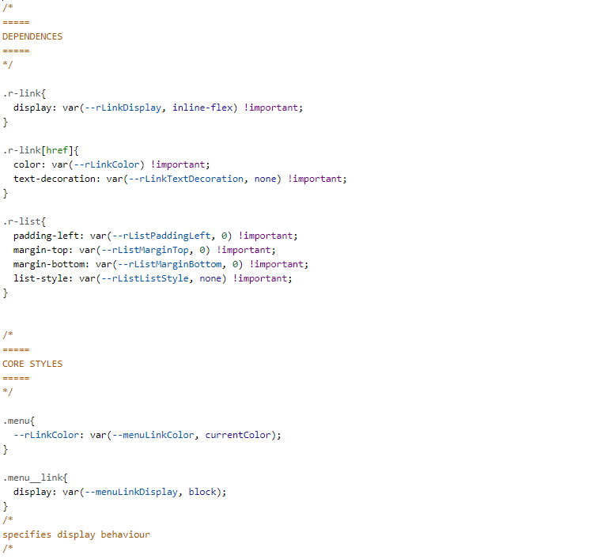

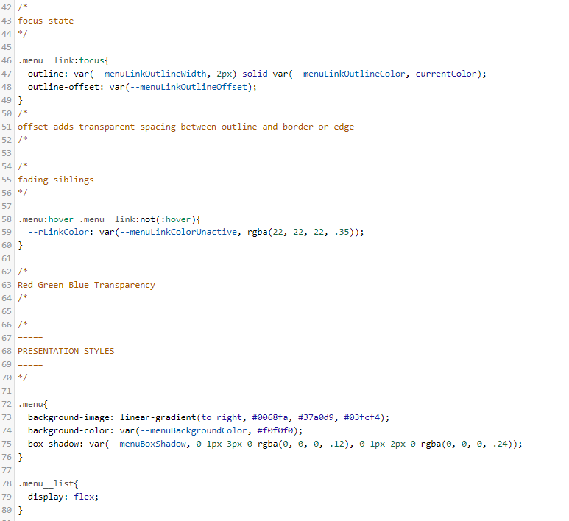

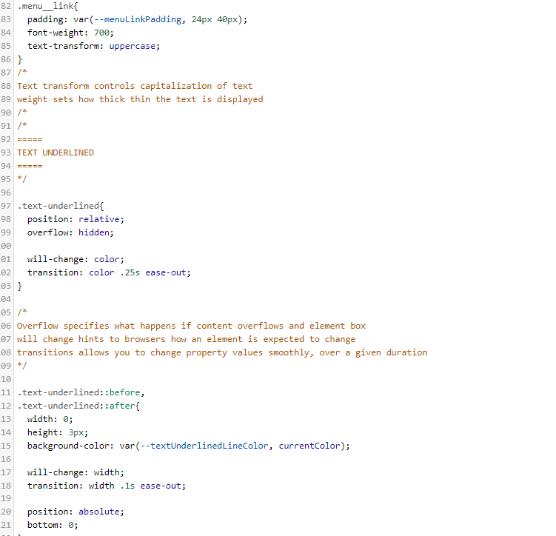

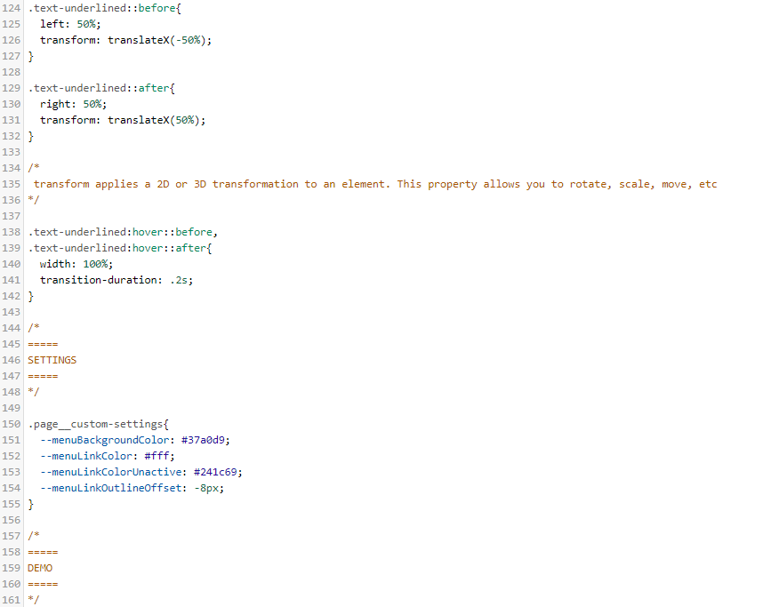

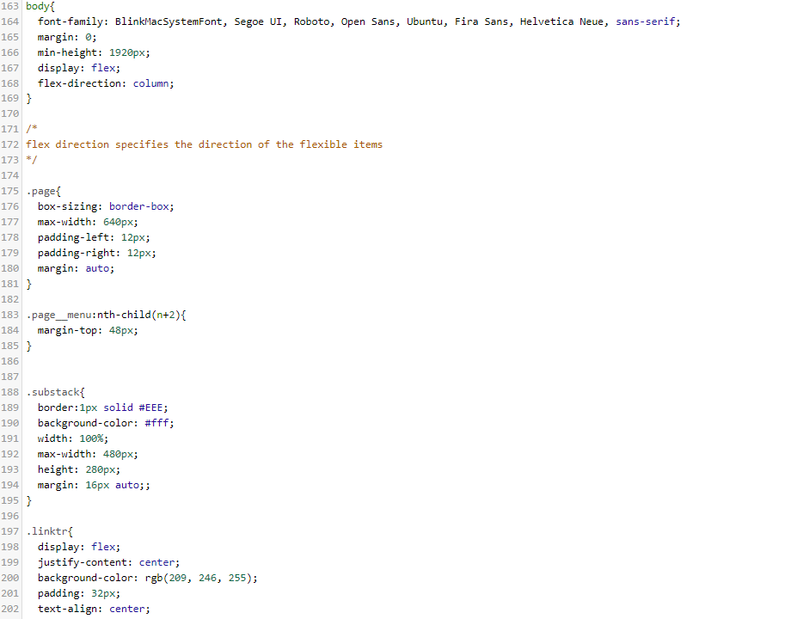

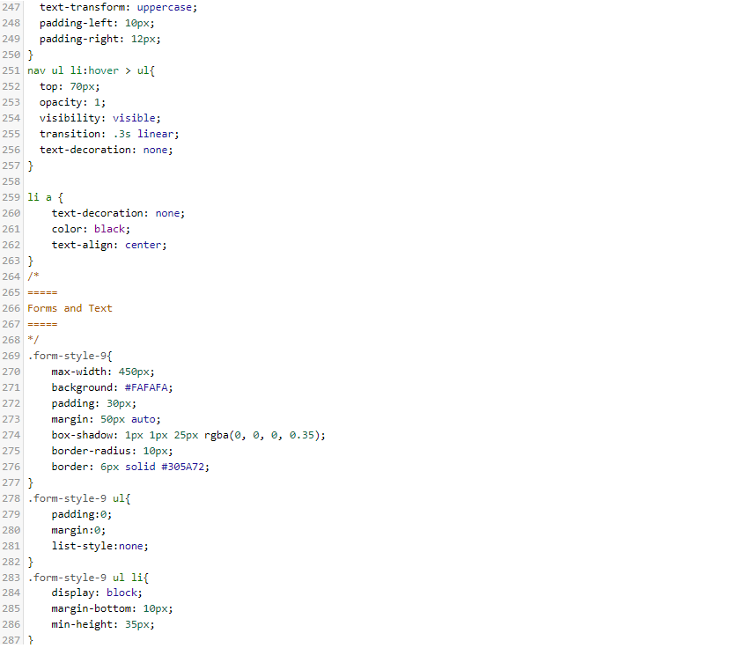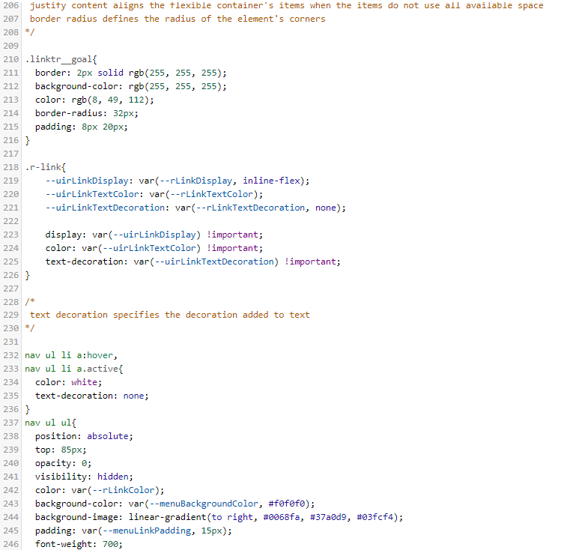

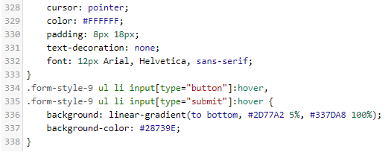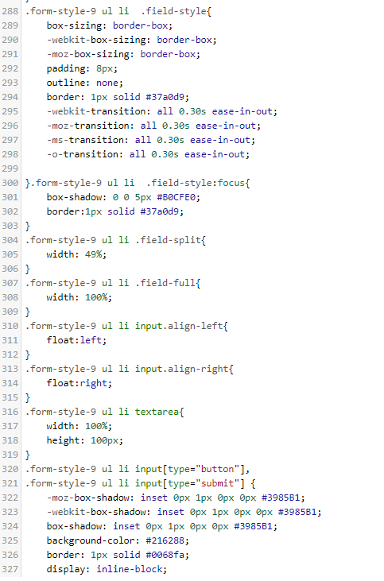

## Amend

### Screen

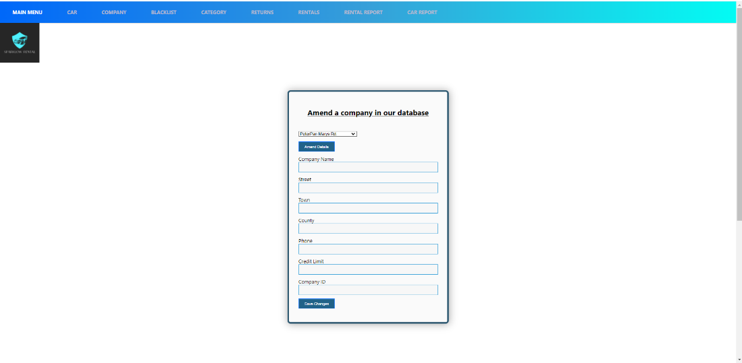

## Code

html

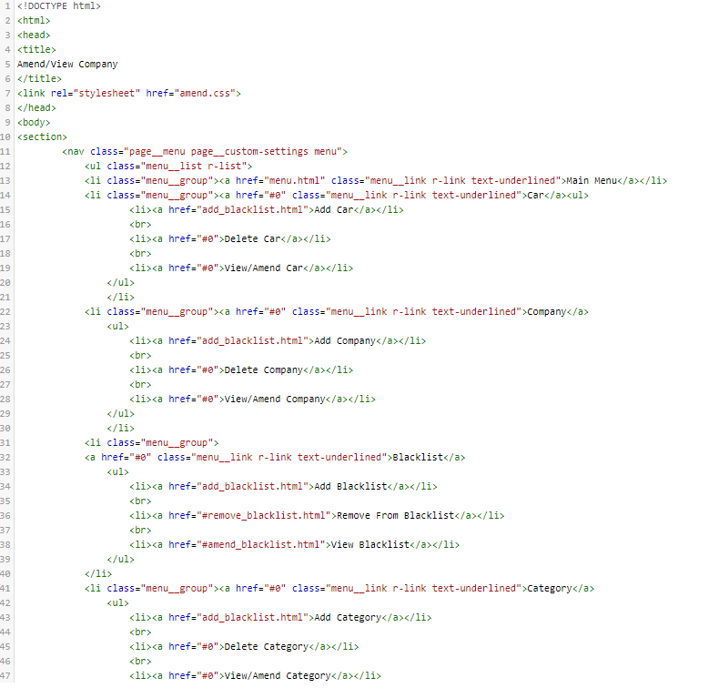

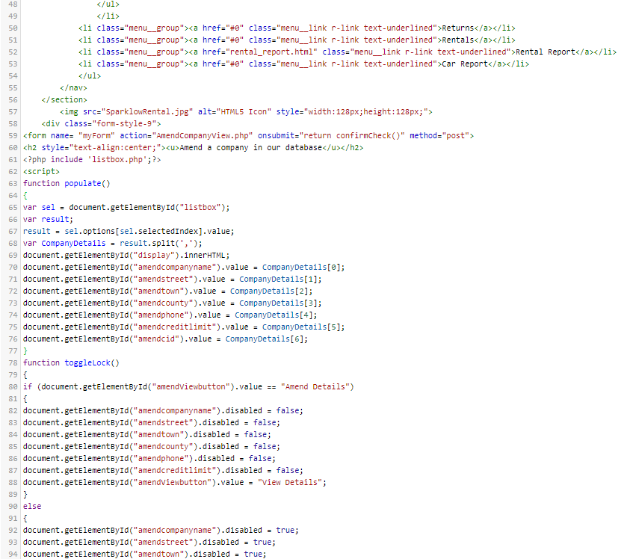

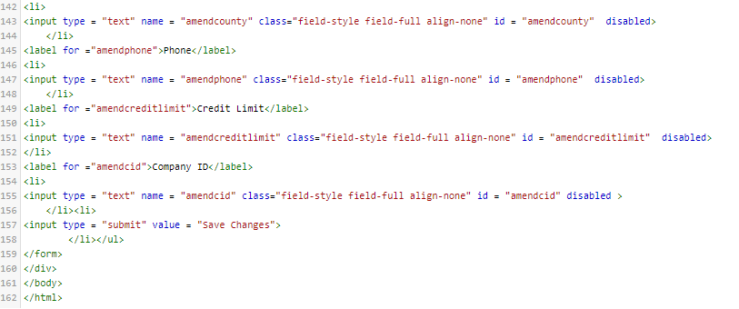

php

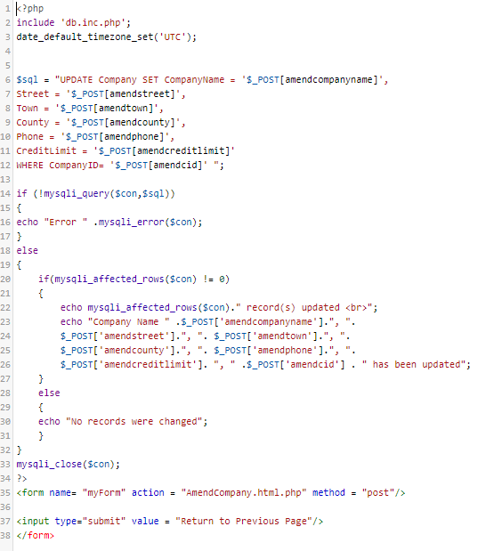

Amendlistbox

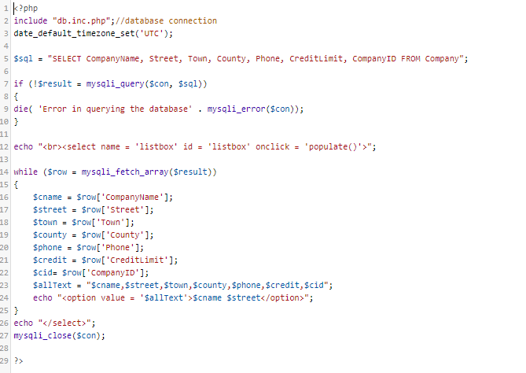

## Delete

### Screen

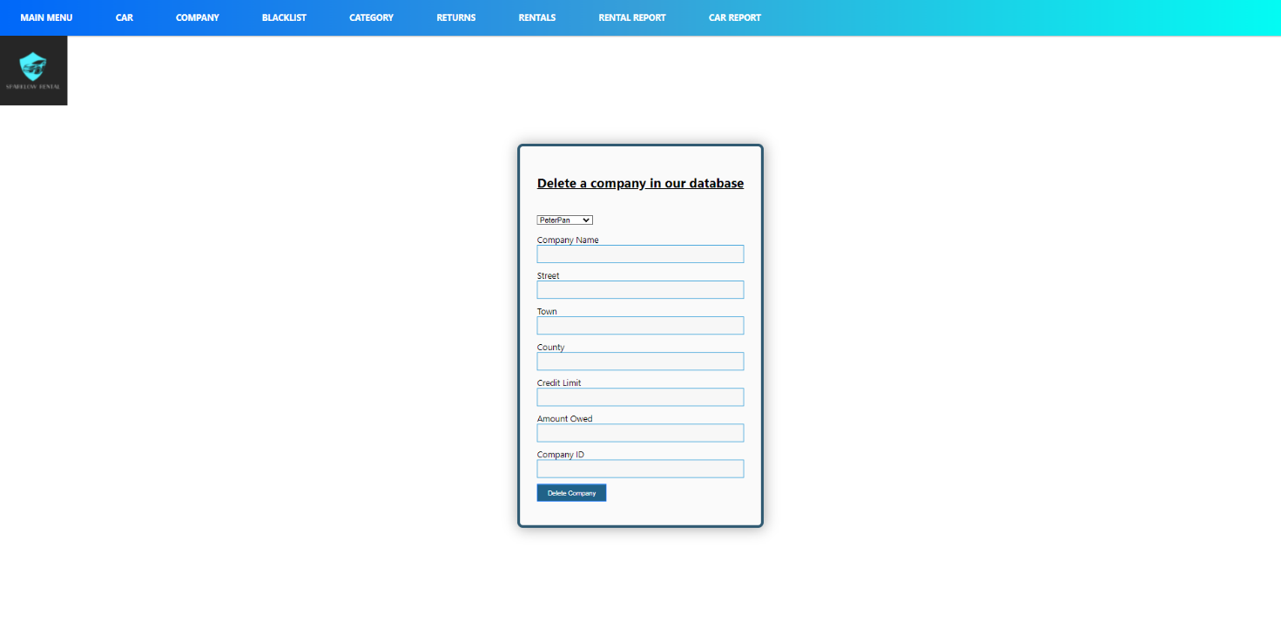

## Code

html

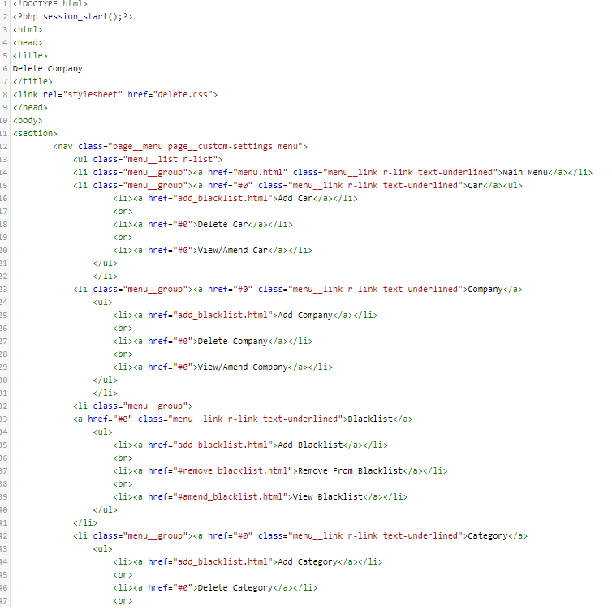

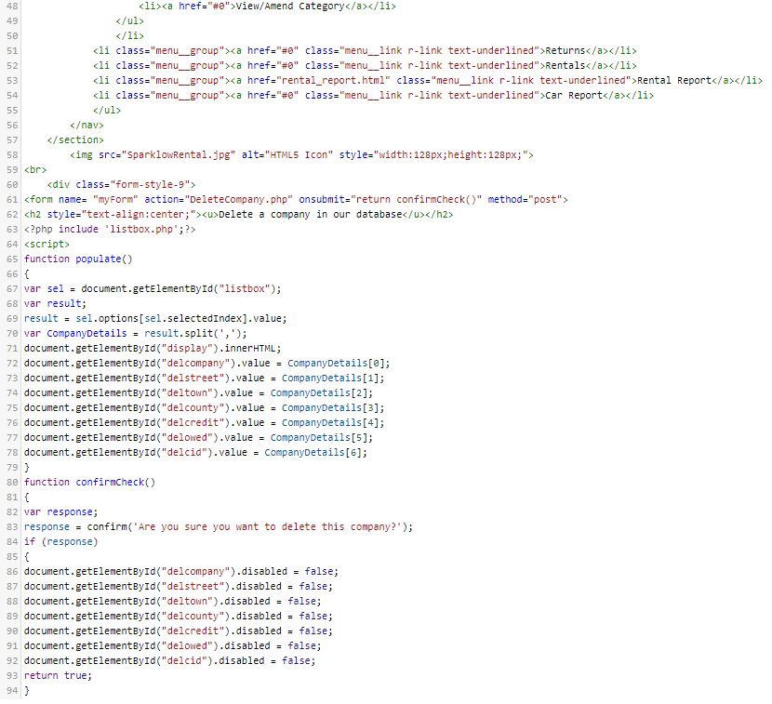

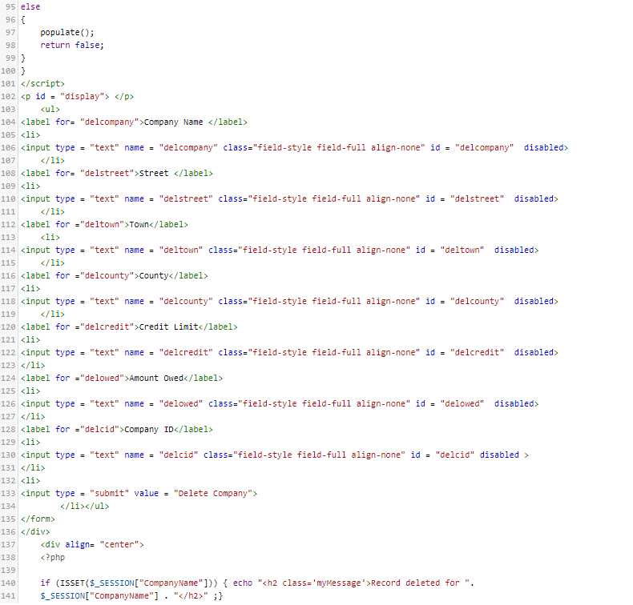

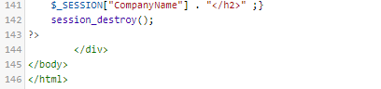

Php

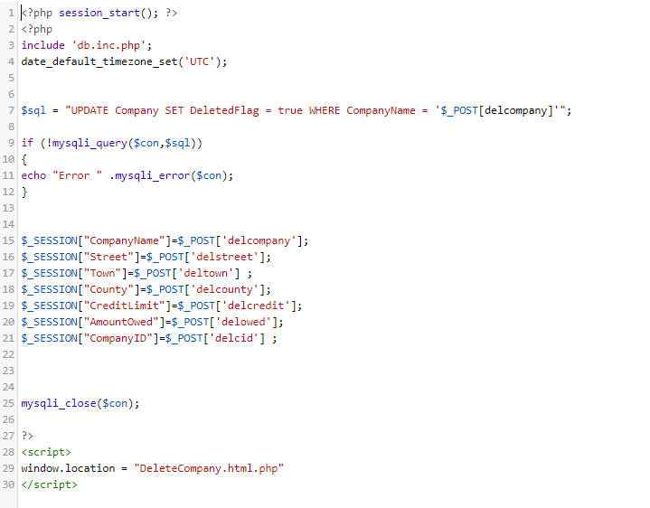

Deletelistbox php



## Rentals

### Screen

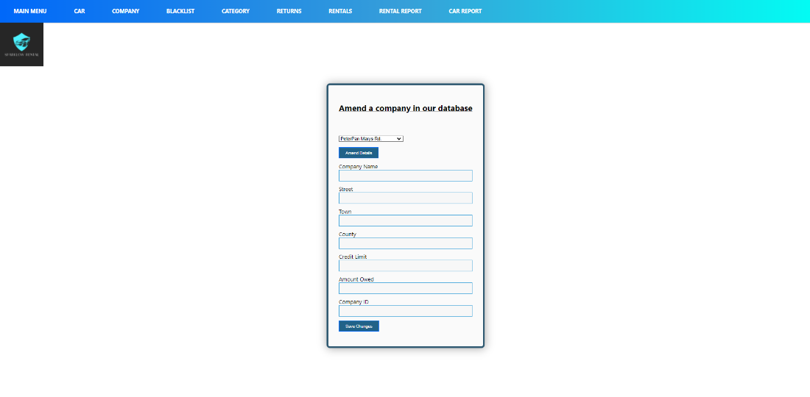

## Code

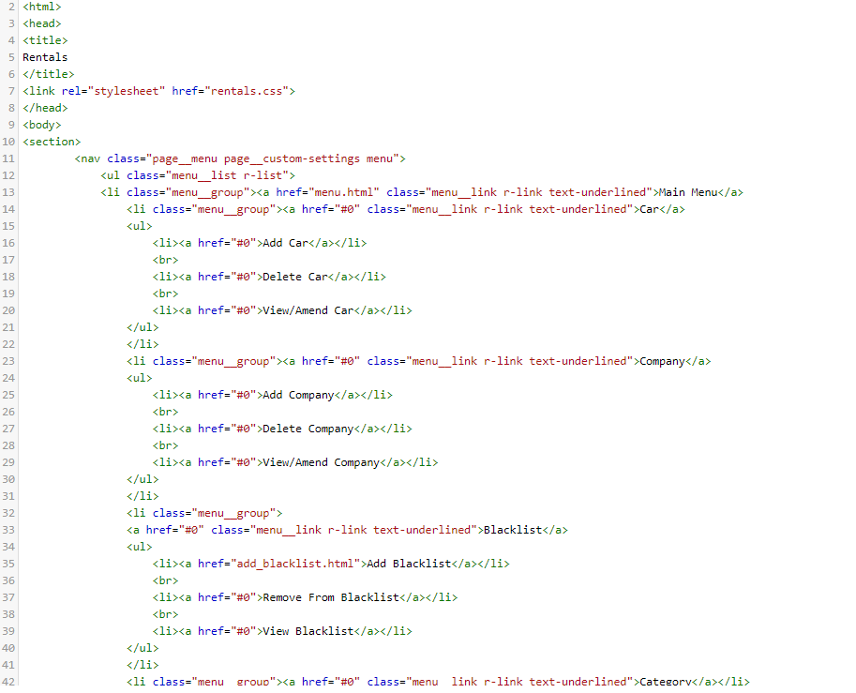

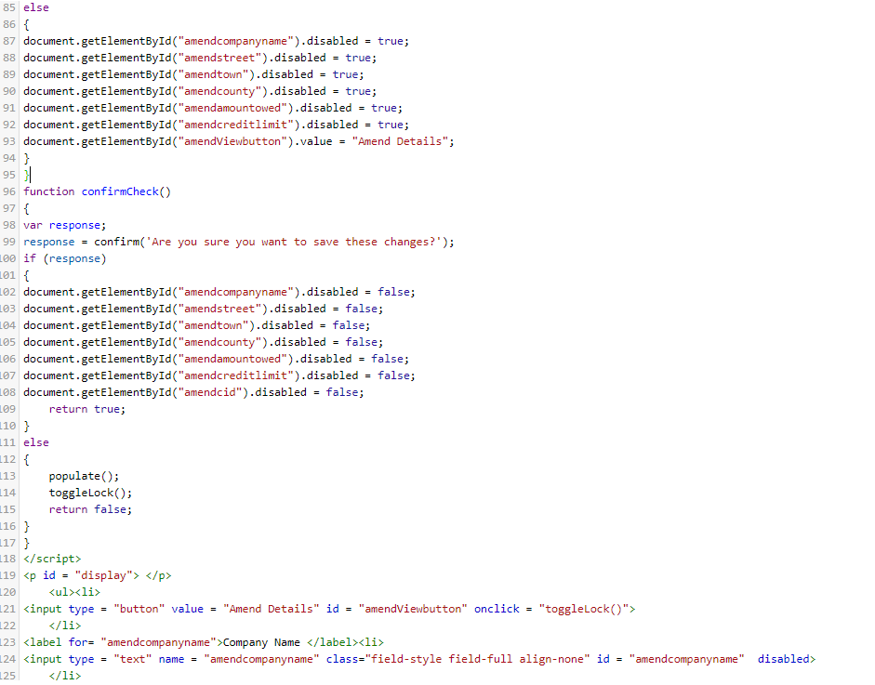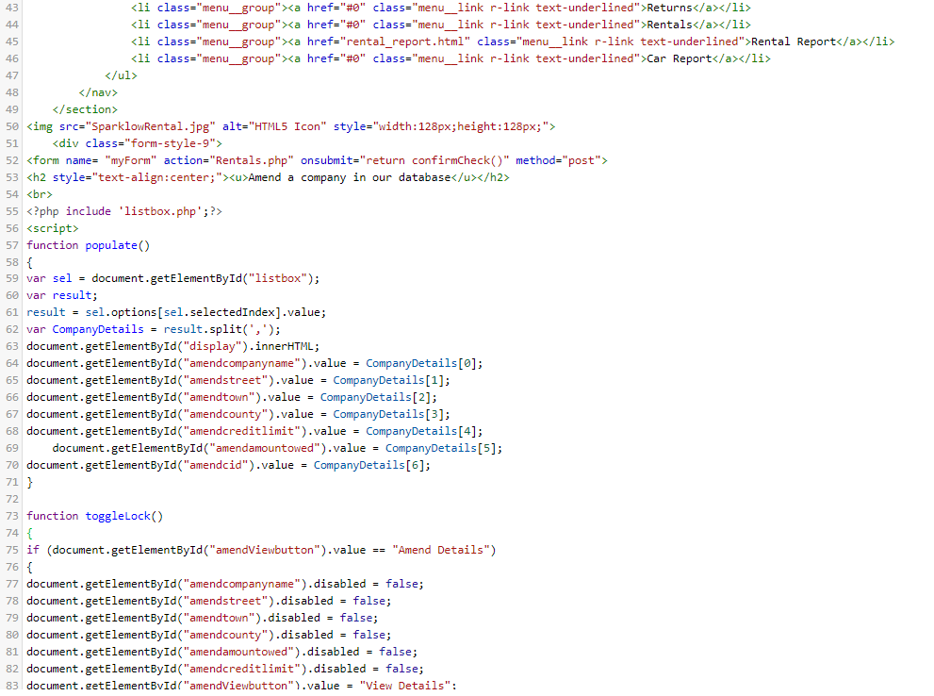

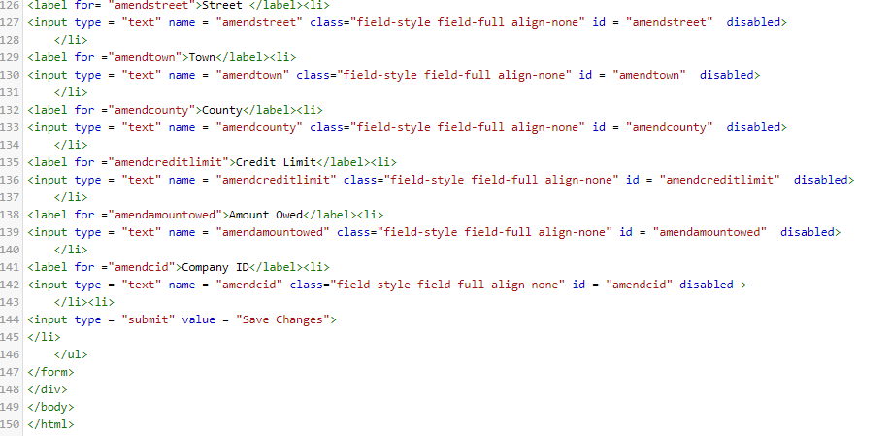

Php

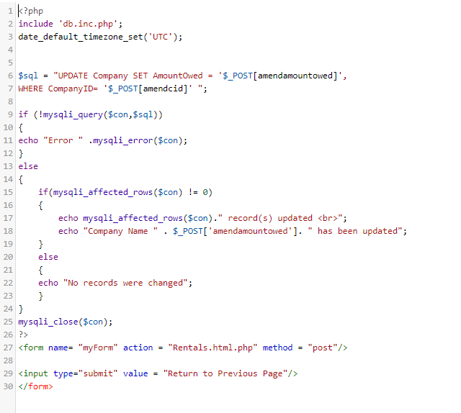

Rental listbox.php

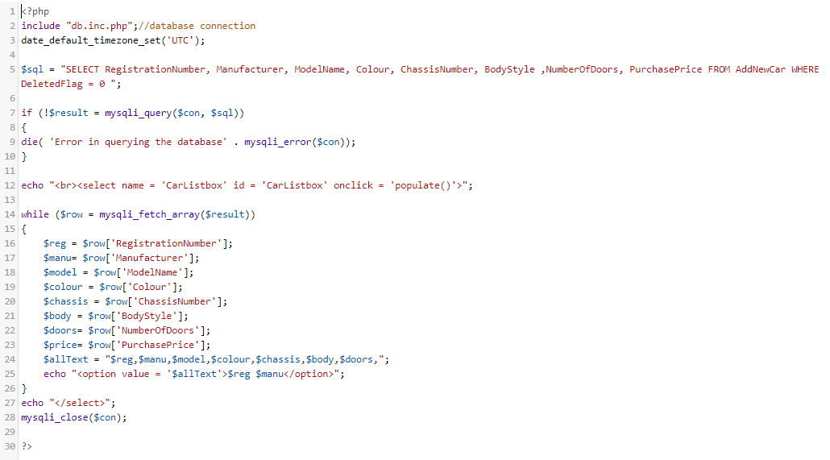

Carlistbox.php



# Sebastian Wisniewski

## Add Blacklist

### Screen

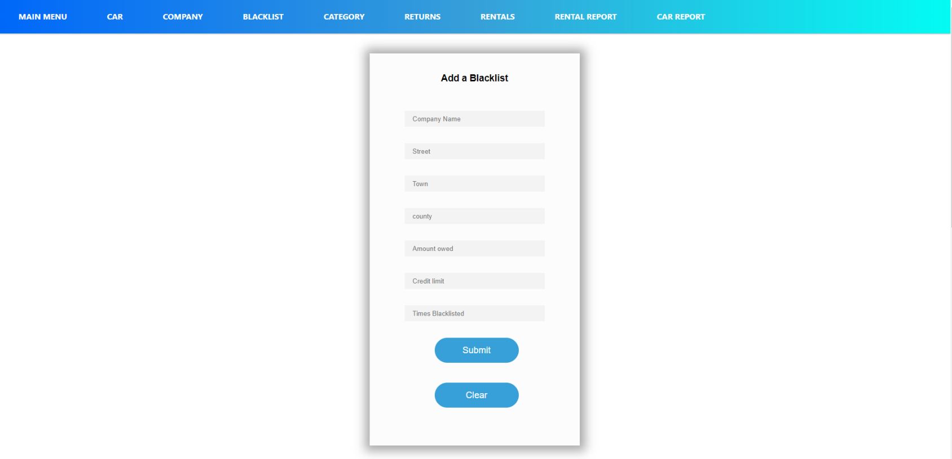

## Code

### Html Code

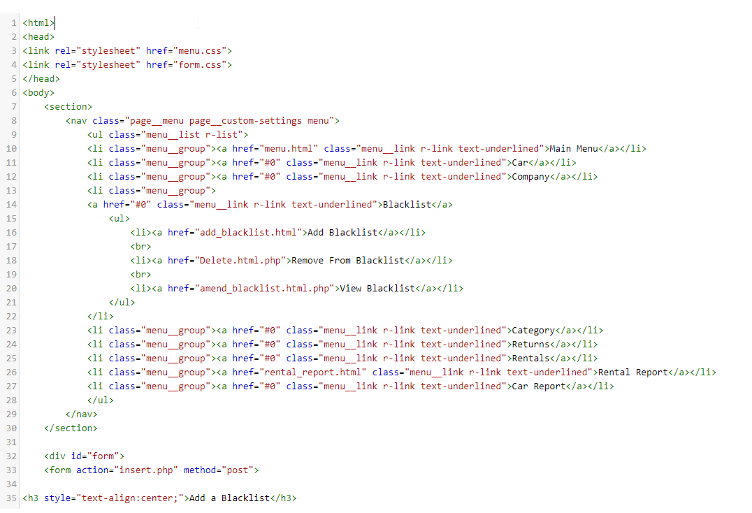

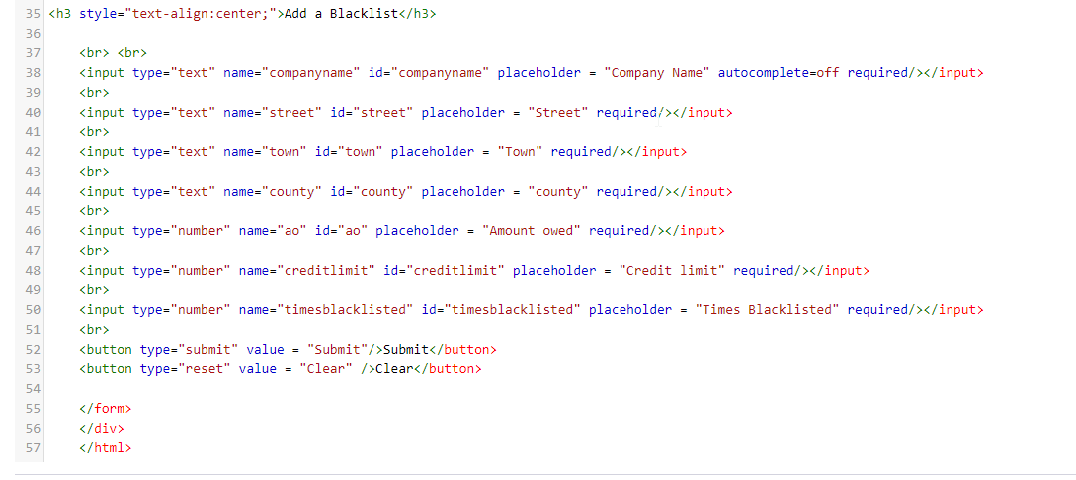

### PHP Code

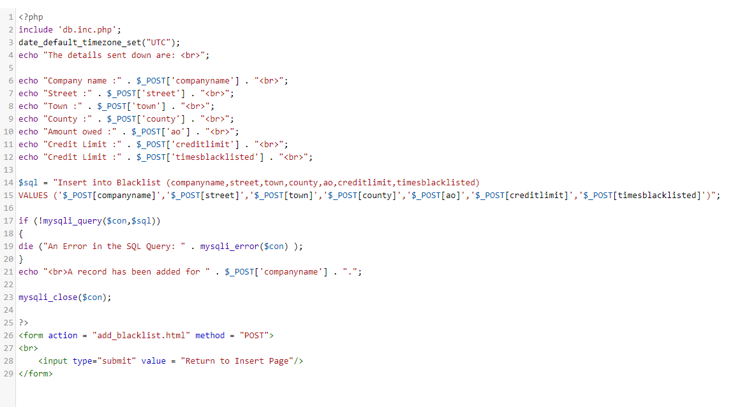

### CSS Code



















### CSS Code 2

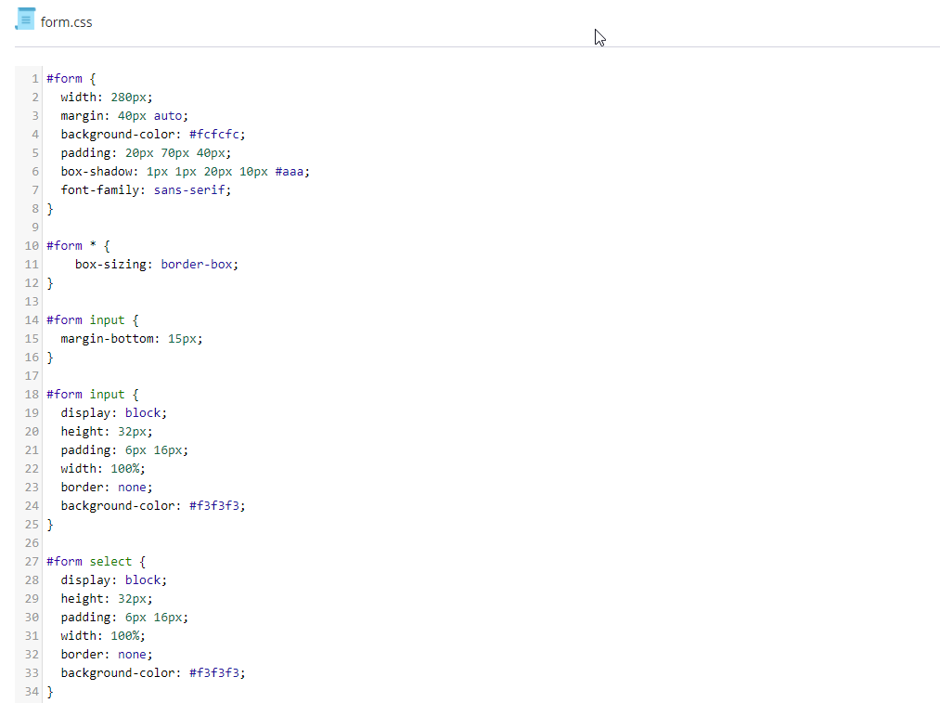

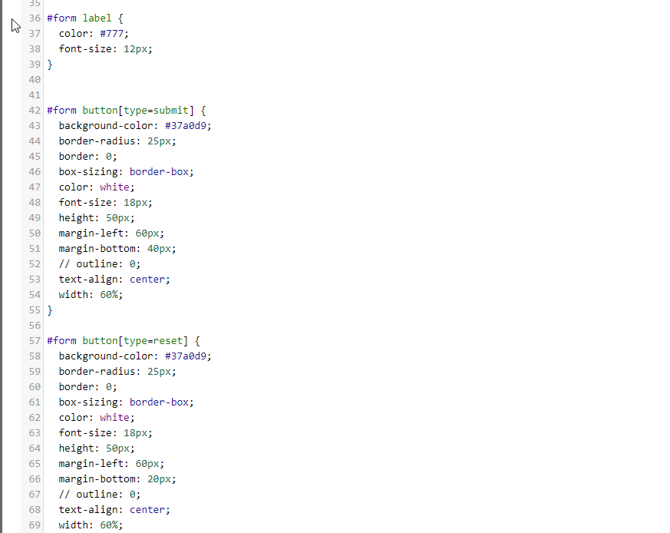

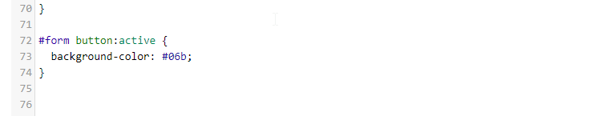

## Amend Blacklist

### Screen

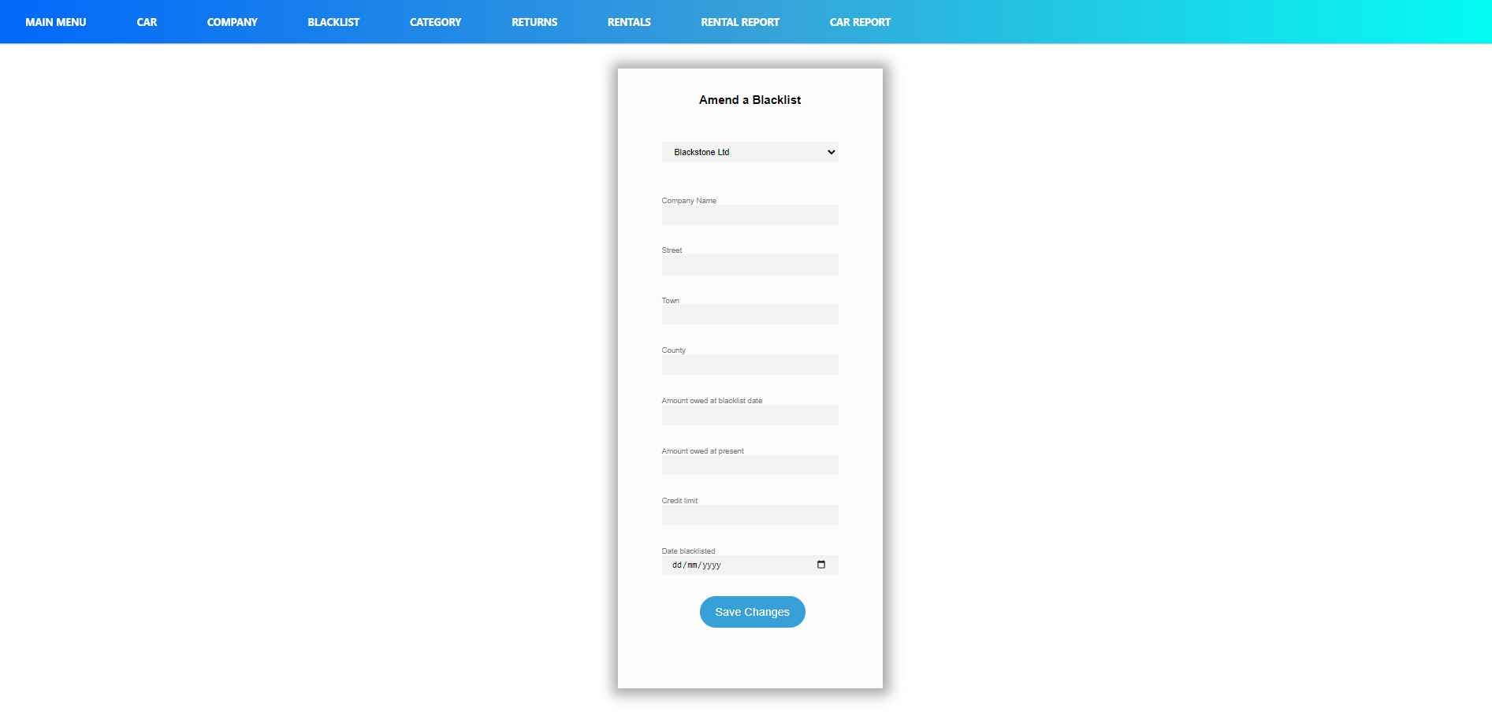

## Code

### Html Code

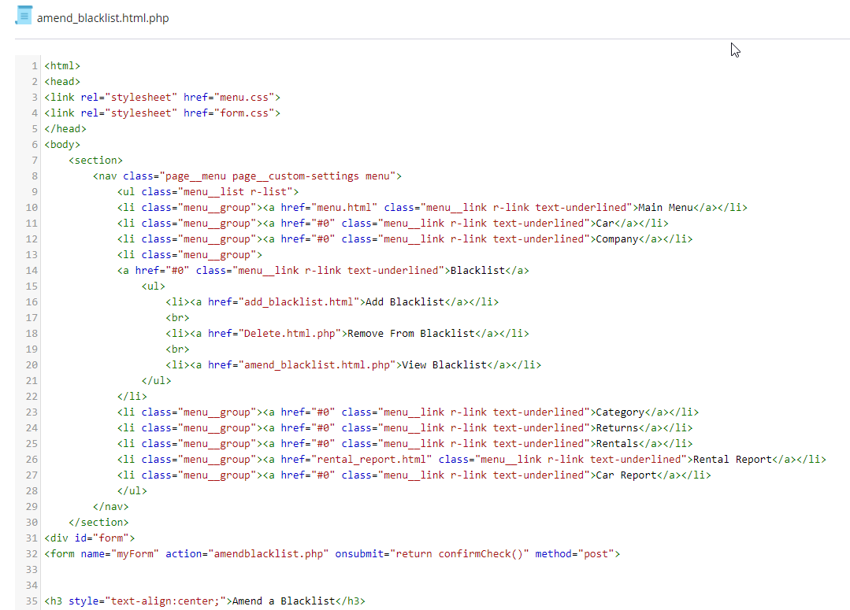

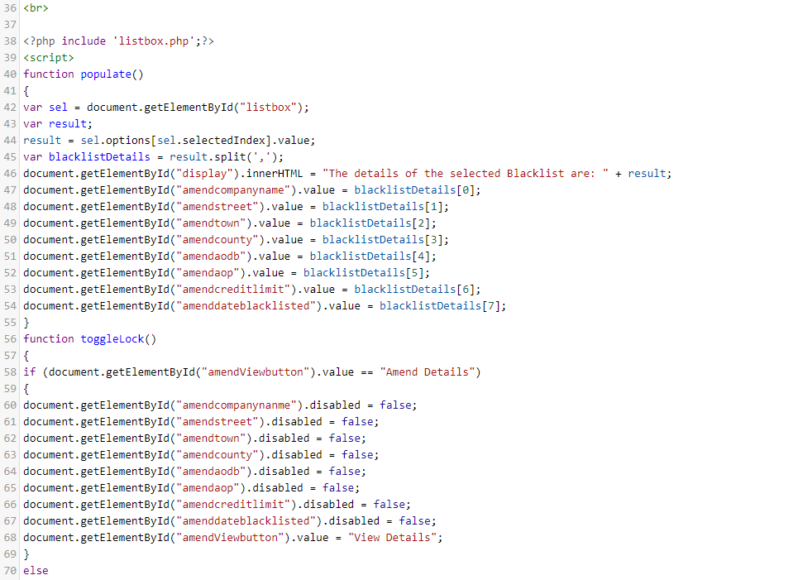

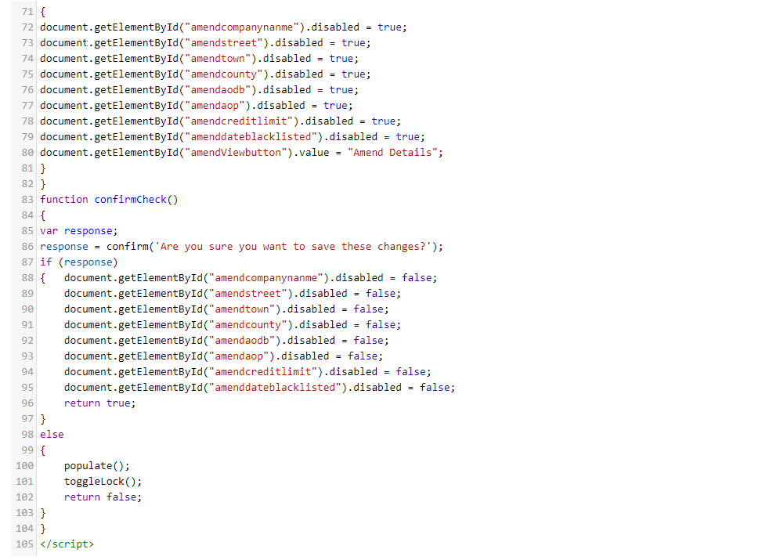

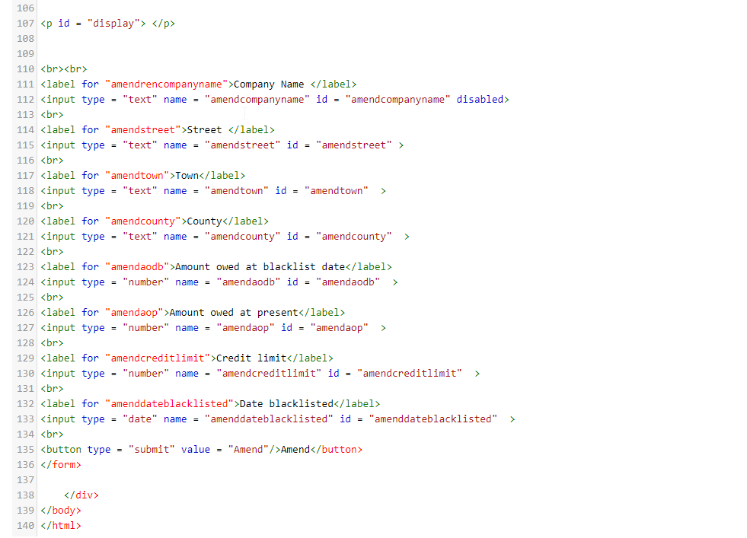

### PHP Code

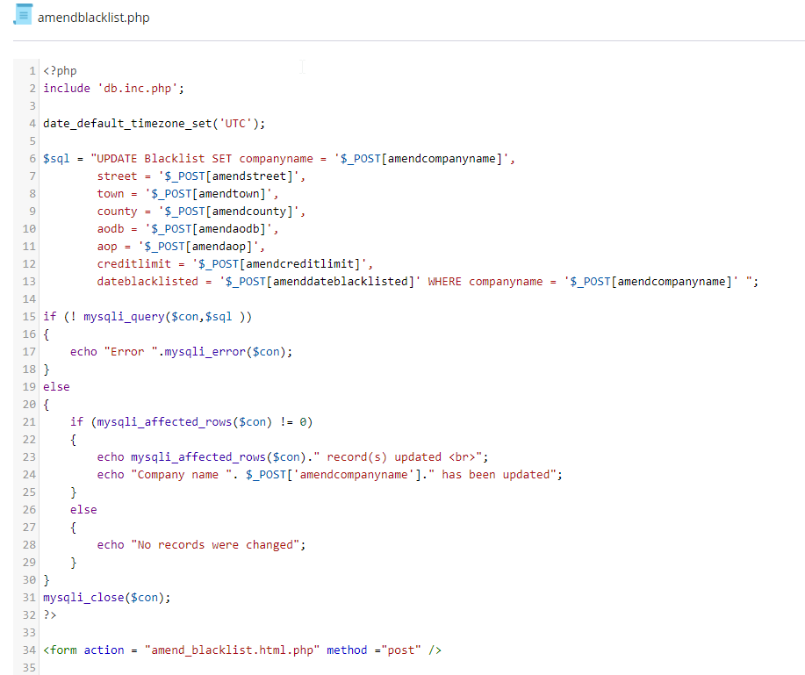

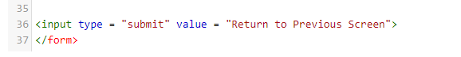

### CSS Code



















### CSS Code 2







## Delete Blacklist

### Screen

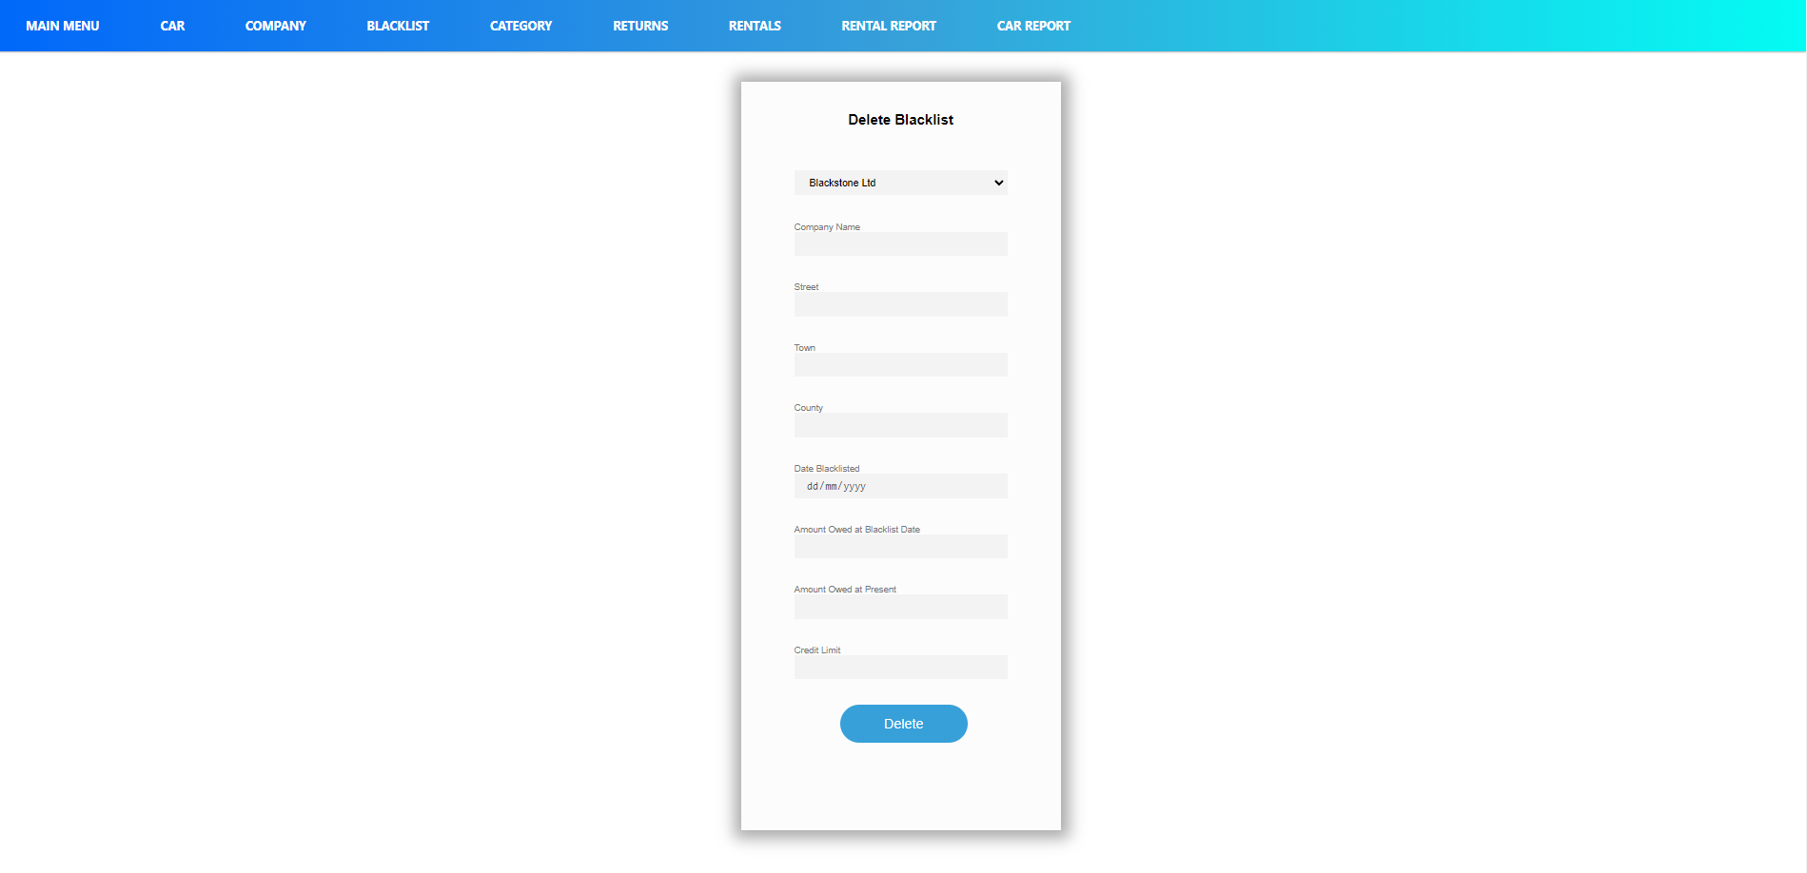

## Code

### Html Code

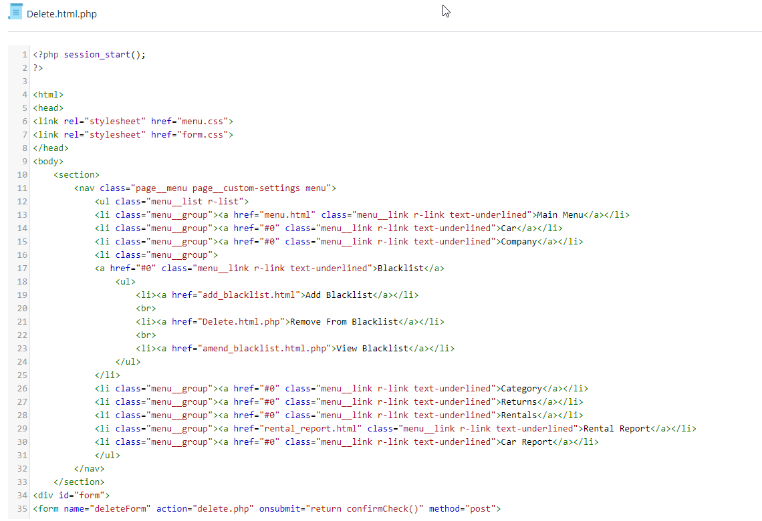

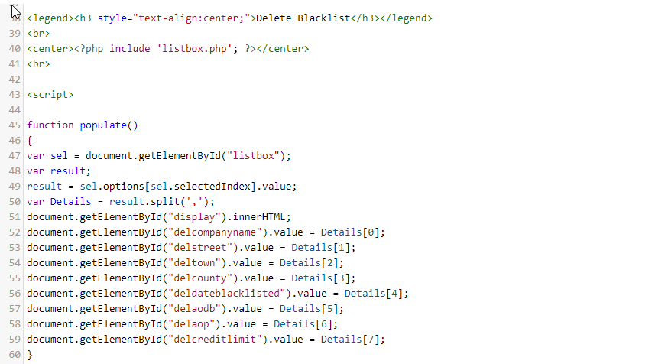

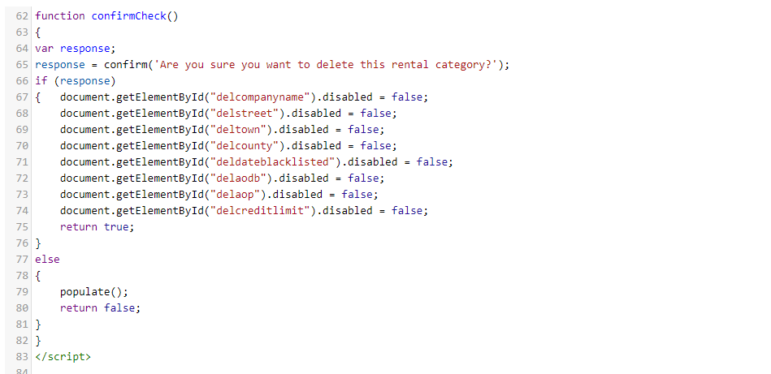

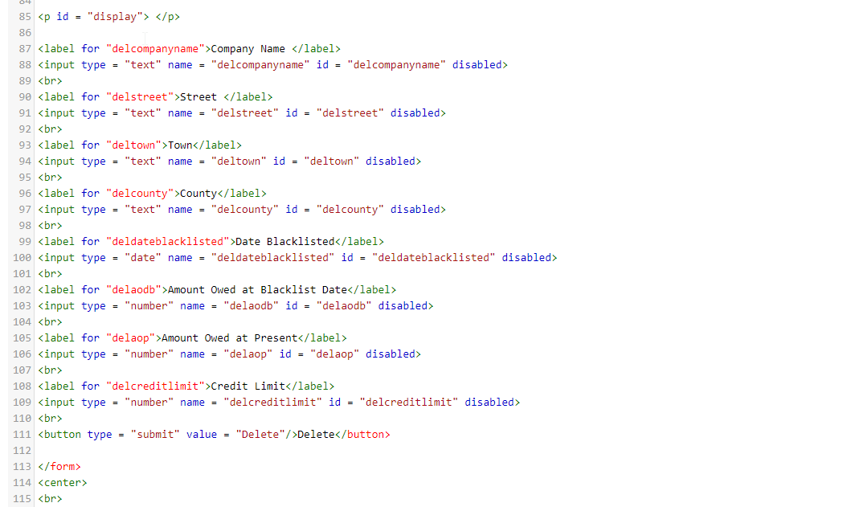

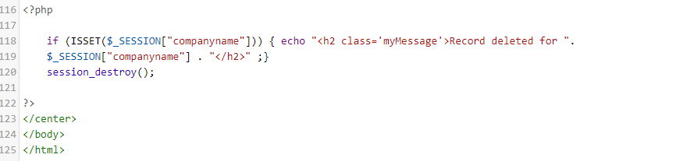

### PHP Code

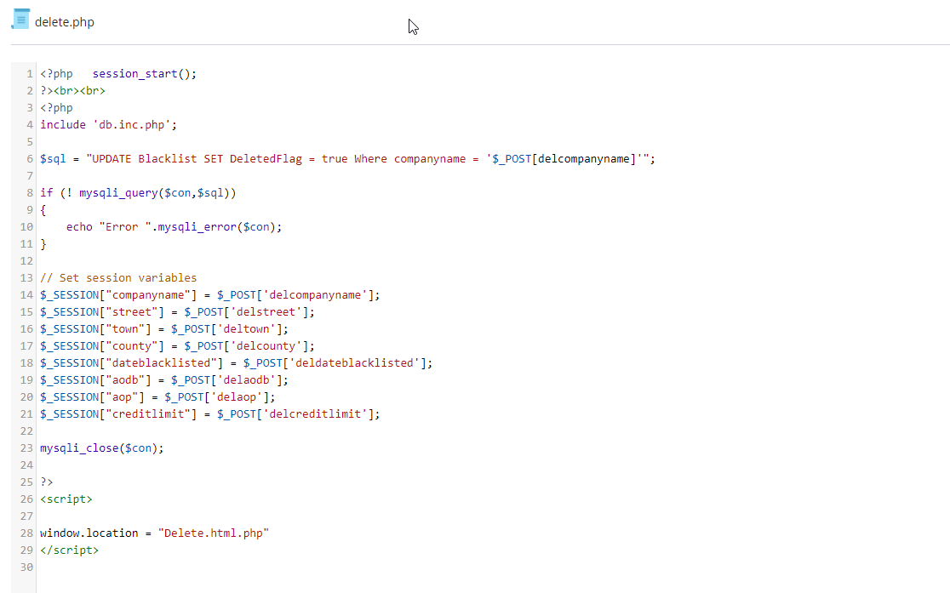

### CSS Code



















### CSS Code 2







## Rental Report

### Screen

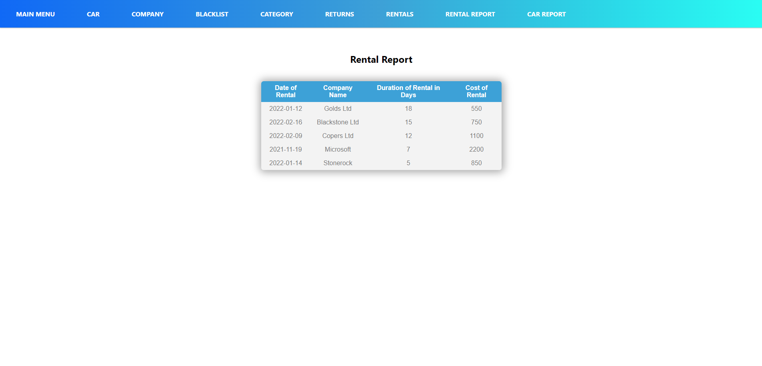

## Code

### Html/PHP Code

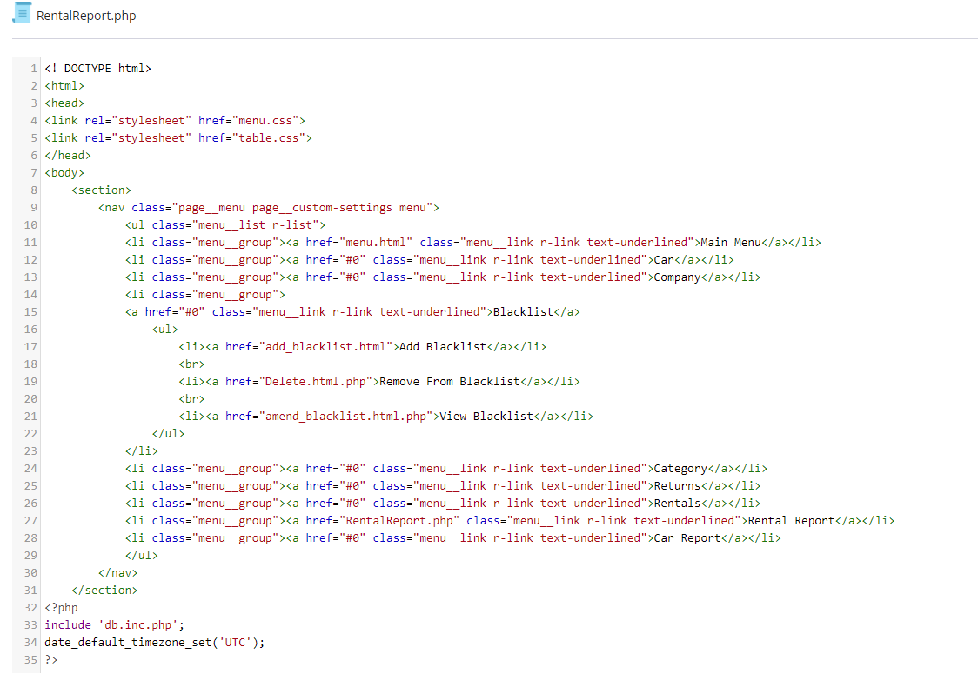

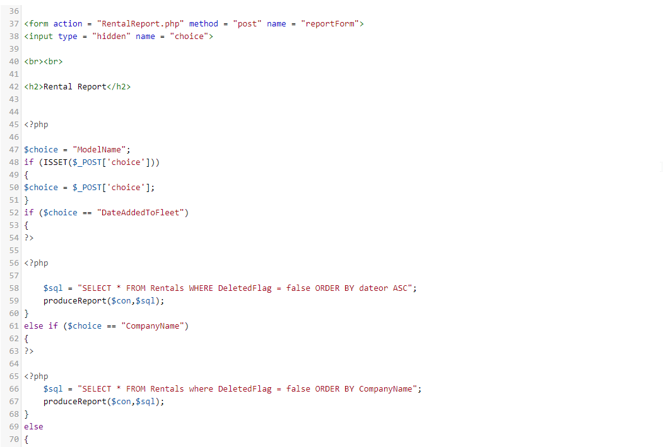

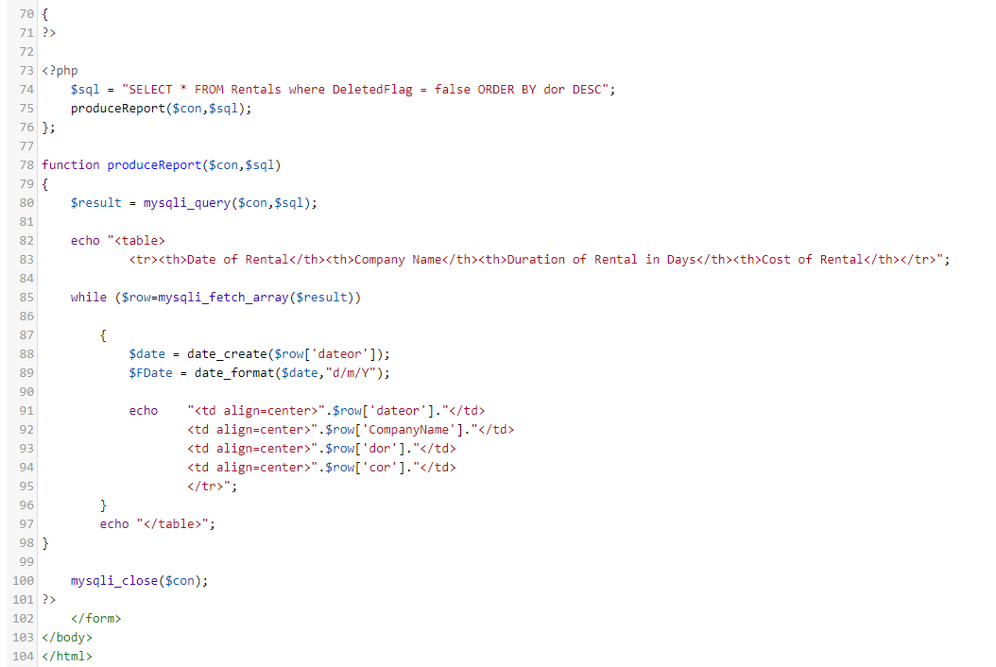

### CSS Code



















### CSS Code 2

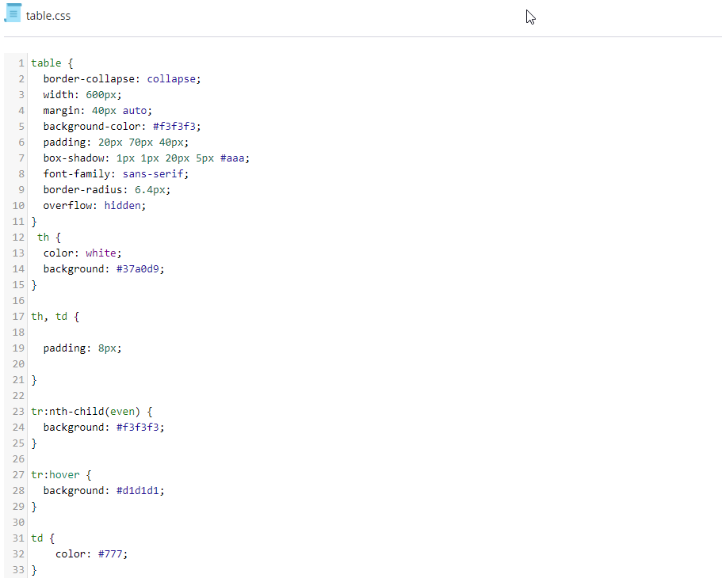

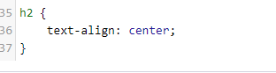

# Daniel Giedraitis

## Add Rental Category

Name of screen: AddRental.html

Purpose of screen: Add rental categories to the database with details for each rental category

Student ID: C00260331

Date: March 2022

### Screen

## Graphical user interface Description automatically generatedCode

### Graphical user interface, text, application Description automatically generatedHtml Code

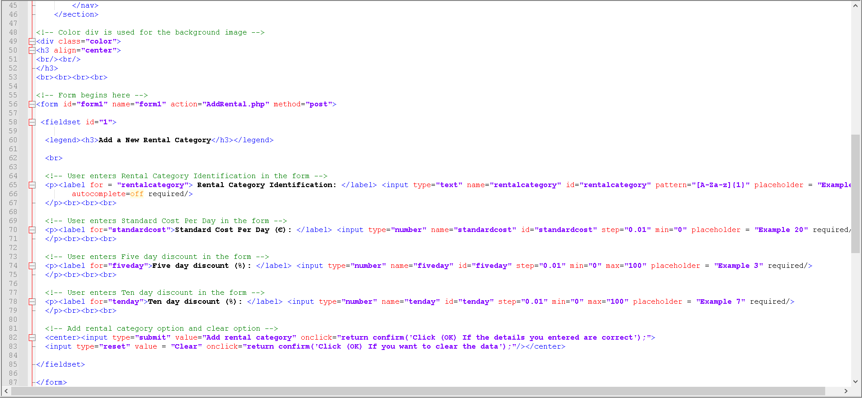



### PHP Code

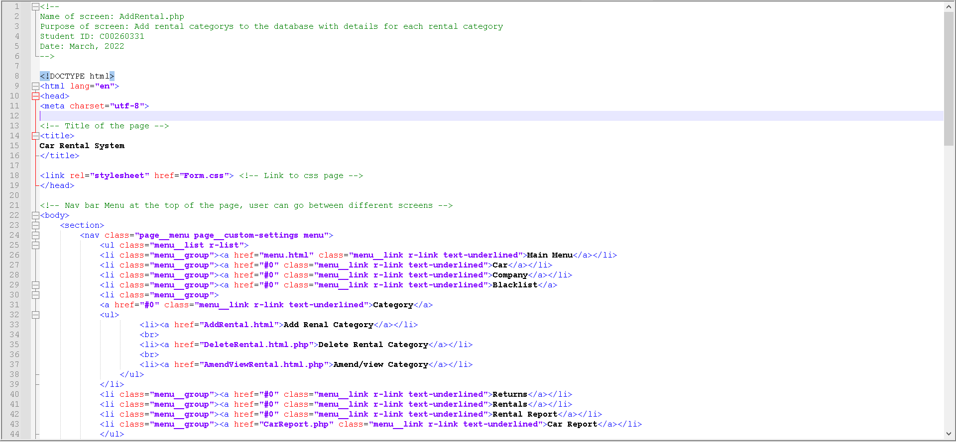

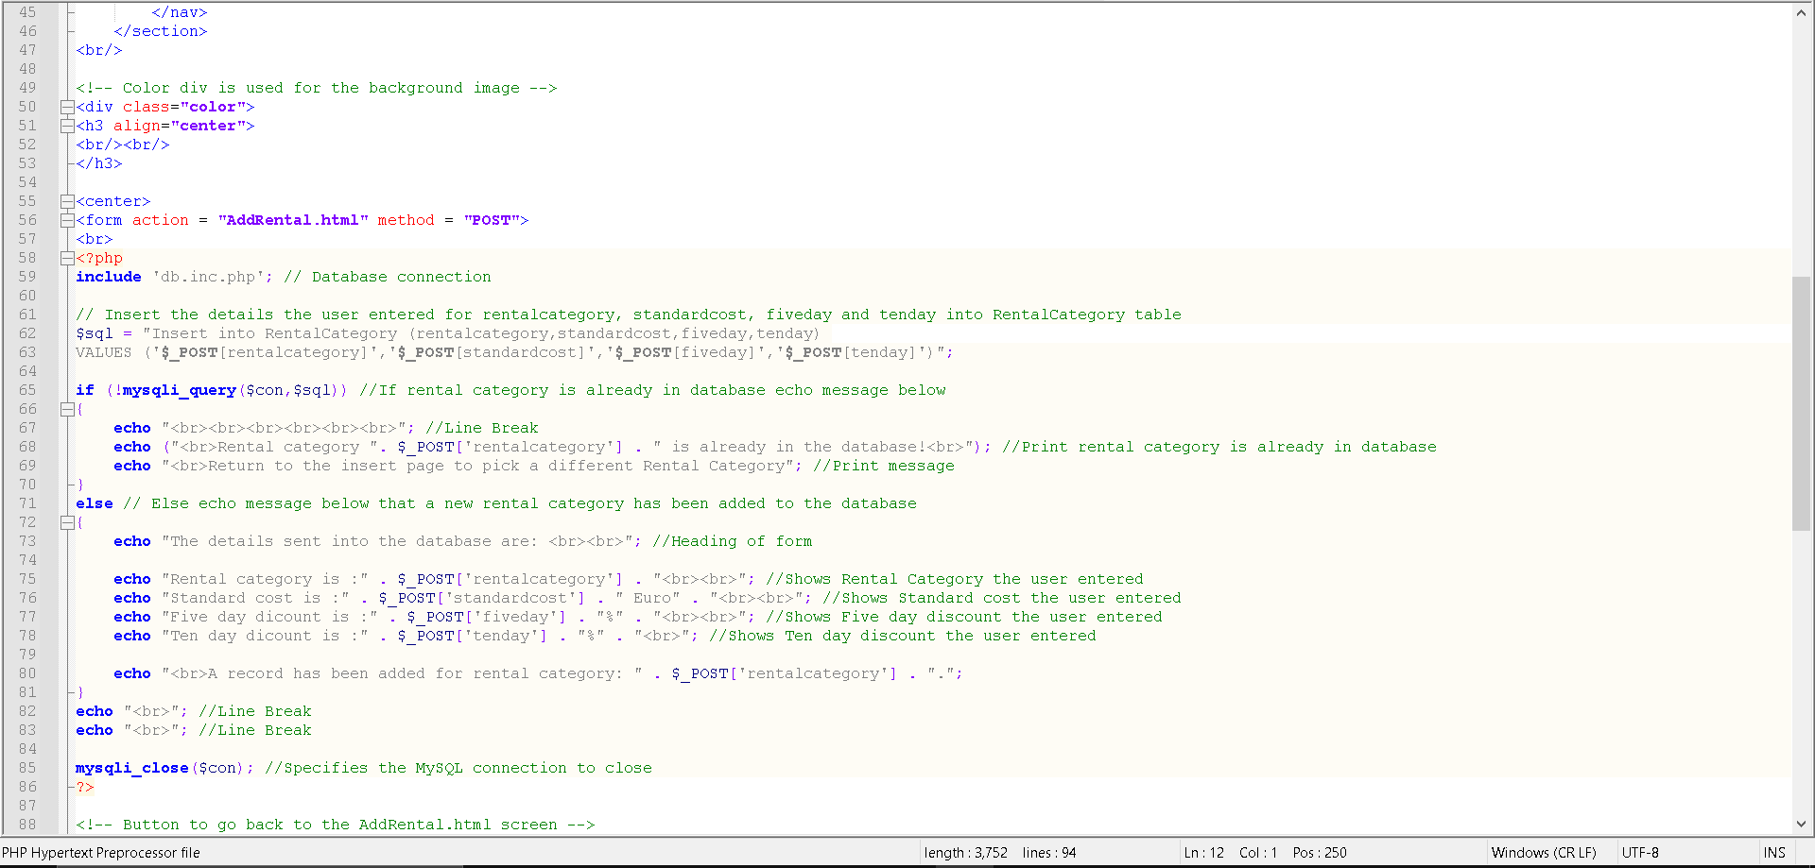

### Graphical user interface, application Description automatically generatedCSS Code

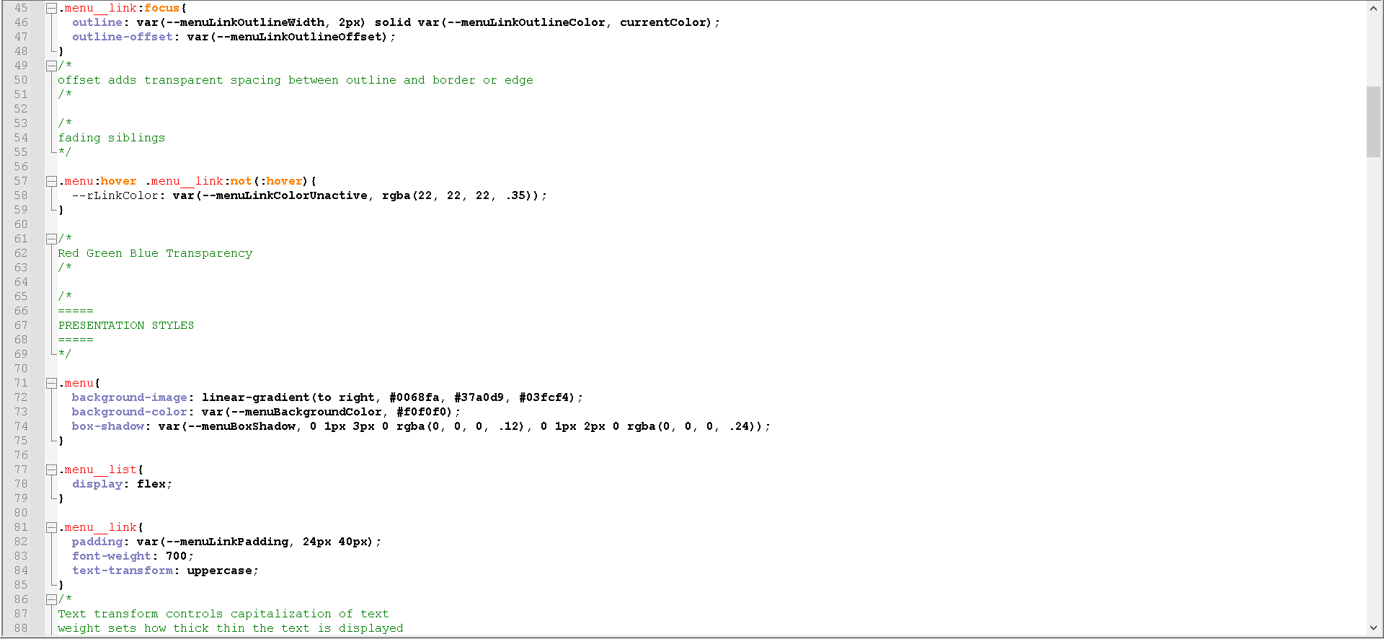

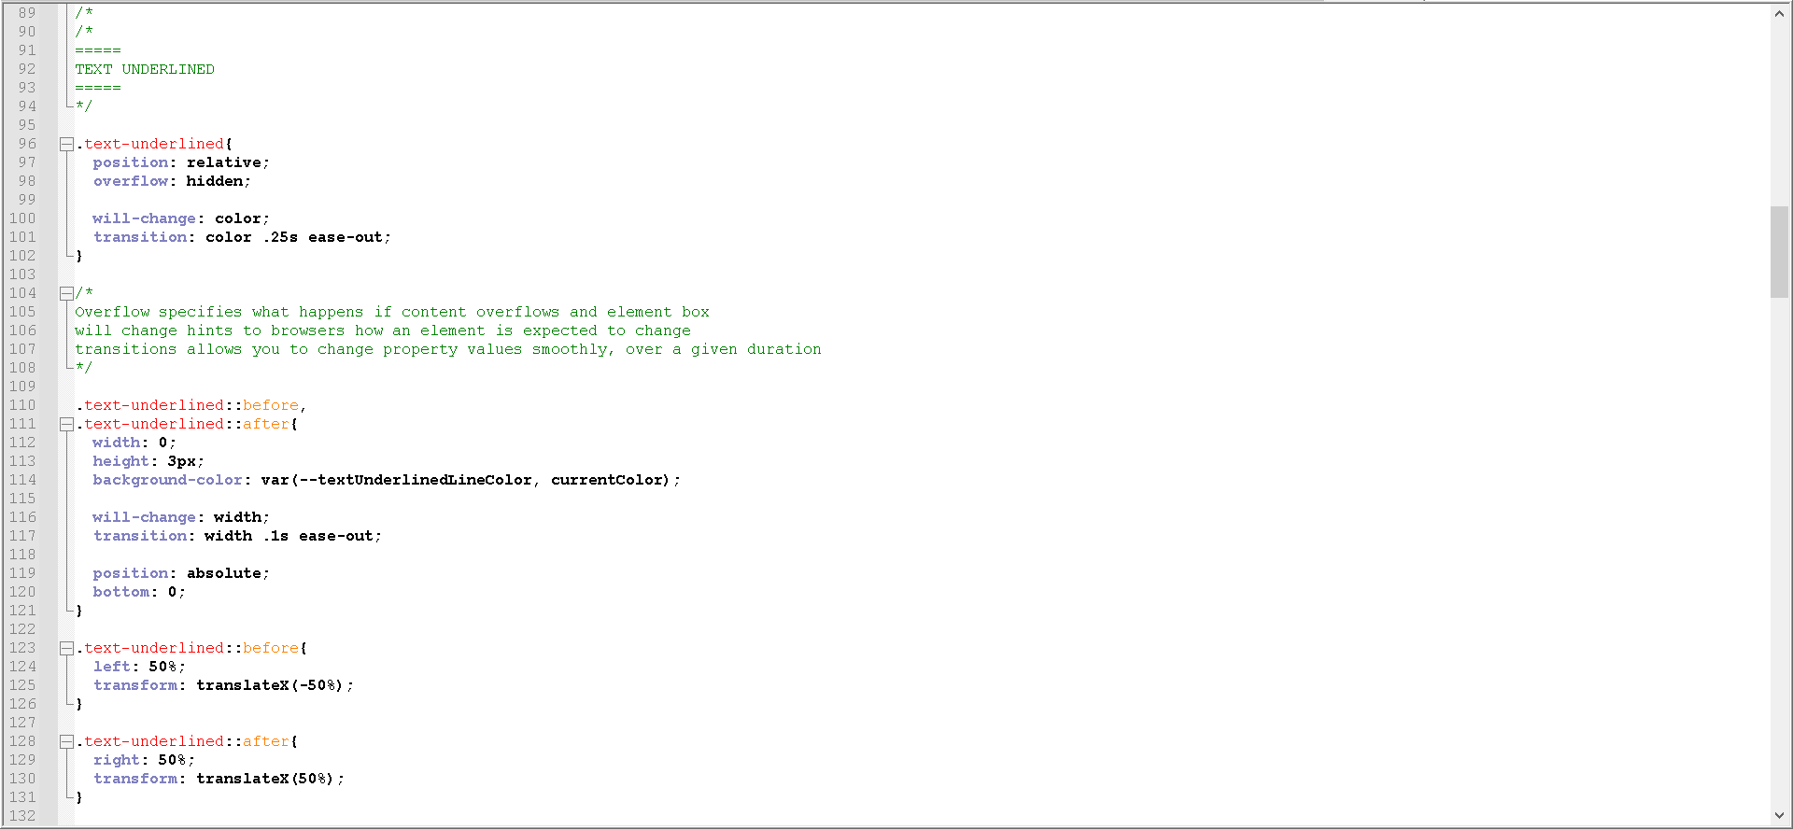

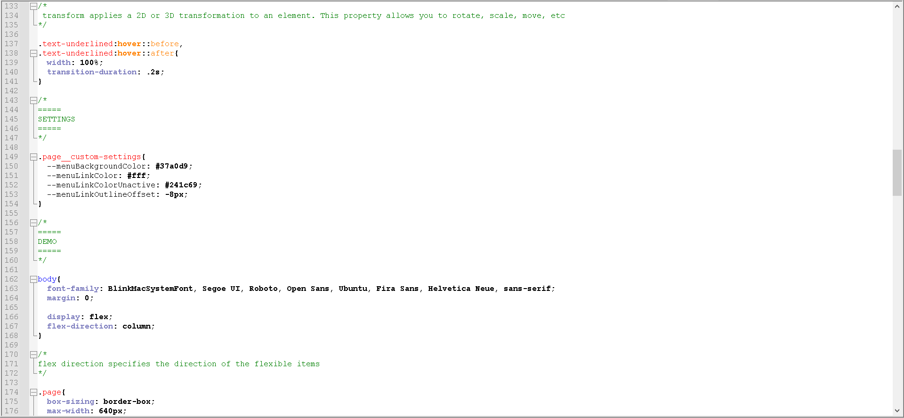

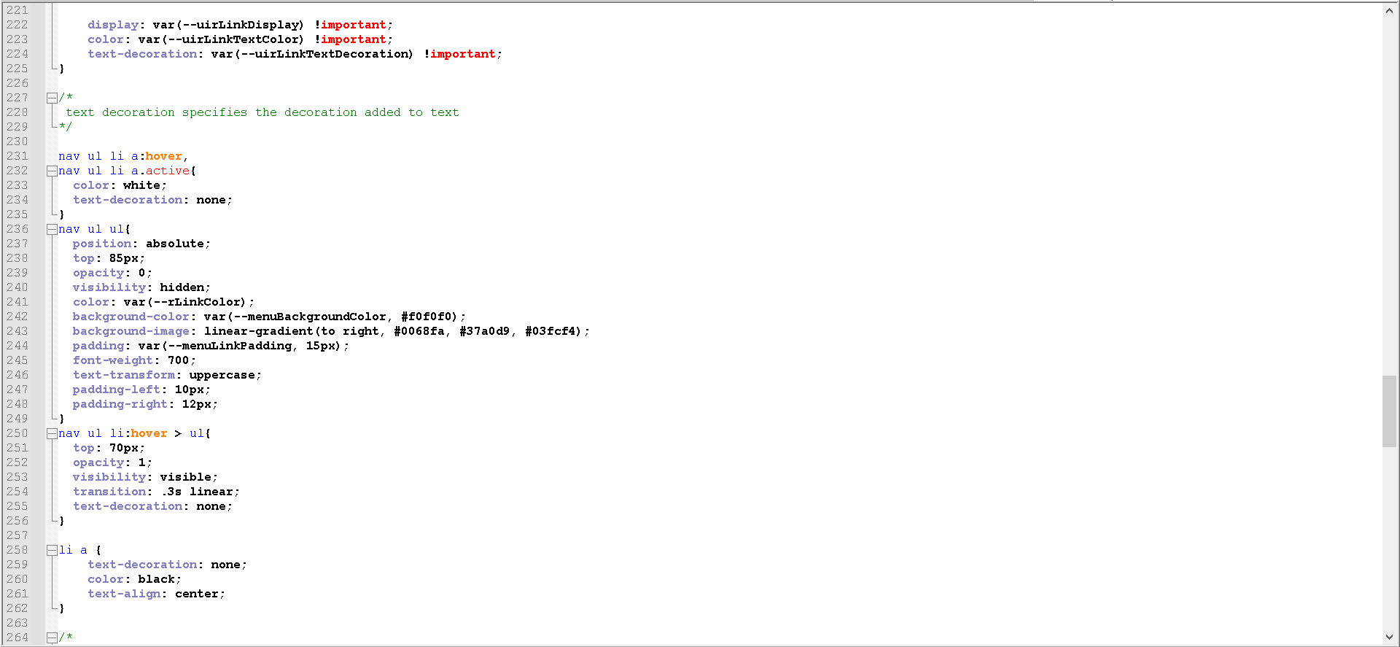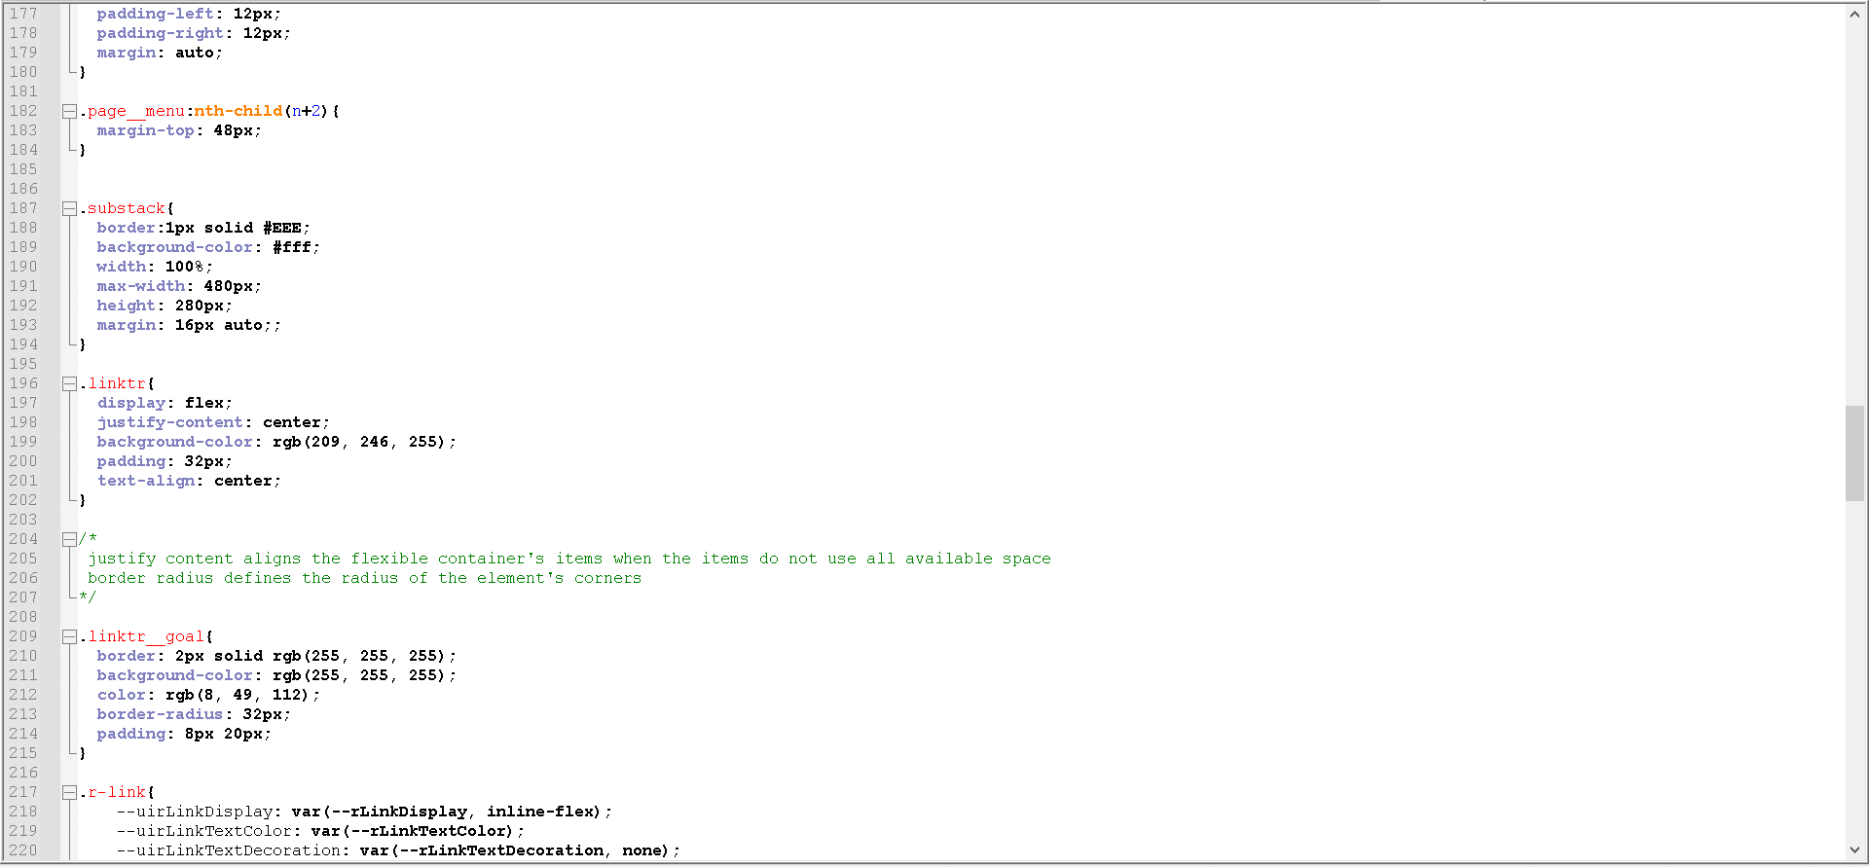

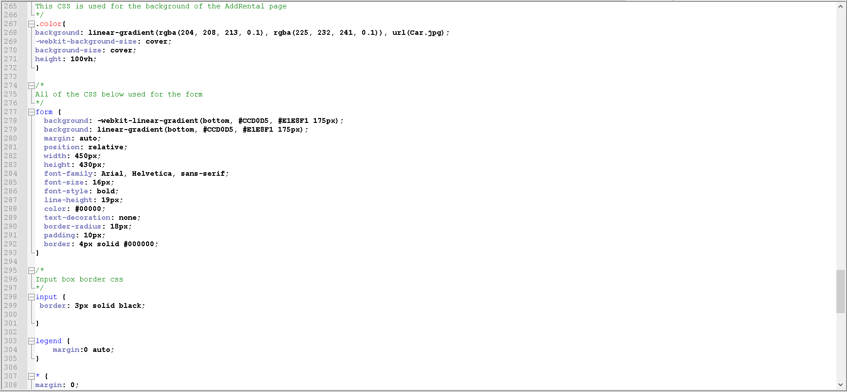

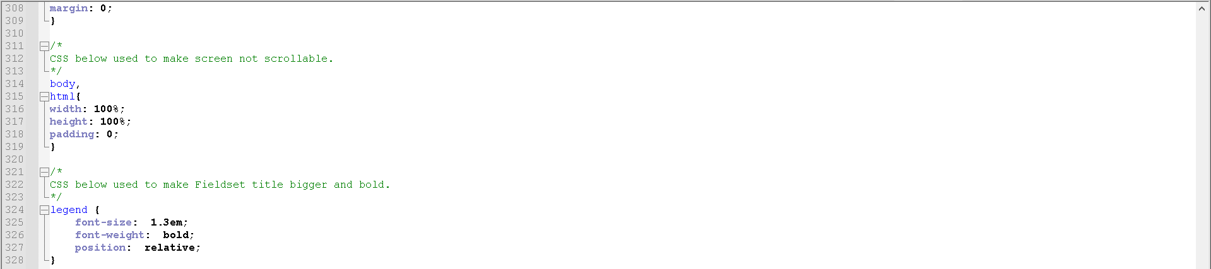

## Amend / View a Rental Category

Name of screen: AmendViewRental.html.php

Purpose of screen: Amend details of rental categories to the database

Student ID: C00260331

Date: March 2022

### Screen

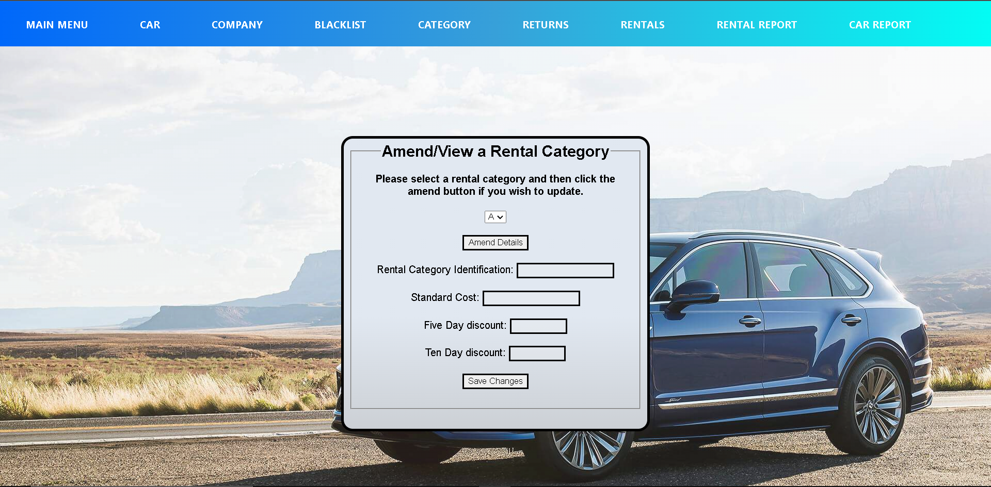

## Code

### Html Code

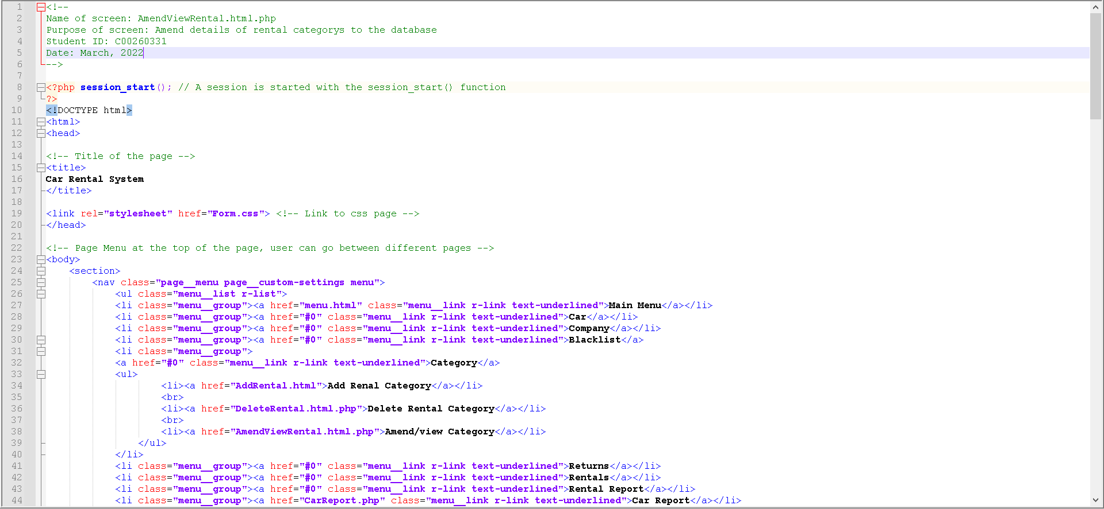

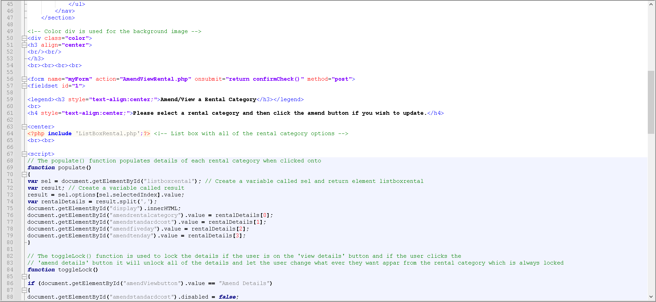

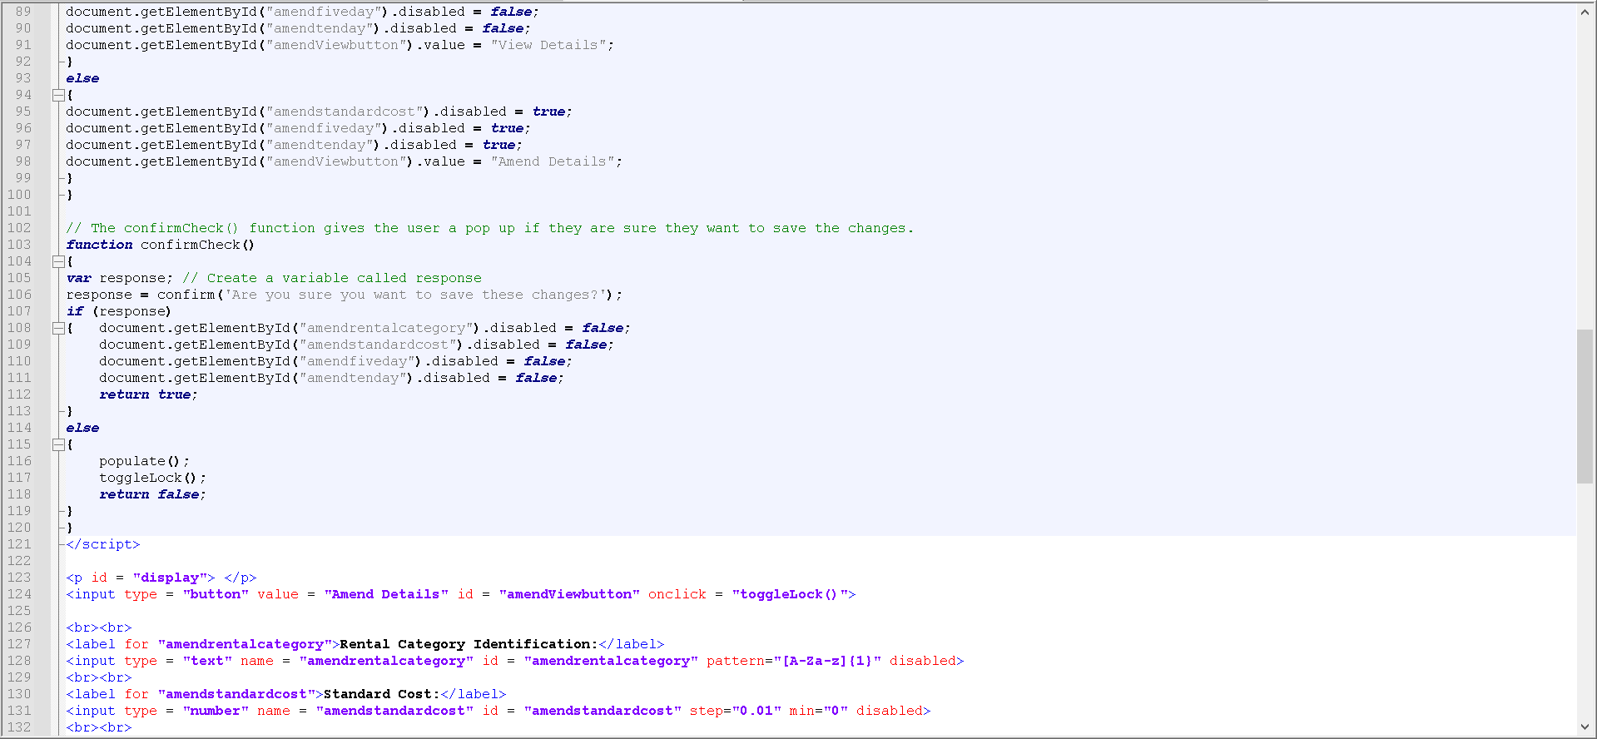

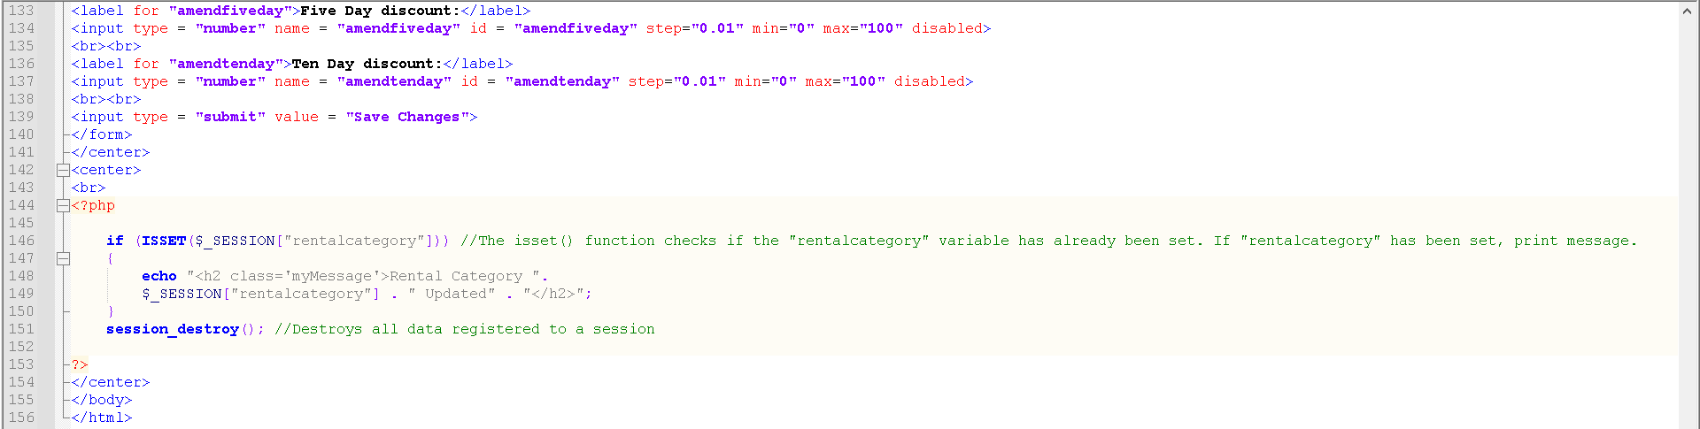

### PHP Code

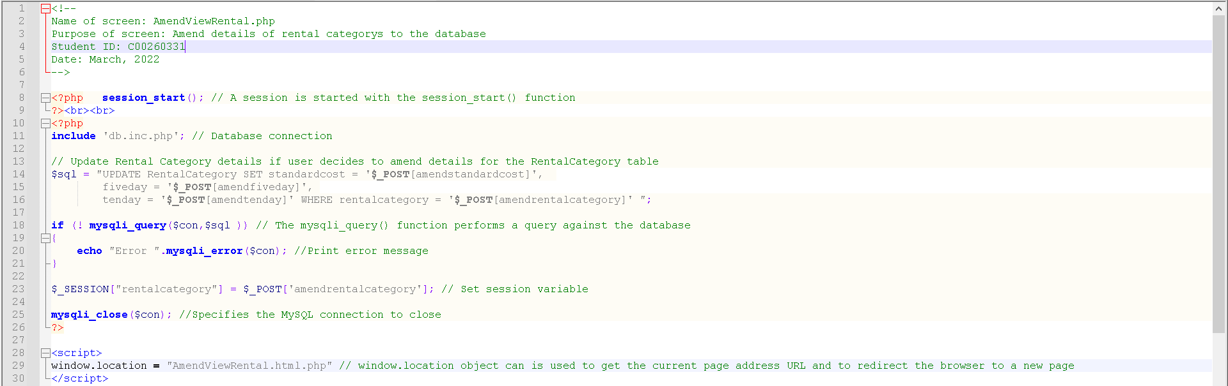

### Graphical user interface, application Description automatically generatedCSS Code













## Delete Rental Category

Name of screen: DeleteRental.html.php

Purpose of screen: Delete rental categories from the database / list box

Student ID: C00260331

Date: March 2022

### Screen

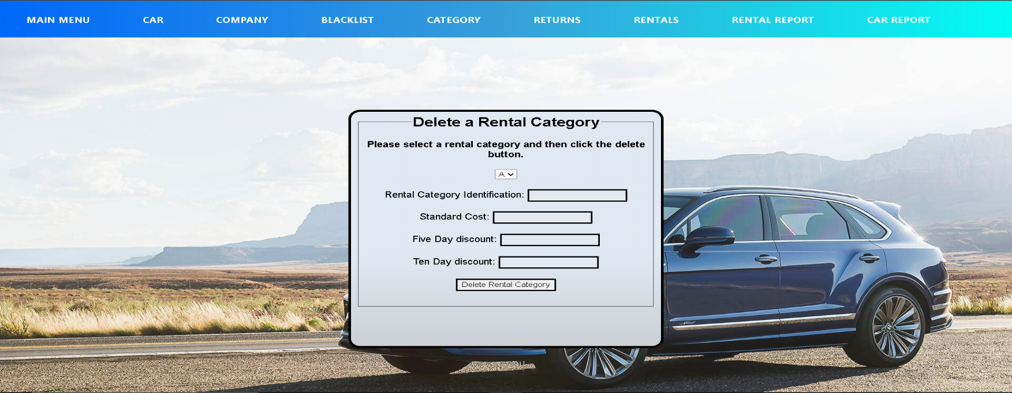

## Code

### Html Code

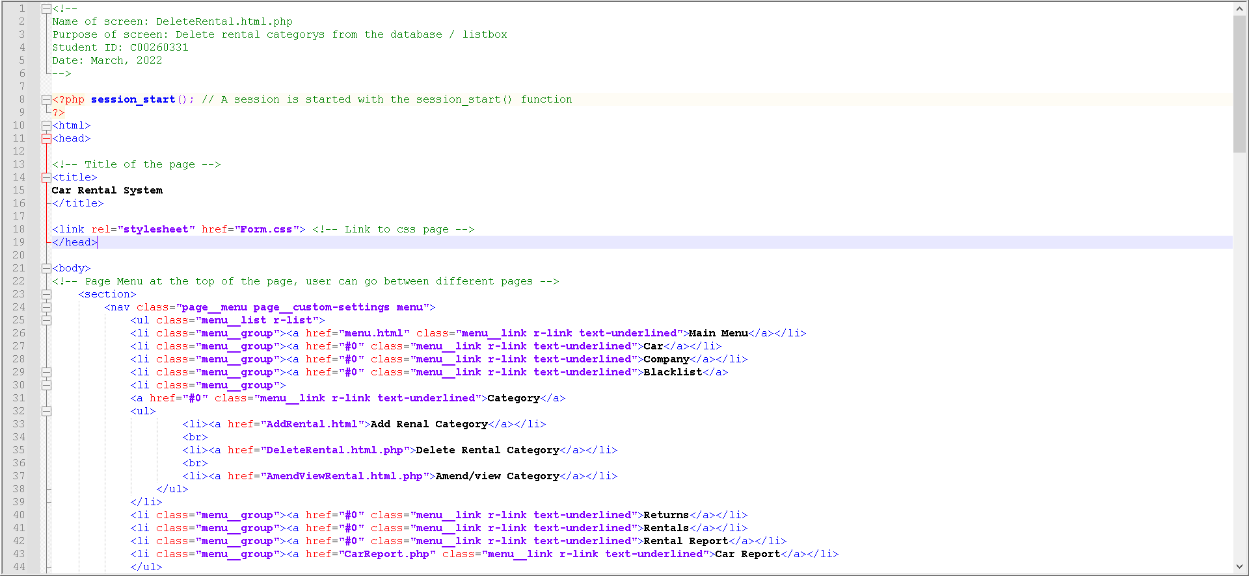

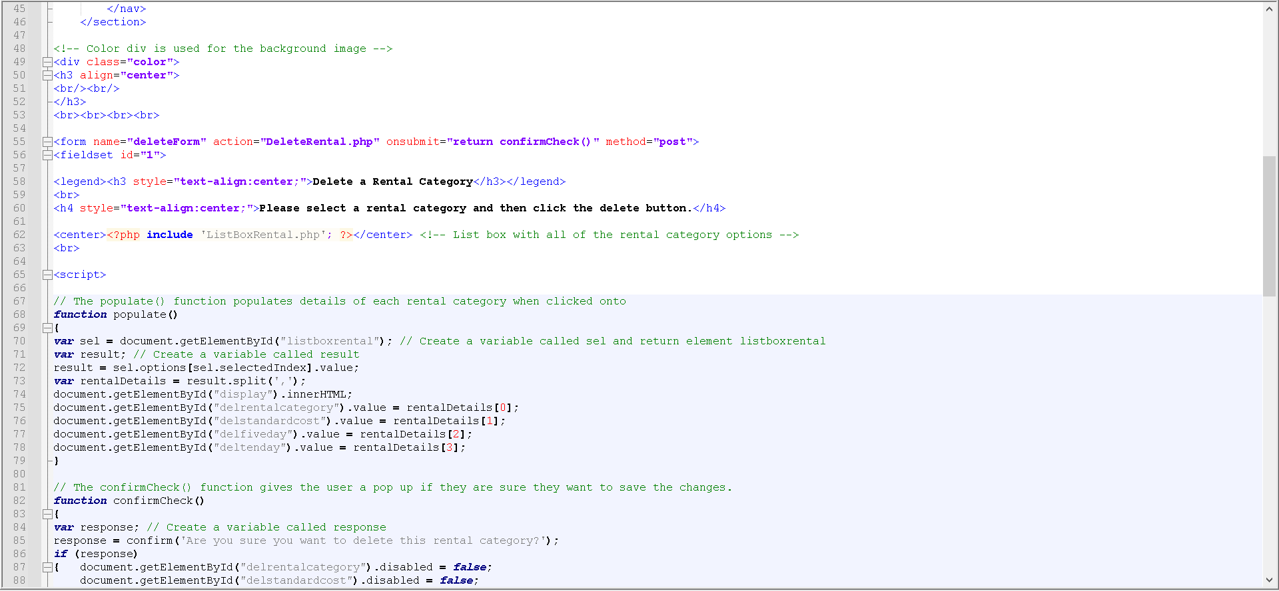

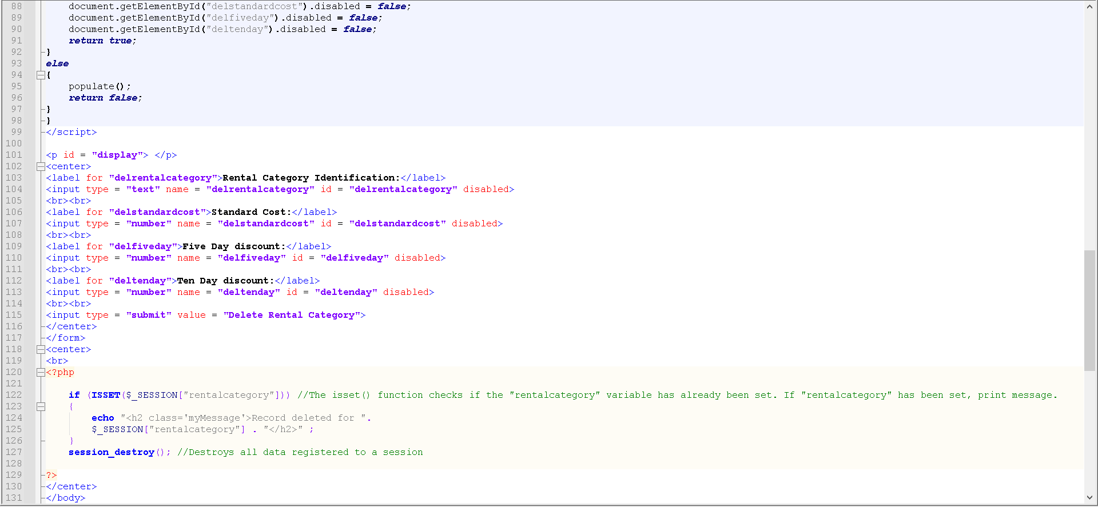



### PHP Code

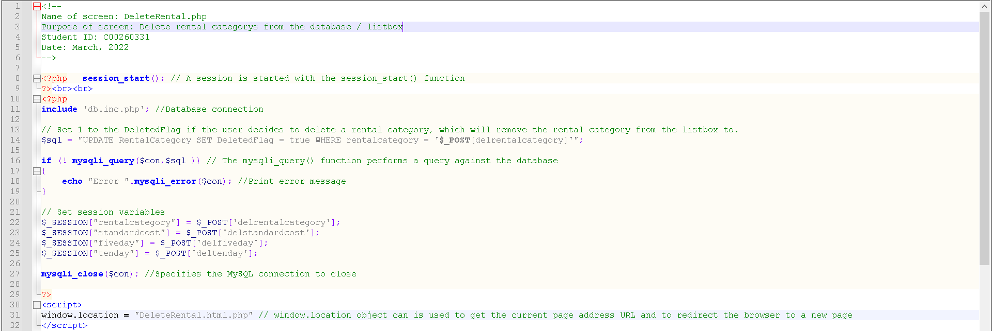

### Graphical user interface, application Description automatically generatedCSS Code













## Car Report

Name of screen: CarReport.php

Purpose of screen: Show a table with the details for Model Name, Manufacturer, Registration, Status, Date Added to Fleet and Cumulative Records.

Student ID: C00260331

Date: March 2022

### Screen

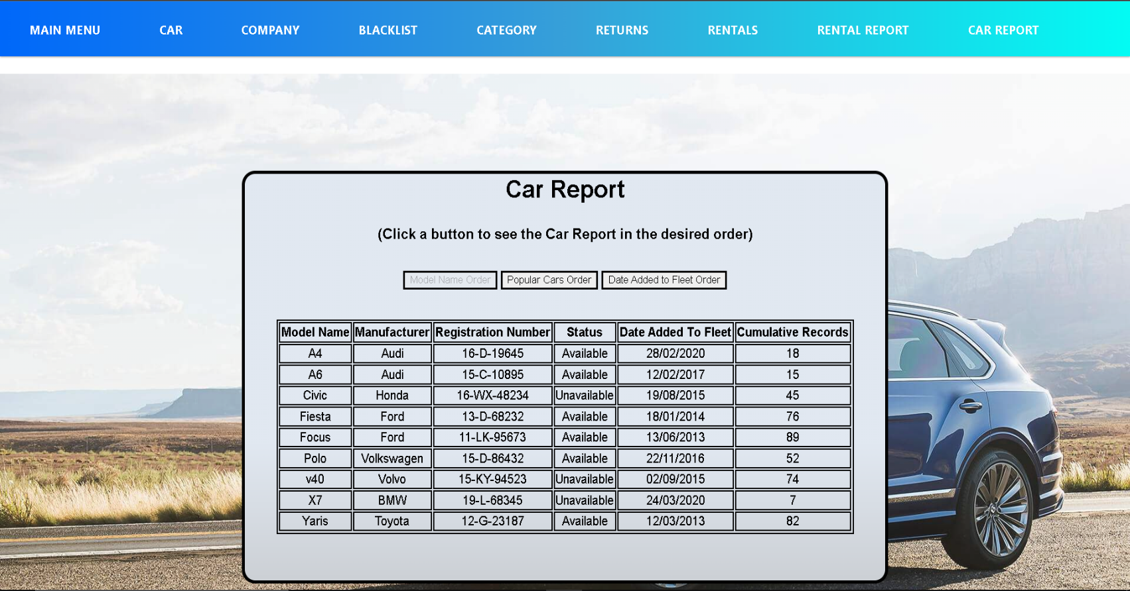

## Code

### Html + PHP Code

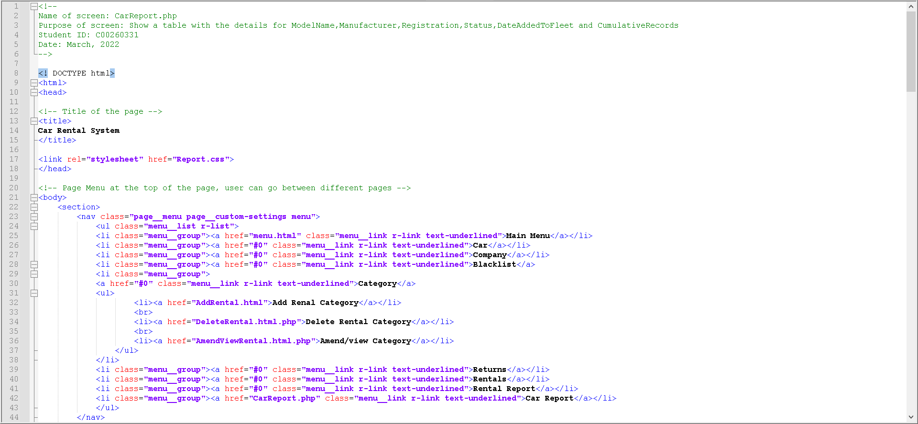

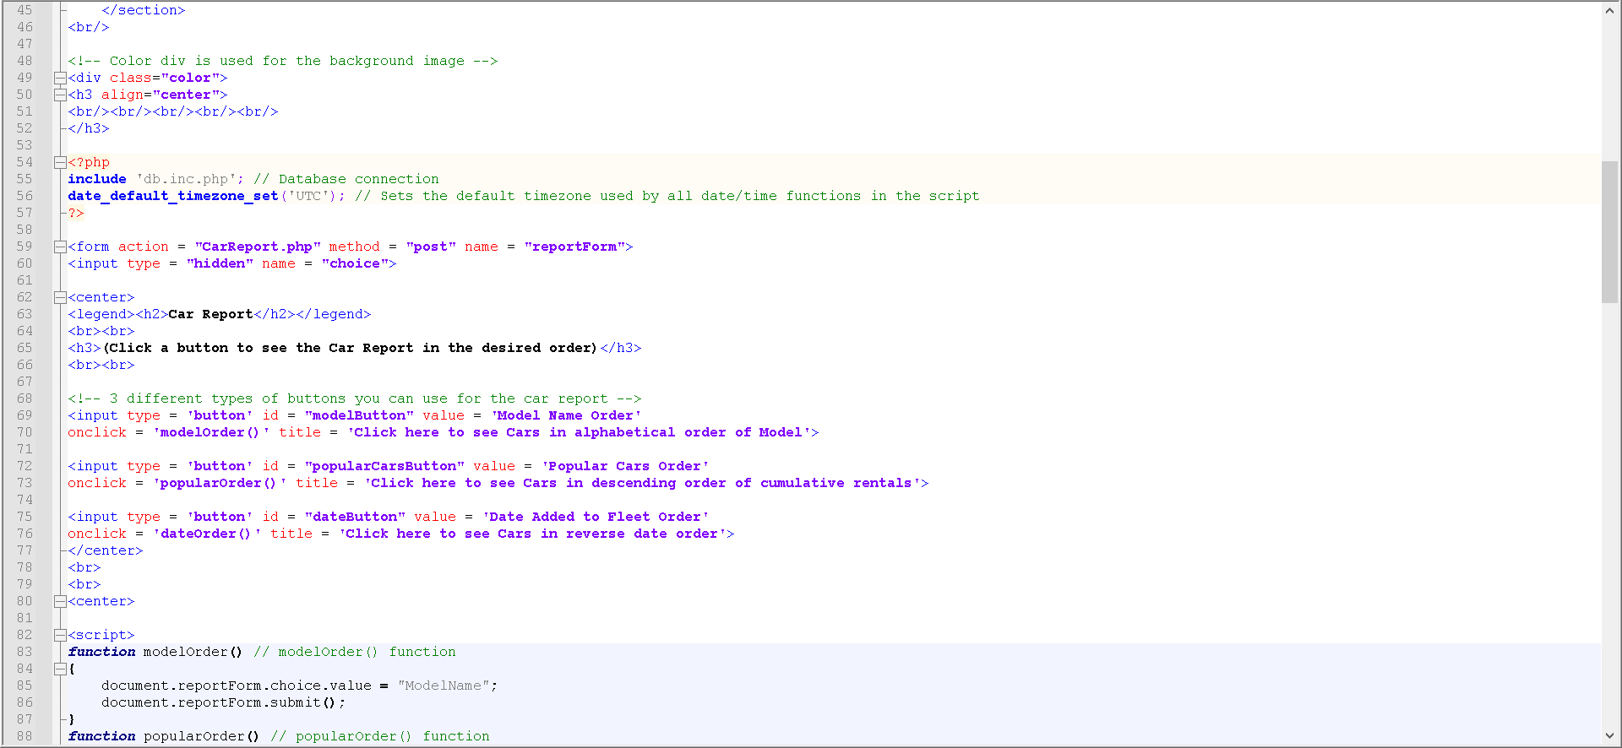

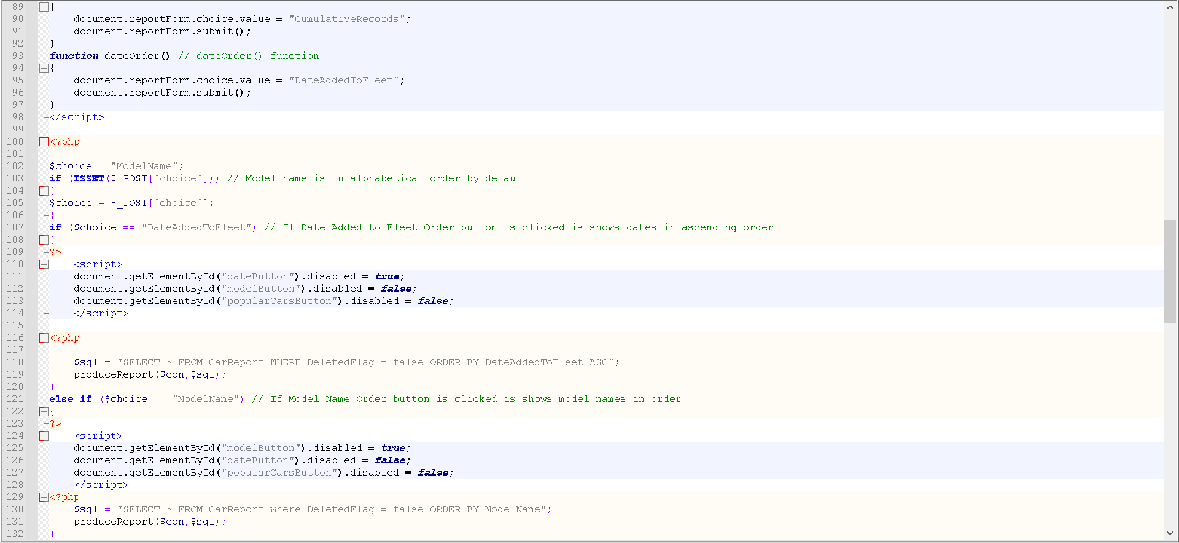

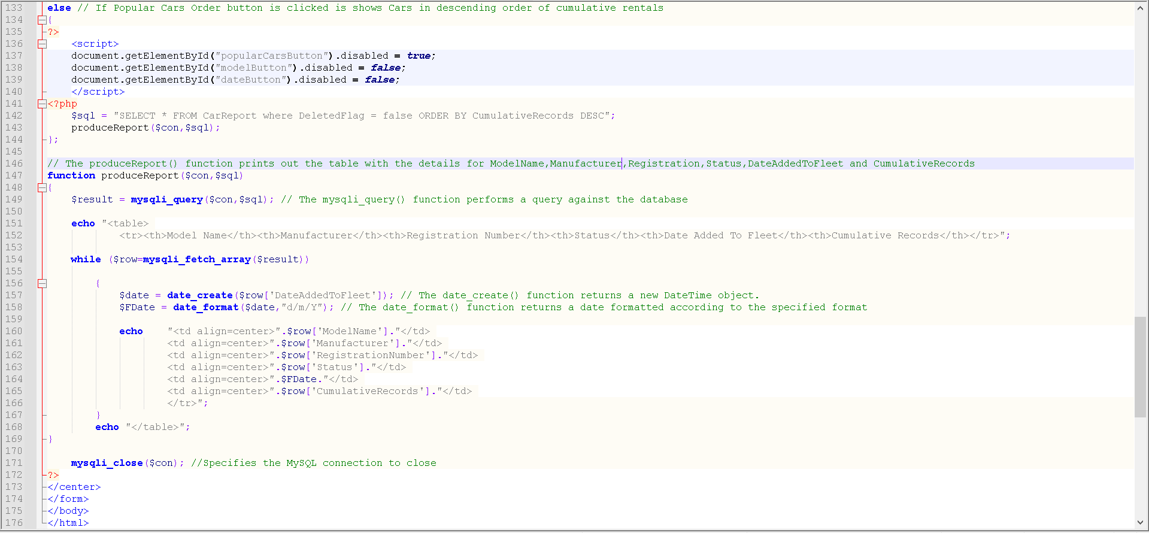

### Graphical user interface, application Description automatically generatedCSS Code









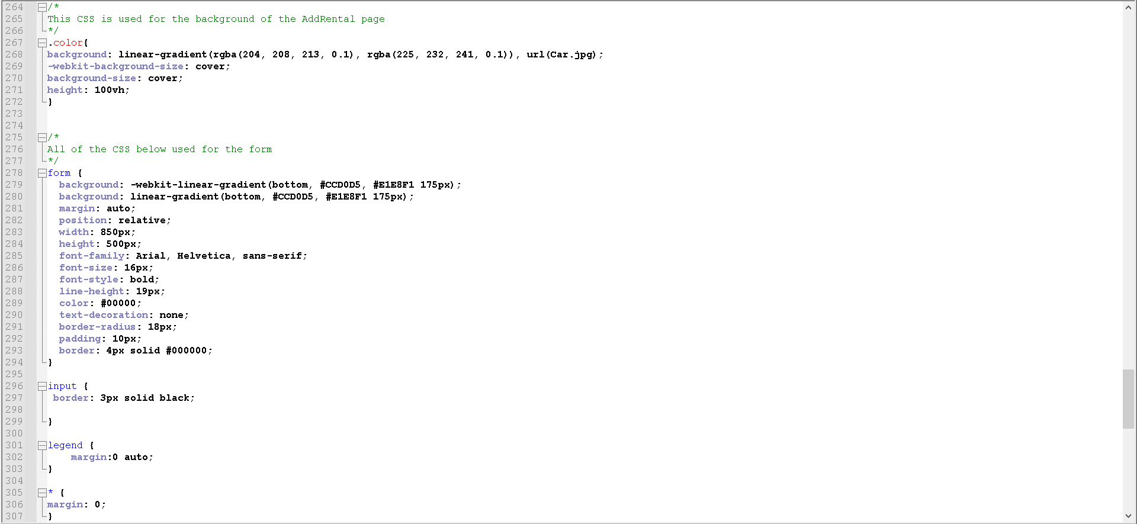

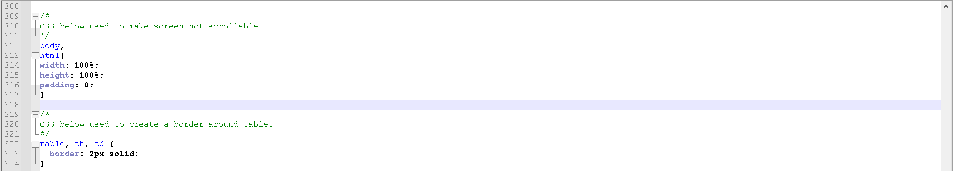

## Database Code

Name of screen: db.inc.php

Used in every screen to connect to the database.

